Look, cover, write, check!
/5
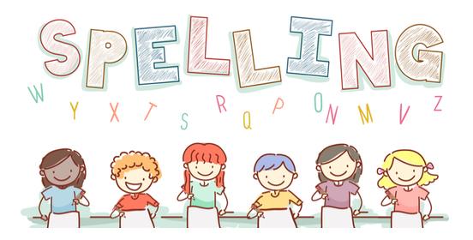
Date: 10.10.22 for a test this Friday!

Spelling  Basics 3 | Monday | Tuesday | Wednesday | Thursday | Friday
pure
beard
fair
be
once

