Spellings
/6
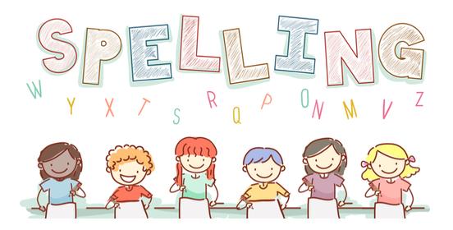
Date: 16.1.23 for a test this Friday!

Level 5 Wk 2 | Monday | Tuesday | Wednesday | Thursday | Friday
rain
play
bake
sweet
dream
swede

