Spellings
/10
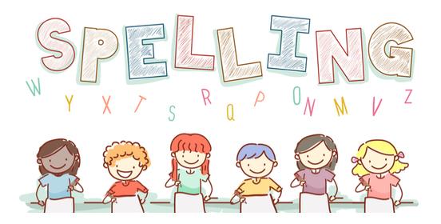
Date: 16.1.23 for a test this Friday!

Suffix est | Monday | Tuesday | Wednesday | Thursday | Friday
cheekiest
craziest
funniest
furriest
hungriest
scariest
dirtiest
silliest
happiest
foggiest

