Look, cover, write, check!
/10
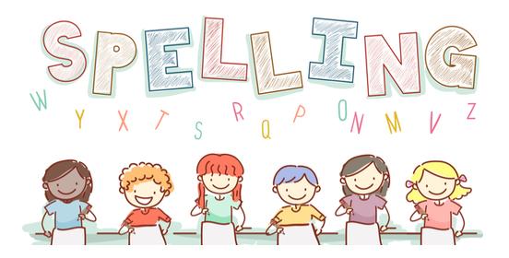
Date: 11.9.23 for a test this Friday!

Spelling  Choose to use 1 | Monday | Tuesday | Wednesday | Thursday | Friday
play
train
sweet
sea
fight
lie
boat
hoe
moon
glue

