Look, cover, write, check!
/5
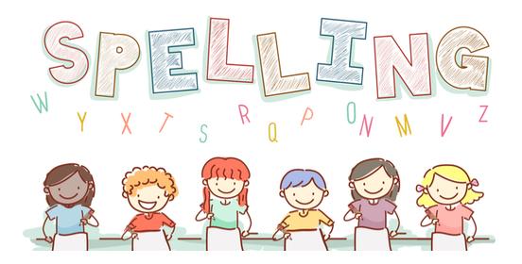
Date: for a test this Friday!

Spelling  itp Phase 3 wk 1 | Monday | Tuesday | Wednesday | Thursday | Friday
jam
vet
wig
mix
six

