Look, cover, write, check!
/10
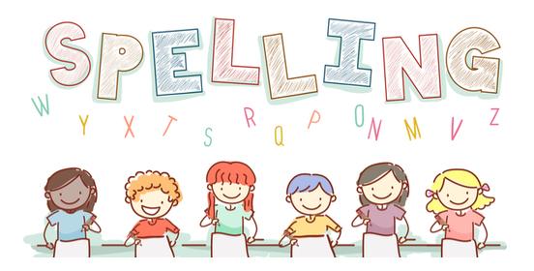
Date: 18.9.23 for a test this Friday!

Spelling  Choose to use wk2 | Monday | Tuesday | Wednesday | Thursday | Friday
rain
clay
cake
bee
leaf
concrete
coat
toe
globe
moon

