Look, cover, write, check!
/5
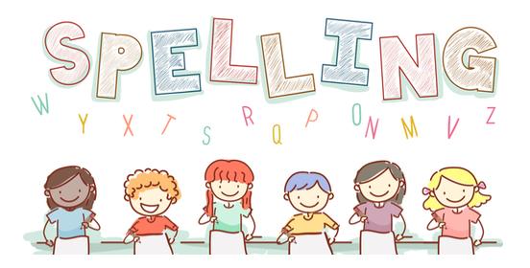
Date: 18.9.23for a test this Friday!

Spelling  itp Phase 3 wk 2 | Monday | Tuesday | Wednesday | Thursday | Friday
yap
zap
fizz
quiff
quit

