Look, cover, write, check!
/10
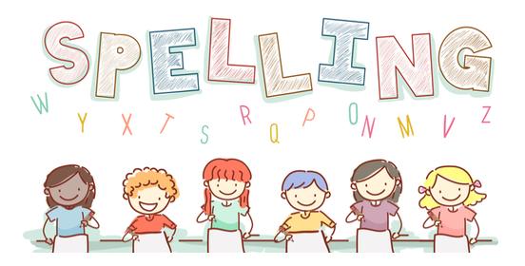
Date: 27.10.23 for a test this Friday!

Spelling  Higher Level | Monday | Tuesday | Wednesday | Thursday | Friday
share
more
stitch
hedgehog
appear
care
store
ditch
bridge
clear

