Look, cover, write, check!
/5
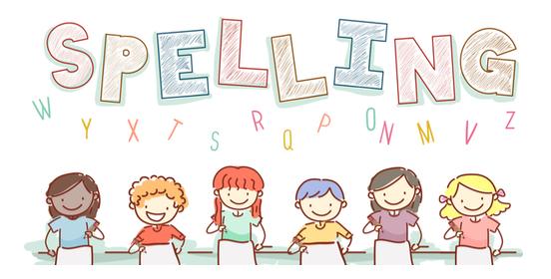
Date: 27.10.23 for a test this Friday!

Spelling  Basics 3 | Monday | Tuesday | Wednesday | Thursday | Friday
the
my
are
you
they

