Look, cover, write, check!
/10
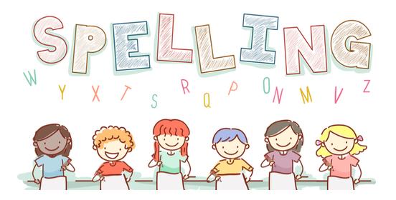
Date: 20.11.23 for a test this Friday!

Spelling  Higher Levels switch it | Monday | Tuesday | Wednesday | Thursday | Friday
shampoo
bacon
watch
mouse
shoulder
frog
gold
sponge
busy
people

