Look, cover, write, check!
/5
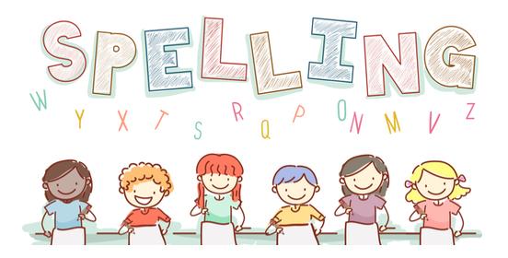
Date:20.11.23 for a test this Friday!

Spelling  Basics 4 | Monday | Tuesday | Wednesday | Thursday | Friday
flag
speck
grip
sniff
green

