Week beginning  Monday 27th April | Monday | Tuesday | Wednesday | Thursday | Friday
English | Super Veggies!  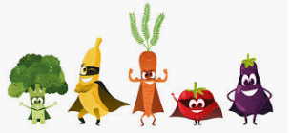  Make a list of the vegetables you have at home.  Draw a picture of your favourite vegetable and label it. | Design a trophy  Include your name.  Can you write your first name and your middle name? Don’t forget your surname. | Arrange a race  It can be a running, hopping or jumping race. Make a certificate for the winner.  Can you record who came 1st, 2nd and 3rd? | Super Villain  If you were a super villain what would your evil powers be?  Draw a picture and make a list of your evil powers. | Super Hero  If you were a superhero what would your super powers be?  Draw a picture and make a list of your super powers. Don’t forget to give yourself a name.
Reading | - Read a variety of books at home. Favourites can be repeated. Hearing the patterns of language in a story will support your child’s language development.  - Children to read to parents daily. Visit Oxford Owl for free eBooks that link to your child’s age range. Please can you create a free account at https://home.oxfordowl.co.uk/ Once you have chosen a book to read and completed it there are some fun activities at the top which are linked nicely to what happens in the book.  - With your child, look in magazines, newspapers and books for the tricky words they are currently learning. They could use a highlighter to highlight in magazines and newspapers.
Maths  All maths activities mentioned can be found on the White Rose Maths website https://whiterosemaths.com/homelearning/early-years/  EYFS Summer Term week 1 - Supertato | A trap for the Evil Pea! -  In “Supertato” the Evil Pea is up to no good. We must keep him frozen! Use your maths skills to make a trap. Remember he is small so what might you have to make sure he doesn’t escape? Could you use a box? Remember we just want to trap him so he will need holes to breath! Do we need to check he is in there? How will we see? Check in your freezer – do you have any peas in there? What other vegetables need to be frozen to keep them in control? How many do you have? Are the bags full or half full?  https://wrm-13b48.kxcdn.com/wp-content/uploads/2020/homelearning/early-years/Day-1-Supertato.pdf | Talking Together -  In this activity there are some correct and incorrect pea maths for you to help Supertato teach the veggies! Can you tell your grown up why they are wrong or why they are right?  https://wrm-13b48.kxcdn.com/wp-content/uploads/2020/homelearning/early-years/Day-2-Supertato.pdf | Run Veggies Run –  The veggies are having a sports day to keep fit. Set up your own veggie race. Discover which veggies roll the best!  Have a look and assemble your veggies! What different kinds have you got? Make your own racetrack! This could be a big one outside or a mini race for peas on the table. Have you got something for a finish line? Take It in turns, who is the winner?  https://wrm-13b48.kxcdn.com/wp-content/uploads/2020/homelearning/early-years/Day-3-Supertato.pdf | Potato Pattern Prints -  If you can, pick potatoes of different sizes so you can talk about large and small designs. If using other veg talk about what size and shape you think that might make e.g. a carrot, a circle – a big circle at the top and a little one if we use the bottom. Find some colours of paint and some paper to print on. Get printing, talking about position, printing in groups, use of colour, shape and how much space between your prints.  https://wrm-13b48.kxcdn.com/wp-content/uploads/2020/homelearning/early-years/Day-4-Supertato.pdf | Growing potatoes! –  So first you will need to pick a potato that is sprouting. Plant your potato where you choose in a big pot or in the garden. If you don’t have soil you can still watch the potato grow by putting it in a jam jar. Mark off the days on your 100 square day by day. When you get to 100 see how many potatoes you have!  https://wrm-13b48.kxcdn.com/wp-content/uploads/2020/homelearning/early-years/Day-5-Supertato.pdf
Religious Education | Value - Thankfulness  Big Question - What is something that you say ‘thank you’ to God for?  Can you draw a picture representing this week’s value? Think about our all NHS heroes and how thankful we are to have them. If you haven’t made a rainbow for your window maybe you can do this and also look out for rainbows in windows if you go out for a walk and count how many you see, a lovely symbol of positivity and hope.
Topic – Science | Frozen Treasure Hunt! –  Gather together some old toys and freeze them overnight in water – you could use a tupperware tub, loaf tin or takeaway container to freeze. Then the next day give your child a spoon and some warm water to dig and chip away at the ice. Lots of fun keeping little ones occupied as they try and dig their toys out.  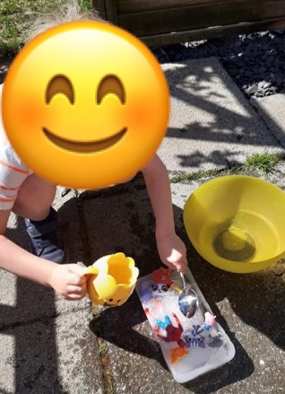

Time for talk

Question time!
Where has the robot come from?
Who do you think is controlling the robot? Does it have a mind of its own?
Are the people in danger?
Can you think of a good name for the robot?
Is there a chance that robots will become part of our society in the future?

Perfect picture!
Imagine your job is to design a robot. Draw or describe what your robot would look like, and what it could do.

