Week beginning  Monday 4th May | Monday | Tuesday | Wednesday | Thursday | Friday
English | Make a map and tell the story  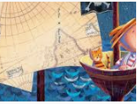  Draw your own map to show the places in the story.  Use the map to tell the story. | Sing a pirate song  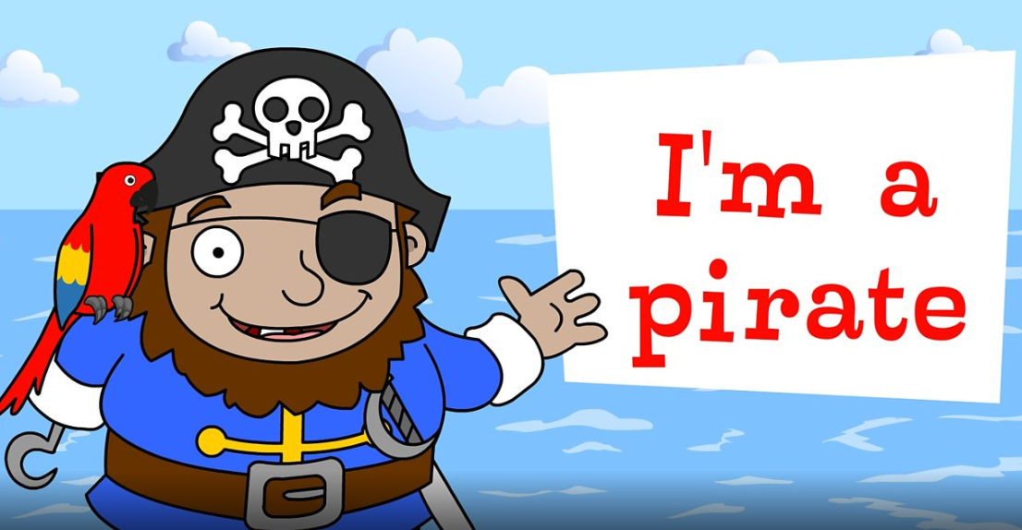  Learn a pirate song.  https://www.bbc.co.uk/teach/school-radio/nursery-rhymes-im-a-pirate/zmmkbdm  Can you make up some pirate moves? | Design your own treasure  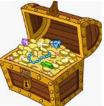  If you found your own treasure chest what would be inside? Draw a picture and write a list of each item. | Pretty Polly Parrot  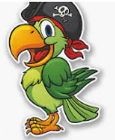  All good pirates have their very own parrot. Draw your own parrot?  Don’t forget to give your parrot a name. | Climb aboard the pirate ship  Write about your own adventure.  Where will the ship take you?  Who will you meet?  What will you see.
Reading | - Read a variety of books at home. Favourites can be repeated. Hearing the patterns of language in a story will support your child’s language development.  - Children to read to parents daily. Visit Oxford Owl for free eBooks that link to your child’s age range. Please can you create a free account at https://home.oxfordowl.co.uk/ Once you have chosen a book to read and completed it there are some fun activities at the top which are linked nicely to what happens in the book.  - With your child, look in magazines, newspapers and books for the tricky words they are currently learning. They could use a highlighter to highlight in magazines and newspapers.
Maths  Maths activities can be found on the White Rose Maths website https://whiterosemaths.com/homelearning/early-years/  EYFS Summer Term week 2 – The Night Pirates | Telescope –  Take a kitchen roll (or toilet roll) to use as a telescope. Alternatively use paper or card, possibly from a cereal box, and roll up to make a tube. Talk about how to make patterns looking at colour and shape. To make this more piratey use your skills in pattern to make an AB pattern. Or if you are feeling adventurous  create a new pattern!  This could be with paints or with tape you have around the house.  https://wrm-13b48.kxcdn.com/wp-content/uploads/2020/homelearning/early-years/Day-1-Night-Pirates.pdf | Walking the Plank –  Collect a set of objects from around your house to experiment with. Pick a number to aim for, let’s say 10. Make these into a numbered list to tick off if you wish. Find something to use as the sea the bath is a good option! If you want to invent an added plank then feel free or they could just walk down your arm. Make the objects walk the plank. Which ones floated? Make these into one group. Which ones sank? Make these into another group. How many in each group? Did any of the objects surprise you?  Tell us about it!  https://wrm-13b48.kxcdn.com/wp-content/uploads/2020/homelearning/early-years/Day-2-Night-Pirates.pdf | Treasure Hunt –  Grown ups - Set up a treasure hunt in your indoor or outdoor  space by providing a set of pictorial clues. You could even make  these together by getting the children to pick certain objects and draw them.  As the children go to each place in the pictures they can hunt for each clue. Prompt them to use positional language to explain where they need to go. Hide some treasure in the last place. This could  be a special snack, a new story to read or something special for  your family.  https://wrm-13b48.kxcdn.com/wp-content/uploads/2020/homelearning/early-years/Day-3-Night-Pirates.pdf | Make your own Pirate Ship -  Have a look around the house  for something you think will float for example a margarine tub or  a plastic bottle or a lid. Grown ups if you have any corks around these will all help your pirate ship! Think about the design of your  ship. Will it have windows? What  shape will they be? A good ship will need a mast and a sail. All ships have a name. What will you call your ship? Test out your ship to see if it will hold 5 pieces of treasure.  https://wrm-13b48.kxcdn.com/wp-content/uploads/2020/homelearning/early-years/Day-4-Night-Pirates.pdf | Game - Bud's Number Garden.  This maths game has been especially created with the support of Early Years experts to help your child learn whilst having fun.  With this game, children will be able to join Bud the bee, explore his magical garden and practise recognising numbers, counting, sequencing and much more!  https://www.bbc.co.uk/bitesize/topics/zjkphbk/articles/zd4b382
Religious Education | Value - Respect  Big Question - Does everyone deserve our respect?  Watch the clip from Sesame Street: Word on the Street - Respect https://www.youtube.com/watch?v=GOzrAK4gOSo  With a grown up can you think of all the different ways respect can be seen, felt or heard in these different settings and with these different groups of people. You could draw a picture and label it showing your favourite one –  In the classroom  In the playground  In assembly  At home  To my friends  To adults and family at home  To myself
Topic – Creative | Jolly Rodger –  The very famous flag pirates have on their ship is called “The Jolly Rodger.”  Can you make your own flag and give it a name?  You will need some big paper, or small if you want to make it for the little ship you have made.  Other ideas, you could use an old plain T shirt or any other spare plain fabric. You will need a stick like a lolly stick or straw for a small one or even a broom handle for a larger one!  The jolly Rodger was designed to warn that the pirates were coming! Will yours be a warning or a welcome?

Time for talk
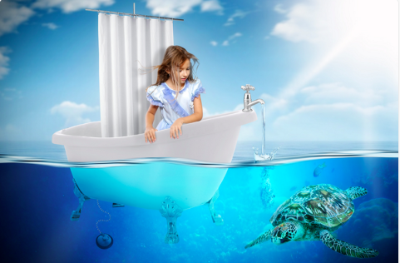

Question time!
Where did her journey begin?
Why was it ‘unexpected’?
Where will she go on her adventure?
What different things will she encounter?
How will she get back home?
How might she be feeling about the adventure?
What will her parents be thinking?
Would you like to go on an adventure like this? Perhaps you can write about it!

Perfect picture!
Can you draw another place she might visit on her adventure in the bath?

