Week beginning  Monday 11th May | Monday | Tuesday | Wednesday | Thursday | Friday
English | 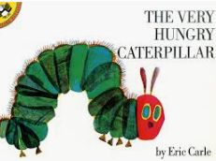  Share the story:  The Very Hungry Caterpillar  https://www.youtube.com/watch?v=75NQK-Sm1YY  What fruits did the caterpillar eat?  What is your favourite fruit?  Draw a picture and write a sentence to go with it. | 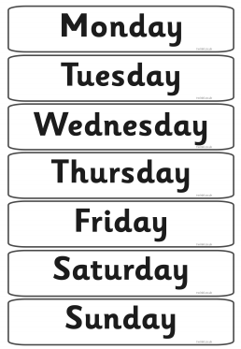  In the story the caterpillar eats different foods each day.  Can you remember what he eats on each day?  Sing the days of the week song to help you.  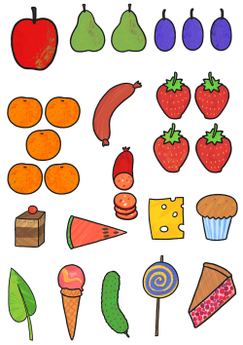 | 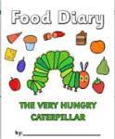  Keep a food diary of the things you eat today.  Draw pictures and label them. | 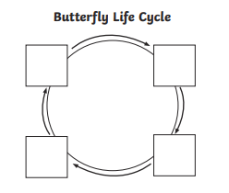  Sequence the life-cycle of a butterfly.  Draw or cut and stick pictures in order and label each stage.  Talk to an adult about what happens first, then next and finally.  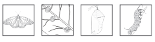 | At the end of the story the caterpillar turns into a beautiful butterfly. Can you find out what a tadpole turns into? You could use the internet or books to help you. Draw a picture and write a sentence to go with it.
Reading | - Read a variety of books at home. Favourites can be repeated. Hearing the patterns of language in a story will support your child’s language development.  - Children to read to parents daily. Visit Oxford Owl for free eBooks that link to your child’s age range. Please can you create a free account at https://home.oxfordowl.co.uk/ Once you have chosen a book to read and completed it there are some fun activities at the top which are linked nicely to what happens in the book.  - With your child, look in magazines, newspapers and books for the tricky words they are currently learning. They could use a highlighter to highlight in magazines and newspapers.
Maths  For other Maths activities Check out White Rose Week 3  https://whiterosemaths.com/homelearning/early-years/ | https://www.topmarks.co.uk/maths-games/3-5-years/counting  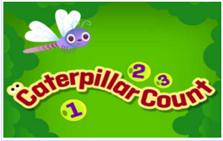 | 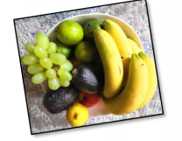  Make a list of your favourite fruits. What will be number 1? Could you work out which fruit is the most popular in your house? Which fruit will be the winner? Is all your fruit in the bowl? I hope there isn’t any evil fruit in the freezer! | Explore your fruit bowl. How many of each fruit have you got in there? Can you look at different ways of combining amounts? For example, what number do you get when you combine apples and bananas? How many bananas would I have if I had one less? Take it further and make some fruity patterns! What will be my next fruit? 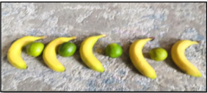  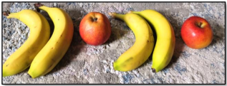 | Picnic Time Have a look and see if you have any of the food the hungry caterpillar has to eat and make a picnic! Think about what you will need and how many people are going to come. (Psst… it could be a picnic in the living room!)  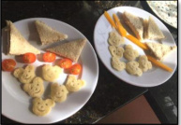  Enjoy getting your things out for your picnic how are you going to share your food? To halve things, we need to share into 2 equal groups. Have a look here. Have these 2 children each got the same? Look closer. | 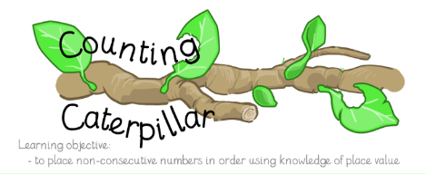  http://ictgames.com/countingCaterpillar/index.html
Religious Education | Value - Tolerance  Big Question – How does God help us?  To mark the end of the second world war, which ended 75 years ago the country celebrated VE day on Friday. During the time of war, the country had to work together. Ladies had to go out to work because men had become soldiers. Everyone helped each other and respected each other. Children had to live away from their parents so they could be kept safe. We are experiencing something similar now. Our country is working together to protect each other from the virus. Strangers are shopping for their neighbours, children have painted rainbows to say thank you, keyworkers are making sure we have food and doctors and nurses are caring for the sick and helping them to get better. The world has come together to help each other. Strangers helping strangers because together we are strong and together we will get through. Showing tolerance to everyone but also showing love, kindness, patience, friendship, gentleness and hope.  Talk to an adult about how you can help others during this difficult time.  You could make up your own prayer or draw a picture for your window.
Topic – Creative | 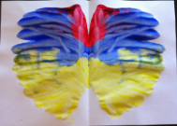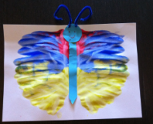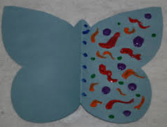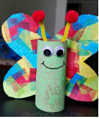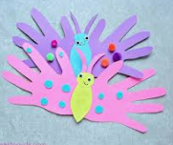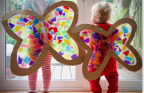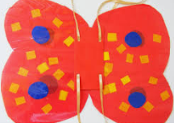  Create, draw or paint a picture of a butterfly. What colours do you need? What different parts do you need to draw? Talk to an adult about your picture. Don’t forget to make it symmetrical. First, you’ll need to find out what symmetrical means.  Go on a bug hunt in the garden or on your daily walk. Take photographs of the bugs you spot. Draw pictures and label them.

Time for talk
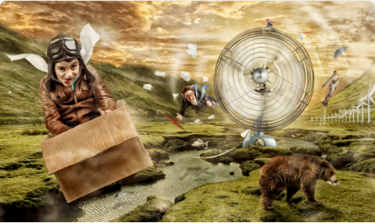

Question time!
Who are the people in the picture?
If you could fly anywhere in the world, where would you like to go?
What do you think it feels like to fly like a bird?
Why do you think the sky is the colour it is?
What is the bear thinking?

Perfect picture!
What would your perfect dream look like? Draw or describe what you have imagined.
Maybe you could draw a dream you can remember having...

