Reception Home Learning
Phonics
https://www.topmarks.co.uk/english-games/5-7-years/letters-and-sounds

https://www.youtube.com/watch?v=W8Jp5MutVlQ
WB 115/20 | Review Sounds | Activity | Review Tricky Words
Monday | https://www.youtube.com/watch?v=W8Jp5MutVlQ  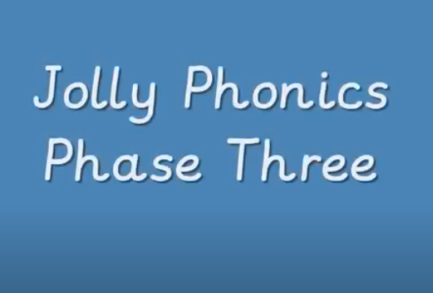 | https://www.ictgames.com/mobilePage/poopDeck/ | Zac the Rat  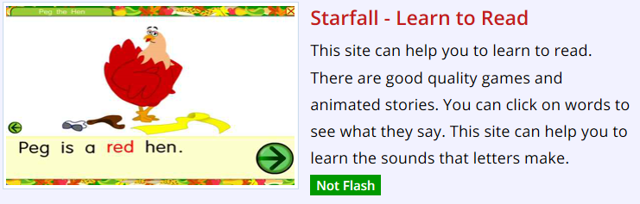  Can you spot the tricky words in the text?
Tuesday | 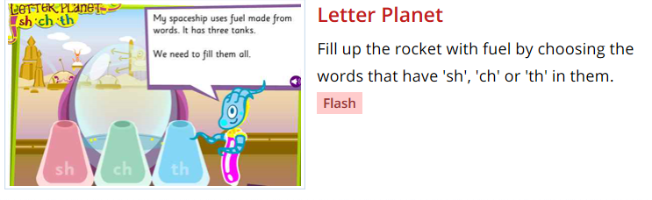 | https://www.ictgames.com/mobilePage/poopDeck/ | Peg the Hen  Can you spot the tricky words in the text?
Wednesday | 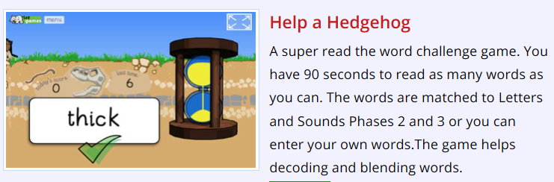 | https://www.ictgames.com/mobilePage/poopDeck/ | The Big Hit  Can you spot the tricky words in the text?
Thursday | 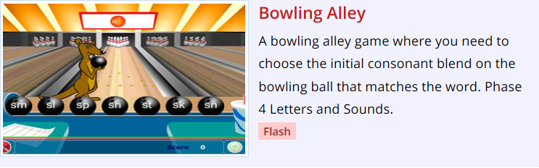 | https://www.ictgames.com/mobilePage/poopDeck/ | Mox’s Shop  Can you spot the tricky words in the text?
Friday | https://www.youtube.com/watch?v=vU2vWZKS7rY  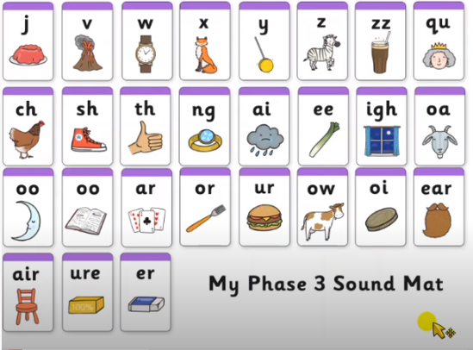 | https://www.ictgames.com/mobilePage/poopDeck/ | https://www.youtube.com/watch?v=R087lYrRpgY  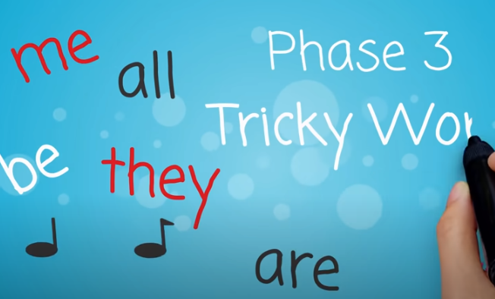

http://www.literactive.com/Download/live.asp?swf=story_files/bowling_alley_US.swf

https://www.ictgames.com/mobilePage/helpAHedgehog/index.html

https://www.starfall.com/h/ltr-classic/?mg=m
https://www.ictgames.com/mobilePage/poopDeck/
https://www.youtube.com/watch?v=vU2vWZKS7rY
https://www.youtube.com/watch?v=R087lYrRpgY

