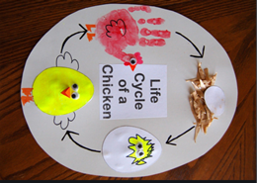

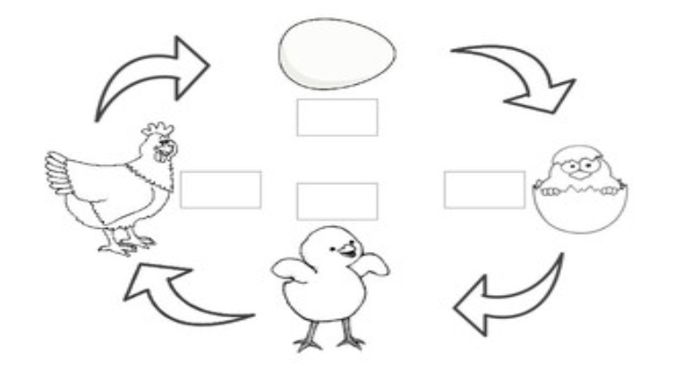

Egg Hatch Chick Hen
Can you match the words to the right picture.

