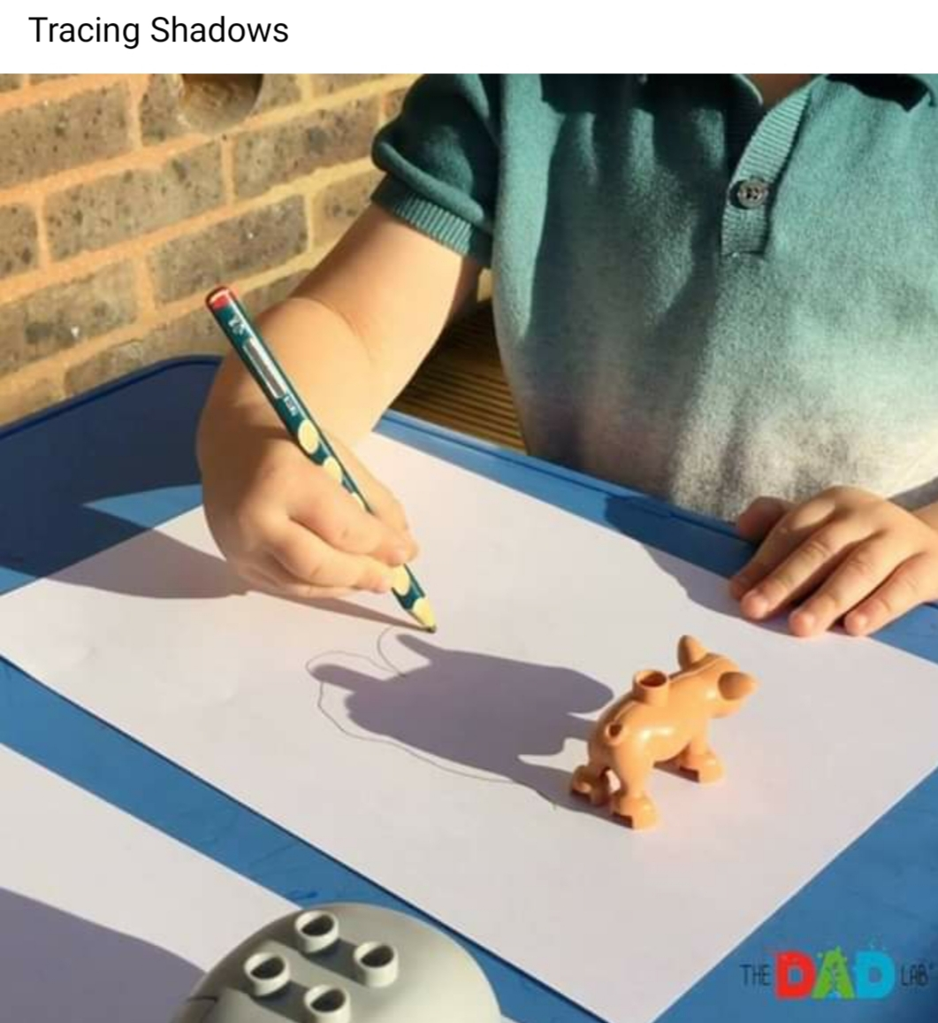

A great activity to support early writing and pencil control, choose different toys to trace round and remember if the sun is not shining you can use a torch or lamp to create the shadow. Have a shadow picture gallery and put them on display around your house, can other family members guess what the shadow picture is.

