Week beginning  Monday 18th May | Monday | Tuesday | Wednesday | Thursday | Friday
The Very Busy Spider | https://www.youtube.com/watch?v=YhkZi28sE_E
English | . 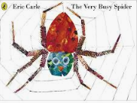  Listen to the story of The Very Busy Spider.  Who did the spider meet? Make a list of all the animals or draw them in your book and label them.  Talk to an adult about your favourite animal. Why is it your favourite? | 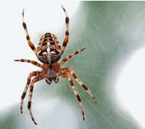  Are spiders good or bad? How do they help the food chain?  Do you like spiders? Why? You must give a reason.  I like spiders because….  I don’t like spiders because…. | https://www.youtube.com/watch?v=QTwqi_dHgmU  or  https://www.youtube.com/watch?v=-aMuD2CRqc4  Have fun singing our favourite spider song  There’s a spider on the floor.  Make your own spider and use it to make up your own song. There’s a spider on the…  Can you think of anymore spider songs? | 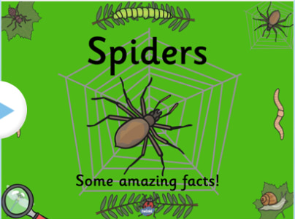  Draw a picture of a spider, research some spider facts and write them down in your book.  I wonder how many legs they have? | Take a walk outside.  What minibeasts can you find? Try Looking under plant pots or stones, look on leaves or bushes, or around some plants or flowers.  You could draw a picture or take a photo of any minibeasts you find.
Reading | - Read a variety of books at home. Favourites can be repeated. Hearing the patterns of language in a story will support your child’s language development.  - Children to read to parents daily. Visit Oxford Owl for free eBooks that link to your child’s age range. Please can you create a free account at https://home.oxfordowl.co.uk/ Once you have chosen a book to read and completed it there are some fun activities at the top which are linked nicely to what happens in the book.  - With your child, look in magazines, newspapers and books for the tricky words they are currently learning. They could use a highlighter to highlight in magazines and newspapers.
Maths  Maths activities can be found on the White Rose Maths website  https://whiterosemaths.com/homelearning/early-years/  EYFS Summer Term week 4 – The Very Busy Spider. | Making Web patterns –  Webs are very complex  patterns. Have a go at being a very busy spider! How will you make yours?  Look closely how the spider does it! Can you follow the steps? Draw your own web! This builds a pattern going outwards! An orb pattern.  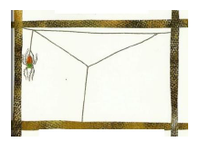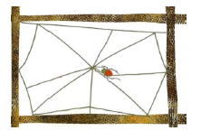  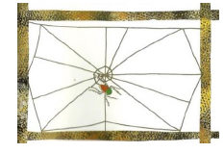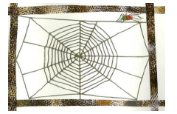  https://wrm-13b48.kxcdn.com/wp-content/uploads/2020/05/Day-1-The-very-busy-spider.pdf | Spot the mistake –  The very busy spider caught  7 flies. Then she ate 3.  Now she has 3 left.  Is she correct?  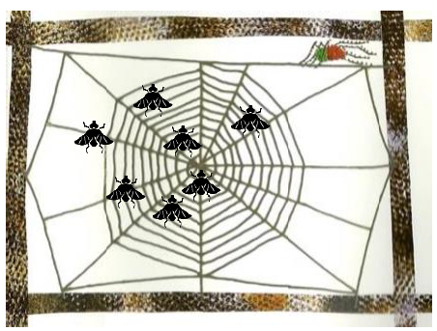  The very busy spider caught 6 flies.  Then she ate 2.  Now she has 2 left.  Is she correct?  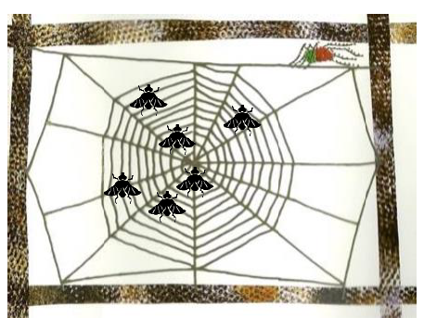  Can you make up your own spider stories to show the spider how to tell them correctly? Challenge your grown ups. Could you extend  this to 2 webs?  https://wrm-13b48.kxcdn.com/wp-content/uploads/2020/05/Day-2-The-very-busy-spider.pdf | Incy Wincy –  We all know the song!  Let’s sing it with a maths theme!  Incy Wincy spider climbed up the water spout. Down came the rain and washed the spider out. Out came the sunshine and dried up all the rain. So  Incy Wincy spider climbed up the spout again!  Now try number bond  Incy -  10 wincy spiders climbed up the water spout. Down came the rain and washed 5 spiders out. Out came the sunshine and dried up all the rain. So  5 wincy spiders won’t climb the spout again!  Repeat with different numbers! | Doubling –  As we know spiders have 8  legs, 4 on each side. Can you  sort spiders into doubles and  not doubles?  Some of our spiders have  been losing their legs! Tell us the amount of legs and  the double they are. Decide which spider is a double and which web  it should live in!  Maybe you could use your webs from earlier this week?  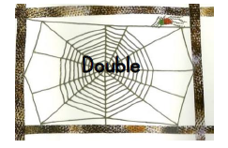  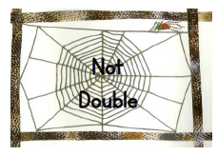  https://wrm-13b48.kxcdn.com/wp-content/uploads/2020/05/Day-4-The-very-busy-spider.pdf | Maths games –  Complete the puzzles by matching the shapes and reveal each animal.  https://www.starfall.com/h/geometry/puzzles-easy/?  Shape Patterns is a sequencing game where children from 3 to 8 years of age need to complete the pattern of different coloured 2D shapes. Three levels of difficulty.  https://www.topmarks.co.uk/ordering-and-sequencing/shape-patterns
Religious Education | Value – Hope  Hope is one of the most important values that children can develop. Children who understand the value of hope will be less likely to lose faith or give up, especially when the going gets a little tough, just like all children across the country and world are facing with the Corina virus and having to stay at home.  Big Question - What do want to be when you grow up?  Help your children keep their eyes on the future -  This activity helps to promote hope in children, it’s good to ask them what they hope to achieve. Also, ask them how they plan on going about achieving this goal? We recommend talking to your children about how they see themselves in the future. This will help them discover what it is they want, and why. You should help your children imagine how far they can go so that they can see the true potential they possess. In light of the current situation and recognition for our wonderful NHS and key workers lots of children may want to be Doctors or Nurses.  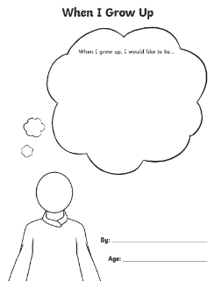  When your child says: “I want to be a marine biologist or Nurse,” you should be encouraging. Ask your child: “What do you think you need to do to make that happen?”  I have enclosed a ‘when I grow up’ activity sheet to use to aid this activity.  Children - Have a go at writing what you would like to be and why? and then draw what you will  look like, will you have to wear a uniform?
Topic – Creative | 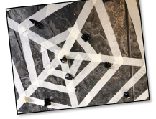  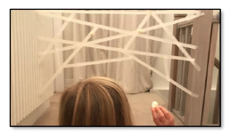  Webs everywhere!  Unleash your inner Spiderman by making your own web.  You could use tape or string to make it a 3D web.  How will you connect it? How will you have to move to design your web?  Can you go under, over and through it?  If you have made a sticky web with tape, see who can get the most flies to stick to it! (You could use pom poms or rolled up tape.) Roll 10 or 20 “flies” and see how many go into your web or are outside your web. You can do this on the  floor like these pictures with tape or just chalk. What else will you catch in your web?

Time for talk
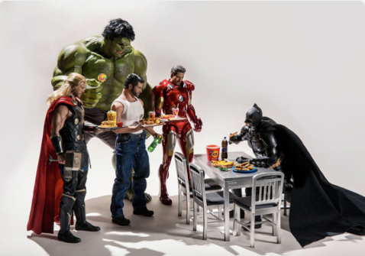

Question time!
Can you recognise each of the characters?
What do you think each of them do on a daily basis?
What do you think each of their favourite foods might be?
What do you think each of the characters are really like?

Perfect picture!
Can you draw the perfect lunch for superheroes? Think carefully about what they would eat

