Home learning 18th May
 | Day 1 | Day 2 | Day 3
Phonics | In the story ‘What the Ladybird Heard’ all the animals make different noises to fool the baddies, can you match the sound to the animal. Look at the pictures of the animals and name each one, what noise do they make? With your grown -ups help can you match the animal noise word to the animal. Your grown up can tell you what sound it starts with or sound it out, for example h-i-ss, oi-n-k. don’t worry if your child is not sure say the word and ask them to repeat it with you showing them what it looks like. | To fool the baddies the animals made different noises so that they got lost. Can you think of different noises for the animals to make it might be noises like a train or car, get your grown up to write them down so that you can mix them around. The cow might go choo choo and the duck could say raagh (like a lion) | With Geraldine the Giraffe on you tube you can practice the ‘p’ sound with her. Here is the link  https://www.youtube.com/watch?v=sUmUpf-JNoU&list=PL-oq_yKpmdoNJhiNtSodP2Nuhn_KfM2ux  this link will give you a number of letter sounds to practice so if you want you can look at s a t p I n. see if you can find things in your house that start with the sound ‘t’.  Watch Jolly phonics and sing along to the alphabet song the link is at the bottom of the page.
Writing | Do you have a special treasure in your house that someone might want to steal, maybe it’s your favourite toy in your bedroom or your garden, can your draw a map like the baddies did? Which way might they go to get to your treasure? | watch the episode on the how the world works  https://www.okido.com/video/episode-45-splish-splash-splosh/ have a go at making good bacteria and bad virus germs for a game of hide and seek, either in the garden or round the house. Remember give the bad virus germs angry faces and the good bacteria smiling faces. | Make your own ladybird finger puppet just follow the instructions on the how to sheet. You could make enough lady birds for each finger.
Math’s | How many spots for the ladybird, using a dice to find out how many spots to put on. First draw a simple ladybird shape and then roll the dice and count the dots to know how many spots to put on each wing of the ladybird. You can also use the link below to play the game on topmarks.  https://www.topmarks.co.uk/learning-to-count/ladybird-spots | Can you find the ladybird? Look carefully check each one. You need to count the spot’s and eyes. Is it the right colour? Then have a go at making your own find the ladybird game. Remember to make it tricky you need to make the ladybirds nearly the same but with one thing that is not the same. | 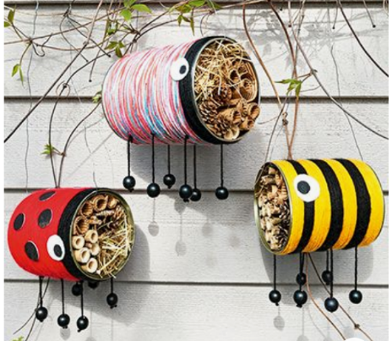  have a go at making your own bug hotel for your garden. Use an old tin can or plastic pot and decorate it to look like a bug or add wings to make it a bird. How many legs do bee’s, ladybird’s and butterflies have. How many spots for your ladybird? When you have decorated the can or pot you will need to ask your grown up to cut some bamboo canes the right length to fit inside. You will need to measure inside then mark your bamboo to make it the same. You can also collect twigs and use dry grass to make it nice and cosy for the bugs. How many will you make for your garden?
Why don’t you make yourself a pair of binoculars using two toilet roll tubes, sticky tape and some string or wool.
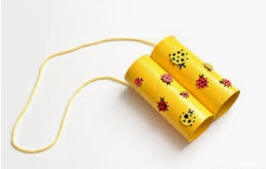
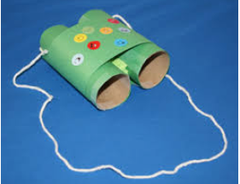

Here are some different designs but you can decorate yours anyway you like, use the binoculars to go on wildlife hunt using the sheet attached or make your own sheet and draw each thing you find with your binoculars.

