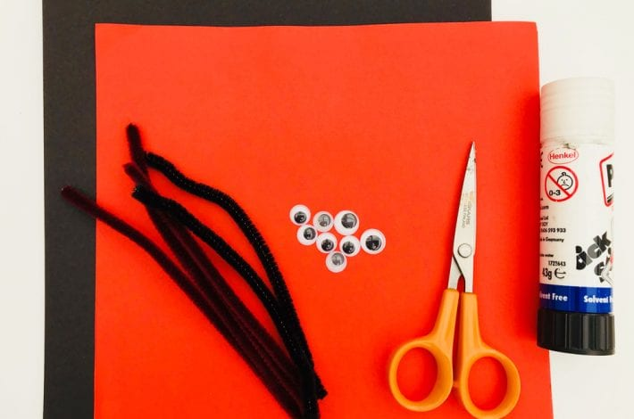
You will need:
- Red and black card
- A glue stick
- Googly eyes
- Pipe cleaners
- Scissors
- Sellotape

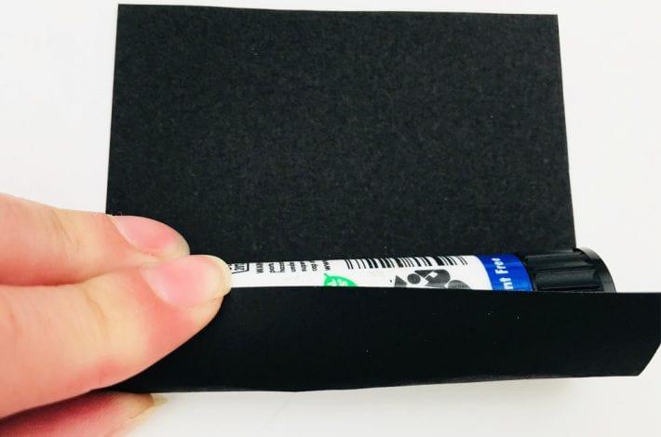
Step 1: Roll a piece of card to fit over your finger
You can use a glue stick as your guide and cut a square of black card the same height as your glue stick and long enough to wrap around it.
Now roll your card around the glue stick to make a tube.
Step 2: Secure the tube with tape
Stick the edges of your rolled card tube with tape.
They should now be the perfect size to fit on your finger.
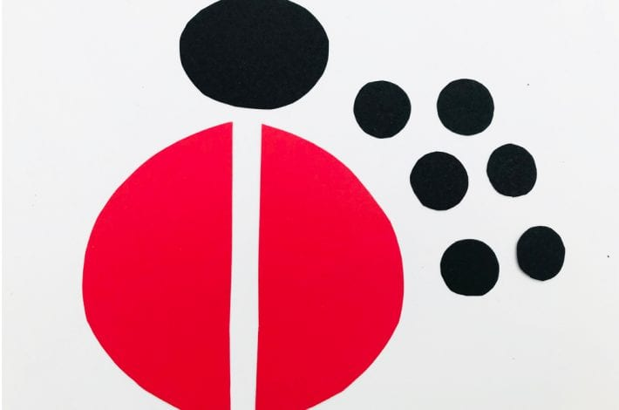
Step 3: Cut out some cardboard shapes
Cut two semi-circles out of red card. Then take the black card and cut an oval shape for the ladybird’s head, and six small circles for its spots.
You can draw round something small, like a button, to help you cut nice circles. Now you have all the pieces of your ladybird.
Step 4: Get dotty
Glue the black dots onto the wings and glue some googly eyes onto your ladybird’s face.
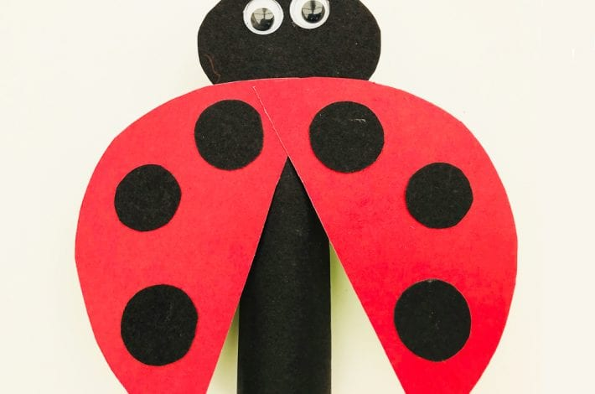
Step 5: Build your ladybird
Glue the head to the top of your black tube. Then stick on both wings, overlapping slightly at the top.
We positioned the wings so it looks like our ladybird is just about to fly off into the sky.
Arrange yours however you prefer.

