 | Monday | Tuesday | Wednesday | Thursday | Friday
Reading | This week, choose a book from purple mash Diamonds or Emeralds. I recommend ‘Percy the Poorly Pony’.  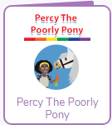 There are activities to do once you have read the story…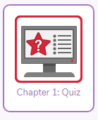
Spellings | We will be concentrating on our Year 2 Common Exception Words (tricky words). These are words that are tricky to use our phonics skills to sound out and blend, so the only the way to know how to spell them… is to learn them!  Also, can you explain the meaning of each word? |  |  |  | Spelling Test!  Ask your grown up to help you complete a spelling test.  Please email Mrs Bayliss and Miss Sangha your test results at beech@hollyhill.bham.sch.uk and evergreen@hollyhill.bham.uk … We would love to see how you are all doing!
English | Play the Tricky Words Game http://www.ictgames.com/mobilePage/spookySpellings/index.html | On Sunday, America launched the SpaceX rocket into space…  Watch the launch here…  https://uk.video.search.yahoo.com/yhs/search;_ylt=AwrJO1VgkdNeENUA9AV3Bwx.;_ylu=X3oDMTB0ZTgxN3Q0BGNvbG8DaXIyBHBvcwMxBHZ0aWQDBHNlYwNwaXZz?p=space+x+launch&type=pipr_5056_CHW_UK&param1=RypDRDjp20T5Vc76fVk9yA%3D%3D&param2=9dUI1n2R0BLDxNuWfiP4aSFOTltNdSPoIx38%2BUf%2FiXrvPdoGmStdlfwLFZYDvqkAJrWWk4yNReCLnBD%2FqPsDZd7olTZcV8HMx1G%2Fk786sE2Tis1g8dJd8zxVWs%2BbKztBnq1TfqUiqPYK9pXifXmJF2dHBPfe0sKRIUa4ojnUD9c2N1O5t%2Fi4WnQTJfFBkFnHOEjn8Tf9ttNyX5NgtG0osQWXmvjZxiVELfuTVZqhL%2BWXfUpXyti%2FojRv5IqNFRimewKgOdocgyVQ%2BUtmqF995RaHnv3XiwoEyMFfAswBmEQ%3D&param3=NwVEMR%2FzKcG52XsVBYEh2zk2Yklq85vdfspZPoqz2M1%2FBfpNLaqltlRYMSLwdzxLbmKuJFvxO%2FCOySkGqu32ne3NbYo1NVtH%2Fks9KEfB0wJgJrbuZEH55IeZSY9rKv5jk6SUmEi6FX0a%2FV30bWIIWHOEpWQuoHKLQFBkeKHTWHr771bcciFKgbhPDRFC6NBX&param4=iJzGF8UG5IXW5q6S3PN%2FbUqqPKvGFFa8mh6rSorTYZI%3D&hsimp=yhs-1&hspart=iba&ei=UTF-8&fr=yhs-iba-1#id=4&vid=0fff6ac330fc8ce7c1203bb09b910603&action=view  If you were an astronaut travelling to space, what 10 items would you take with you?  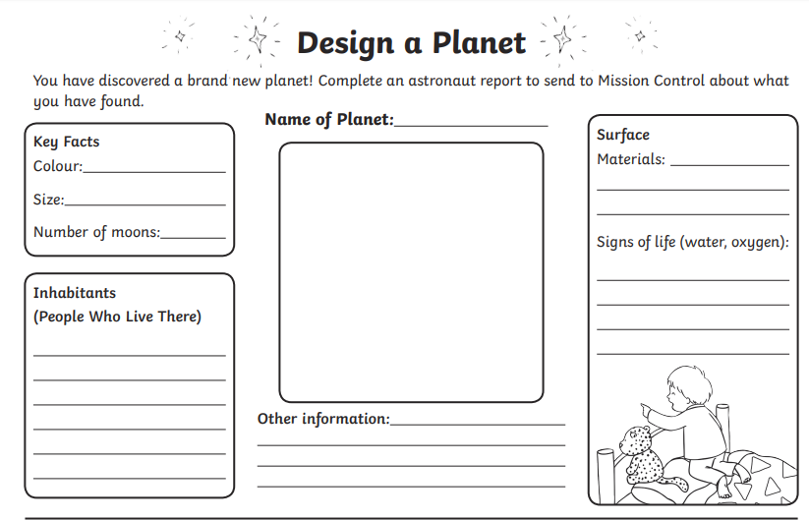  - Jupiter is massive!  - Jupiter cannot become a Star.  - Jupiter is the fastest spinning planet In the solar System.  - The clouds on Jupiter are only 50 km thick.  - Jupiter has a Great Red Spot.  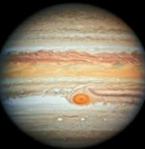  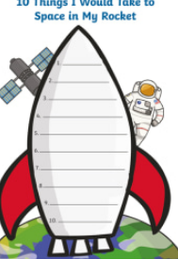 | :  Does anybody live on your planet? Draw a picture of what they look like and write 5 sentences to describe them…  Now create you own planet….  There are 8 planets in our Solar Systen. Can you name them?  There are 8 planets in our Solar Systen. Can you name them?  Which is your favourite planet? Find five amazing facta about it e.g
Maths | Multiplication  Play 2, 5 and 10 X tables…  https://www.topmarks.co.uk/maths-games/hit-the-button | Multiplication  Answer the questions:  - 2 x 3 =  - 5 x 5=  - 10 x 2=  - 2 x 6=  - 5 x 4=  - 10 x 10=  - 2 x 1=  - 5 x 12=  - 10 x 3=  - 2 x ?= 20  - 5 x ?= 50  - 10 x ?= 70  Don’t forget to draw an array to help you to work out the answer. | Word problems.  Sarah as 3 fish tanks. There are 5 fish in each tank. How many fish does she have altogether?  There are 6 bikes in our playground. Each bike has 2 wheels. How many wheels are there altogether?  There are 10 trees in an orchard. 8 Apples grow on each tree. How many apples are there altogether?  What is 5 multiplied by 7? | Reasoning  1.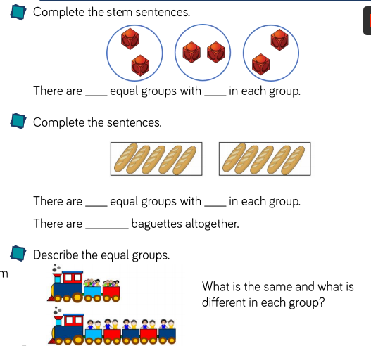  2. 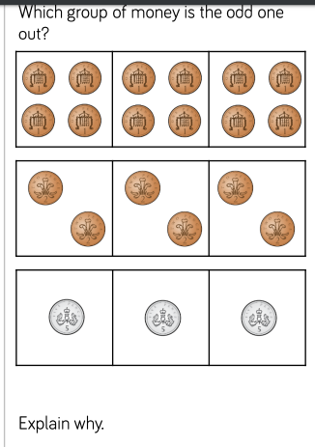 | Reasoning  1. 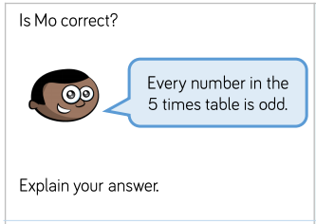  2.  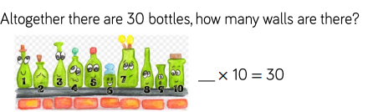  3.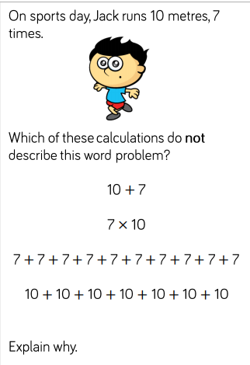
R.E – Gentleness | This week’s Cristian Value is Gentleness. Take a photo, draw a picture or write a prayer about the ways that you have shown gentleness this week to…  One of God’s Creatures (you may have cuddled a pet or saved a snail)  A family Member (you may have held a grown-ups hand)  One of God’s Creations (you may have helped to water the plants in your garden or looked closely at a flower without picking it)  Or something else!
Topic – Pace Rocket D.T | Create a space rocket!  Here are some instructions but please be as creative as you wish!  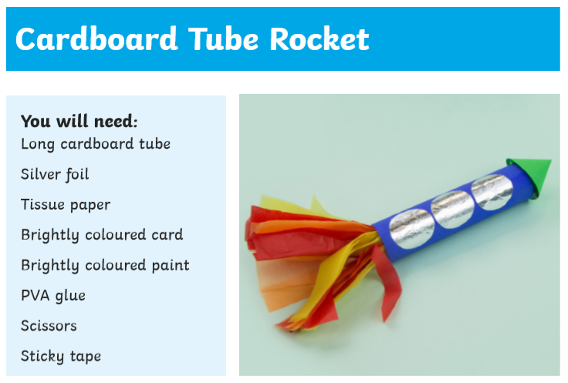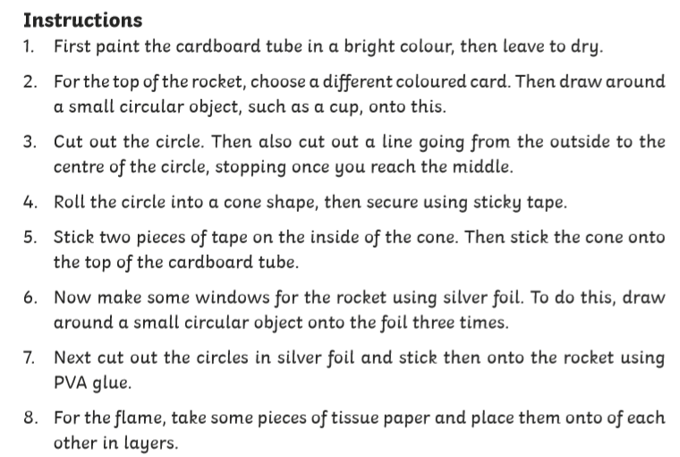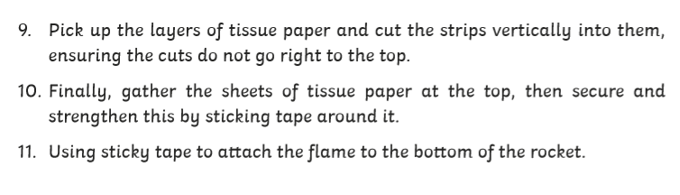  Don’t forget to send photos of your rockets to beech@hollyhill.bham.sch.uk or evergreen@hollyhill.bham.sch.uk  We are looking forward to seeing your wonderful designs!

