Week beginning  Monday 8th June | Monday | Tuesday | Wednesday | Thursday | Friday
These activities and ideas are  based around the book  “The Snail and the Whale”  By Julia Donaldson. | https://www.youtube.com/watch?v=x887mPO9X9c  Story  https://www.bbc.co.uk/iplayer/episode/m000cslw/the-snail-and-the-whale  Programme  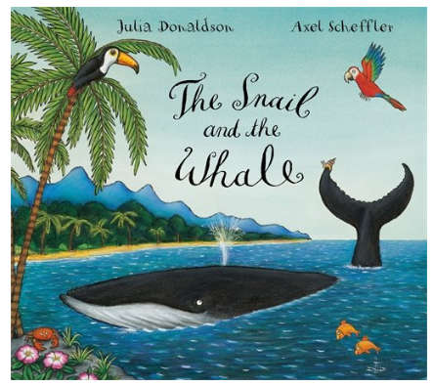
English | 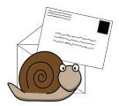  Snail writes a thank you letter to whale.  What does she say?  Can you say why you are writing the thank you letter?  What did you like on the trip?  Where do you want to go next with whale?  Worksheet enclosed with this e-mail. | Whale and snail are rhyming word. How many other words can you think of that rhyme with ‘whale and snail’? | 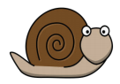  The snail wants to see more of the world. The snail chooses a different animal or way to travel. Draw the way the snail travels next.  What will the snail choose to travel on?  Where will the snail go?  What will the snail see?  What adventures will the snail get up to? | 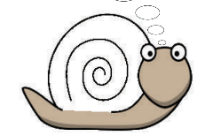  Decorate the Snails shell –  The Snail wants to look different. What sort of shell would you give her?  What patterns and colours will you use to make her look different?  Worksheet enclosed with this e-mail. | 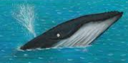  How did the Whale feel?  Look through the book and try to decide how the whale felt at different times.  When did he feel happy?  When did he feel sad?  Where did he feel scared?  Worksheet enclosed with this e-mail.
Reading | - Read a variety of books at home. Favourites can be repeated. Hearing the patterns of language in a story will support your child’s language development.  - Children to read to parents daily. Visit Oxford Owl for free eBooks that link to your child’s age range. Please can you create a free account at https://home.oxfordowl.co.uk/ Once you have chosen a book to read and completed it there are some fun activities at the top which are linked nicely to what happens in the book.  - With your child, look in magazines, newspapers and books for the tricky words they are currently learning. They could use a highlighter to highlight in magazines and newspapers.
Maths | Adding snails on whales and  rocks and…?  See if you can work on your addition skills and tell us a  first, then, now story!  How many snails?  First we have 1 snail  Here on the whale!  Then 1 more comes?  Now we have?  Answer the addition questions in the link below –  https://wrm-13b48.kxcdn.com/wp-content/uploads/2020/05/Day-2-The-Snail-and-the-Whale.pdf | The snail certainly has an adventurous journey!  He is on another journey. Can you see where he goes, who he meets and if it is an odd or even number?  Odds and evens – use a ten frame to help you if you want.  Remember the numbers are even if they can be shared equally between two groups.  Answer the odd and even questions in the link below  https://wrm-13b48.kxcdn.com/wp-content/uploads/2020/05/Day-4-The-Snail-and-the-Whale.pdf | Snail Trail –  Snails leave a silvery trail where they have been. If you were a snail where would your trail have been  today?  “Slimy Snail sets out on a trail. But where exactly does he go?  Up a hill, over a bridge, down a slope.”  Make a map of where you have been and talk about position and  distance. Did you go under the table? Around the settee?  Or plan your trail ahead – where will you leave your silvery slimy  messages? | 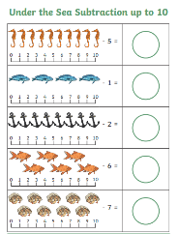  Under the sea subtraction worksheet to 10.  Worksheet enclosed with this e-mail. | Don’t forget the song! -  There's a snail at the bottom of the garden and his name is Christopher Crawl  There's a snail at the bottom of the garden and he crawling up my wall. He  crawls all night, he crawls all day, slowly crawling on his way. There's a snail  at the bottom of the garden and his name is Christopher Crawl.
Religious Education | Value of the week – Forgiveness  Big question - Are there any things which are unforgivable?  Listen to the story Rosa learns about forgiveness –  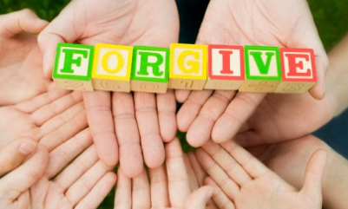  https://www.youtube.com/watch?v=8asjwbF1hnc  Listen to the shot song “Forgive and Forget” by Doc McStuffins  https://www.youtube.com/watch?v=PuLo7dsflaI  Have you ever hurt anyone’s feelings like Ana and didn’t mean it?  How did you feel?  Did you say sorry?  Have your feelings ever been hurt?  How did it feel?  Can you remember a time when you forgave like Rosa?  We all make mistakes and do things that aren’t always right. It can be hard to say sorry for what we have or haven’t done.  Can you think of some ideas to show that you are sorry?  Maybe you could tell them how you feel  Say sorry  Do something nice for the upset person like give them a hug  You could also make them a picture or do some colouring for them. I have also enclosed a ‘we forgive’ colouring sheet for you to complete.
Topic – Science | Salt Water Density – Egg and salt science experiment  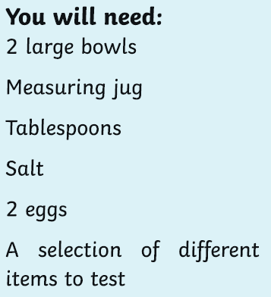  Method –  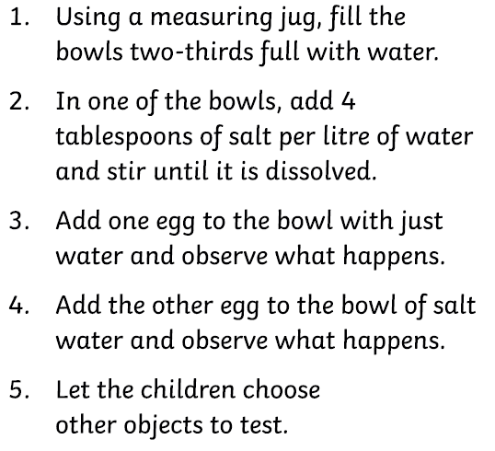  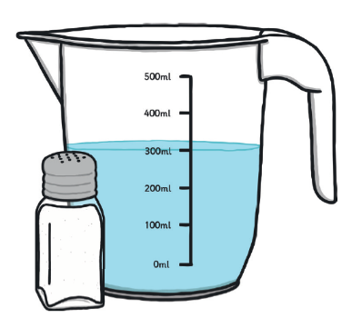
Physical Education | Have you visited the ‘Cosmic Kids Yoga’ channel on Youtube? https://www.youtube.com/user/CosmicKidsYoga  It has some fantastic exercises and activities.  • See if you can find and copy the ‘whale pose’ on the Cosmic Kid’s Yoga channel.  • Have your parents take a picture of you performing the whale pose or any other poses you find on the Cosmic Kids Yoga channel

Time for talk
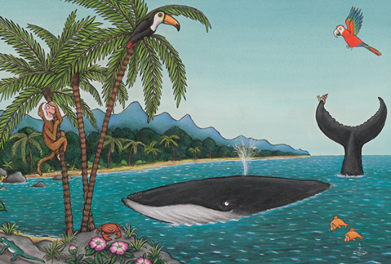

Question time!

The whale shows the snail around the exotic island.
- When you next go out, can you describe all the things you can see and hear all around you?
- When you get home can you recall what you saw and draw some pictures?
- Could you try labelling the pictures you have drawn?
- Who helps who in the story?
- How do you feel when you help people?
- What could you do at home to be ‘helpful’?

