Nursey Home learning 8.6.20

8.6.20 | Day 1 | Day 2 | Day 3
The majority of these activities and ideas are  based around the book  “The Snail and the Whale”  By Julia Donaldson. | https://www.youtube.com/watch?v=x887mPO9X9c  Story  https://www.bbc.co.uk/iplayer/episode/m000cslw/the-snail-and-the-whale  Programme  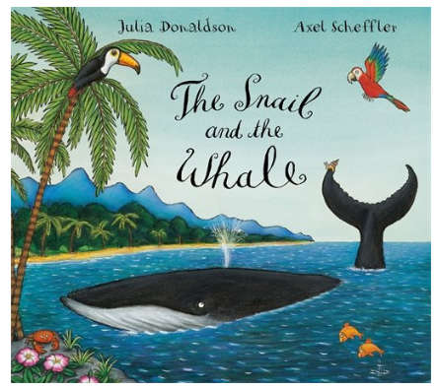
Phonics | Play Super smoothie on PhonicsPaly.co.uk –  https://www.phonicsplay.co.uk/  Username: march20  Password: home  Phase 1 – Super smoothie  An interactive sound matching game. Drag the words that start with the same sound into the blender. Find all three to blend up a super smoothie. | Play the game ‘I hear with my little ear’! Take it in turns to imitate the sound of something and guess what makes that sound. You could imitate the sounds of the animals from ‘The snail and the whale’ story or things found around your house like a clock or a telephone.  Talk about the sounds you like and the sounds you don’t like and why. | Alliteration (words that start with the same initial sound) - ‘Can You Find...?’  The snail saved the whale from the beach. The children were so happy they enjoyed a day at the beach themselves.  Can you find these things in the picture?  sad sun  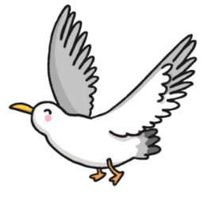  silver, spotty snake  small sailboat  sneaky seagull  stinky, smelly sausages  super-slippy sand  sparkling sea  spotty snake skin  Can you make the ‘s’ sound?  Can you think of any other things that start with the ‘s’ sound?  Can you count how many things there are in the poster that start with ‘s’?  Can you use your finger to draw an ‘s’ in the air?  Can you now have a go at writing it on paper?  Alliteration worksheet enclosed with this e-mail.
Writing | 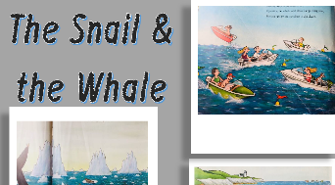  The Snail and the Whale story sequencing – Can you put the pictures in the correct order to help re-tell the story? What happens first, then, next and last?  A great way to recall and re-tell the story using pictures. These lovely pictures prompt the children to remember what happened in the story.  Completing story sequencing tasks helps improve comprehension and aids children's ability to organise information and ideas effectively.  Worksheet enclosed with this e-mail. | 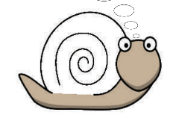  Decorate the Snails shell –  The Snail wants to look different. What sort of shell would you give her?  What patterns and colours will you use to make her look different?  Worksheet enclosed with this e-mail or have a go at drawing your own. | 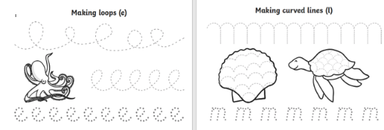  Under the sea pencil control activity sheets –  Use your pencil to follow the dotted lines to make loops (e) and curved lines (m).  Pencil control sheet attached to this e-mail.
Math’s | Snail Trail –  Snails leave a silvery trail where they have been. If you were a snail where would your trail have been today?  “Slimy Snail sets out on a trail. But where exactly does he go?  Up a hill, over a bridge, down a slope.”  Pretend to be a snail and make a map of where you have been. Talk about position and  distance. Did you go under the table? Around the settee? Up the stairs? On the bed? | 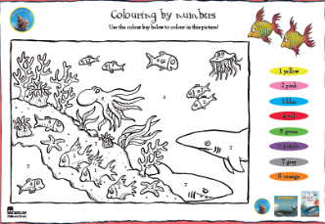  The Snail and the Whale colour by number. Helping to recognise colours and numbers 1-8.  Worksheet enclosed with this e-mail. | 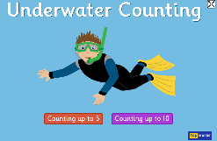  Top Marks Underwater counting game - https://www.topmarks.co.uk/learning-to-count/underwater-counting  Underwater counting is an interactive counting game for young children involving counting the number of objects to 10 and helps children with number recognition. The game has two difficulty levels which can be matched to appropriate numerical ability.
Religious  Education | Value of the week – Forgiveness  Big question - Are there any things which are unforgivable?  Listen to the story Rosa learns about forgiveness –  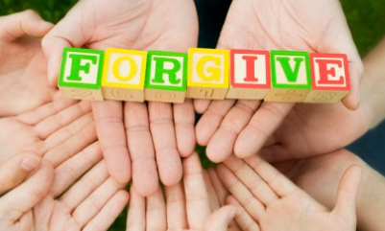  https://www.youtube.com/watch?v=8asjwbF1hnc  Listen to the shot song “Forgive and Forget” by Doc McStuffins  https://www.youtube.com/watch?v=PuLo7dsflaI  Have you ever hurt anyone’s feelings like Ana and didn’t mean it?  How did you feel?  Did you say sorry?  Have your feelings ever been hurt?  How did it feel?  Can you remember a time when you forgave like Rosa?  We all make mistakes and do things that aren’t always right. It can be hard to say sorry for what we have or haven’t done.  Can you think of some ideas to show that you are sorry?  Maybe you could tell them how you feel  Say sorry  Do something nice for the upset person like give them a hug.  You could also make them a picture or do some colouring for them. I have also enclosed a ‘we forgive’ colouring sheet for you to complete.
Topic – Science | Salt Water Density – Egg and salt science experiment  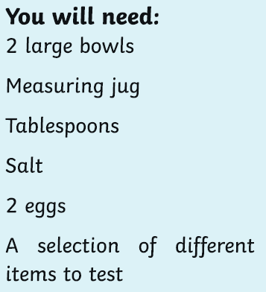  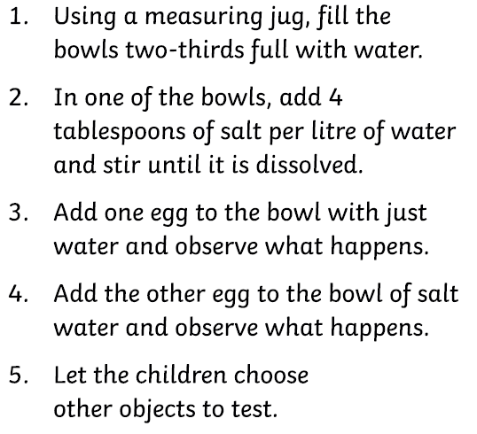  Method –  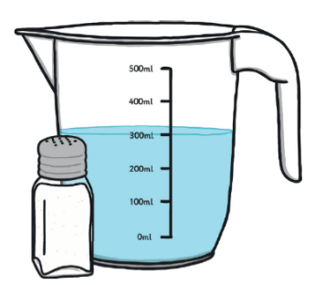
Talking Together | 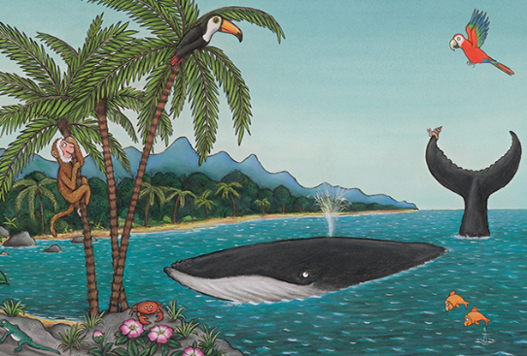  Question time!  The whale shows the snail around the exotic island.  • When you next go out, can you describe all the things you can see and hear all around you?  • When you get home can you recall what you saw and draw some pictures?
Physical Education | Have you visited the ‘Cosmic Kids Yoga’ channel on Youtube? https://www.youtube.com/user/CosmicKidsYoga  It has some fantastic exercises and activities.  • See if you can find and copy the ‘whale pose’ on the Cosmic Kid’s Yoga channel.  • Have your parents take a picture of you performing the whale pose or any other poses you find on the Cosmic Kids Yoga channel
Song | Don’t forget the song! -  There's a snail at the bottom of the garden and his name is Christopher Crawl  There's a snail at the bottom of the garden and he’s crawling up my wall. He  crawls all night, he crawls all day, slowly crawling on his way. There's a snail  at the bottom of the garden and his name is Christopher Crawl!

