Sensory activity ideas

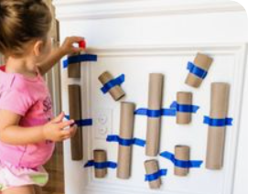

Make a simple ball drop using toilet and kitchen roll tubes create a simple run for the balls. The balls could be small pom poms or even rolled up paper, but small enough to fit through tubes. Encourage your child to take turns with you as well as siblings or playing alone. Colour the tubes different colours and ask them to put it down a certain coloured tube.

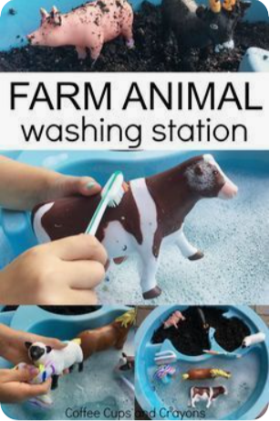

For this game you could use any toy cars; animals; people as long as they are washable. Make a muddy mess first for them to play in and get them muddy then create an area to wash them. Encourage your child to talk about the object they are playing with naming it can they copy you or can they name it? Encourage sharing experience with you talking about which toy you have and which they have.

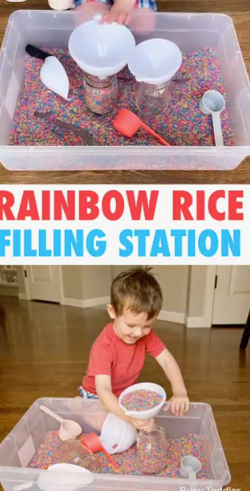

Coloured rice is a fun alternative to water and less messy. You don’t have to colour the rice but if you want to use coloured rice here is how you make your own.

Fill a zip-up bag with 1 cup of **rice** and 1 teaspoon of vinegar. Scoop or pour about 1/8 teaspoon food **colouring** into the bag. Zip the bag shut. Squeeze the bag and mix the **rice** all around until the food **colouring** is well distributed. Add more food **colouring** to reach the desired **colour**.

Use with different jugs cups and funnels or use to make a musical shaker for singing favourite rhymes with.

What about making sensory mats for walking on. Make some circles from card then stick different things to them to create different textures, so feathers; small stones; rice; compost; sand paper; grass; leaves. Anything you can find around the house or outside, get your child to help you make them and then talk about how they feel, walk on them or use your hands have fun.

