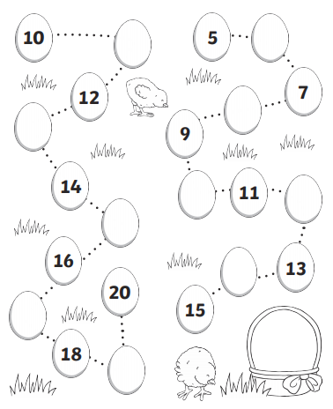**Can you fill in the missing numbers?**