Week beginning  Monday 15th June | Monday | Tuesday | Wednesday | Thursday | Friday
These activities and ideas are  based around the book  “Dora’s Eggs”  By Julie Sykes | https://www.youtube.com/watch?v=xtQAPs47THo  Story  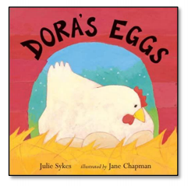
English | Life Cycle of a Hen –  Have a go at cutting and sticking the life cycle of a hen in the correct order. Then write a few sentences about the hen life cycle.  Life Cycle worksheet enclosed. | What animals did  Dora visit? Make a  story map to show the  different animals.  Can you draw them in the correct order and label them? | Feelings - How does Dora feel about her eggs? Does this change at the end of the story?  Write sentences to  explain her feelings at the end of the story. | Eggs –  Find out what animals lay eggs. Is it only birds or do other animals lay eggs? | Go out for a bird hunt and see how many birds you can see. Were they all the same?  See if you can see any nests in the trees.
Reading | - Read a variety of books at home. Favourites can be repeated. Hearing the patterns of language in a story will support your child’s language development.  - Children to read to parents daily. Visit Oxford Owl for free eBooks that link to your child’s age range. Please can you create a free account at https://home.oxfordowl.co.uk/ Once you have chosen a book to read and completed it there are some fun activities at the top which are linked nicely to what happens in the book.  - With your child, look in magazines, newspapers and books for the tricky words they are currently learning. They could use a highlighter to highlight in magazines and newspapers.
Maths | Colour and size ordering –  Have a look at the eggs. Let’s sort them into colours and sizes.  Can you make comments such as - these are the same, these are different?  Can you have a go at sharing these eggs out between you and a partner? Who has the most,  who has the fewest?  Is it fair? Have you shared them equally?  If I have 3 blue and 2 green how many do I have altogether in my basket?  Oops I ate one! What happens now?  Different colour egg size ordering enclosed. | Egg box play –  Use empty 10 hole  egg boxes or ice trays for sorting trays.  Draw on the bottom of the egg box numbers in order 1-10 Go hunting for tiny objects of the same amount to put inside. I wonder what kind of objects will fit? Will you need smaller objects for bigger numbers?  Now close your eyes and choose two egg numbers. Can you take the objects out and add them together? No can you do this a few times to make different addition sums? | 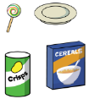  Number and/or Shape Hunt - Go on a hunt for numbers or shapes.  Sing “We’re going on a shape hunt, we’re going to find them all. We’re really excited, hurray for numbers/shapes today!”  Point out numbers or shapes in the environment and let your child take photos of them. Encourage them to spot the shapes.  How many did we get altogether? How many of each shape or number? Let’s look back at the photos we took.  When you next go for a walk have a go at doing this again but outside. | Egg and Spoon Race - Boil real eggs until  hard. Use some  big cooking spoons to balance them  on. Have a race with your child in  the garden or inside. Who can walk the furthest without dropping your egg?  Who can balance their egg the longest standing on 1 leg? You could time it using your phone. You can count how many steps you  can take. Can you balance your egg on your hand? Can you stand and balance your egg and count to 10 or 20?  What about to 20 and back again? | Roll a hard-boiled egg on the ground and  measure how far it rolls. Make a ramp for an egg to roll down. Does it roll further than  the egg that was flat to the ground?
Religious Education | Value - Kindness  Listen the Kindness song https://www.youtube.com/watch?v=enaRNnEzwi4  Watch the episode of Sesame Street called ‘The Kindness Kid’ below.  https://www.youtube.com/watch?v=brOKBsOs4Ik  In this episode ‘The Kindness Kid’ helps Elmo and Grover find ways to be kind to others.  Big question - How can we be kind to ourselves? -  We often think about how we can be kind to others and what effect our behaviour has on other people. Have you ever thought about how you can be kind to yourself? Have a think about how you can be kind to yourself. I’ve given you some ideas to start you off below. Have a go at drawing a picture of these and labelling them.  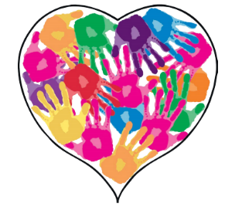  Eating healthy  Being positive  Making good choices  Trying something new  Choosing kind friends that make you happy  Having fun  Remembering to laugh  If you have some paint at home have a go at making a home handprint heart of kindness. You could ask your parents, brothers, sisters or carers to put their handprint in the heart too. If you don’t have any paint draw around your hands and colour them in.
Topic | Growing Cress in Eggshells -  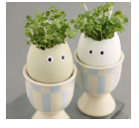  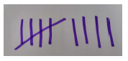  Crack eggs so they have half an empty shell. Carefully draw on silly faces.  Fill shells with wet cotton wool and sprinkle on cress seeds. Keep damp and watch the  eggs hair grow!  Talking Together –  Make a tally of how long it takes your eggs hair to grow or mark the days off on a calendar.  Encourage your child to take a photo every day and look back to discuss what happens over time.  Go hunting for other seeds in your house look and talk about inside tomatoes apples and other fruits.  Can you count the seeds or see the patterns inside when you cut them open.

Time for talk
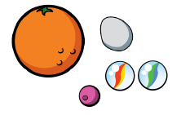
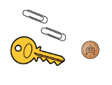
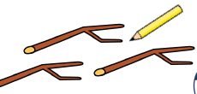

Question time!
Making Collections -
Go on a springtime walk and hunt for objects that your child finds interesting. You could take a basket or use any container from around the
house.

Spread the objects out and talk about them. Sort into groups or make arrangements. Discuss them e.g. Some of these are plastic some are made of wood. This has corners, this looks like a circle. Can we make a pattern with our objects?
Why are they a group? Do they have the same number of stripes, holes or points?

