Reception Home Learning
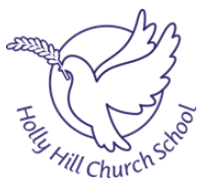
Phonics

Letters and Sounds Youtube channel – Phonics daily lessons uploaded daily at 10am and 11am.
Available are -
- Reception lesson - lessons suitable for children who can blend and read words such as 'fish', 'chat' and 'rain'. New lessons uploaded every week day at 10am.
- Learning to blend lessons - lessons for children who need more practise sounding and reading words such as 'tap', 'cap', 'mat'. New lessons uploaded every week day at 11am.
https://www.youtube.com/channel/UCP_FbjYUP_UtldV2K_-niWw/featured
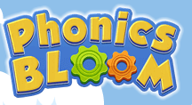 https://www.phonicsbloom.com/

WB 15/6/20 | Review Sounds | Activity | Review Tricky Words
Monday | 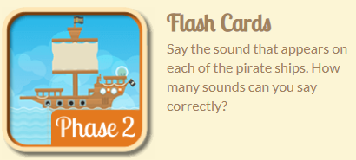 | 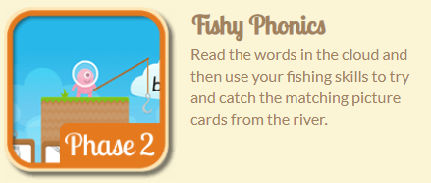 | Tricky word hunt  Ask a grown up to write out the tricky words I no to go no the into and hide them around the house for you to find.
Tuesday |  | 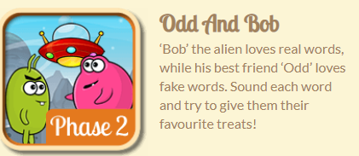 | Tricky word hangman  Play hangman with the tricky words I no to go no the into
Wednesday | 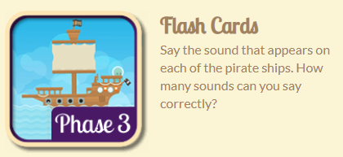 | 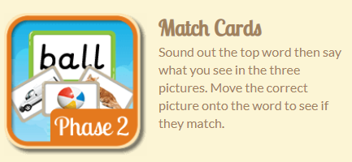 | Tricky word hunt  Ask a grown up to write out the tricky words me he she we my and hide them around the house. or you to find.
Thursday |  | 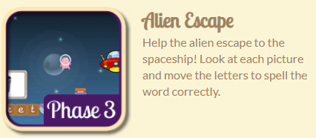 | Tricky word hangman  Play hangman with the tricky words me he she we my
Friday | 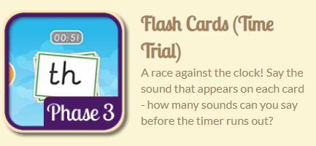 | 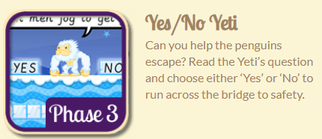 | 