Nursey Home learning 15.6.20

15.6.20 | Day 1 | Day 2 | Day 3
The majority of these activities and ideas are  based around the book  “Dora’s Eggs”  By Julie Sykes | https://www.youtube.com/watch?v=xtQAPs47THo  Story  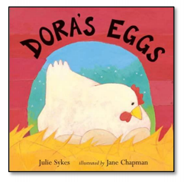
Phonics | 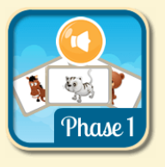  Play match the sounds on Phonics bloom–  https://www.phonicsbloom.com/uk/game/list/phonics-games-phase-1  Phase 1 – Match Sounds  Can you guess which animal makes the sound? I wonder if you can find any animals from the story. Click on the button to play the sound, then choose the animal that makes that sound. | Practice writing the sounds – s,a,t,p  Trace over the letters in the worksheet enclosed and then have a go at writing your own underneath.  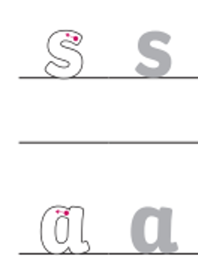 | 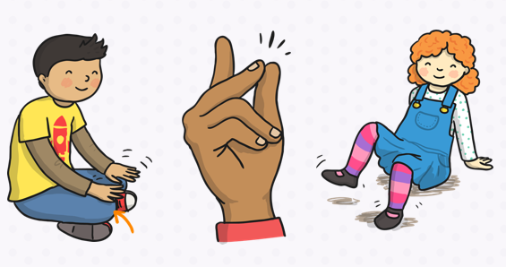
Writing | Life Cycle of a Hen –  Have a go at cutting and sticking the life cycle of a hen in the correct order.  Life Cycle worksheet enclosed. | What animals did Dora visit? –  Can you draw them in the correct order and have a go at writing their initial sound? Can you also make the noises the animals make? I.e cow starts with a ‘c’ and it makes a ‘moooo’ sound. | Eggs –  Find out what animals lay eggs. Is it only birds or do other animals lay eggs?
Math’s | Bird hunt -  Go out for a bird hunt and see how many birds you can see; can you count them? Were they all the same? See if you can see any nests in trees.  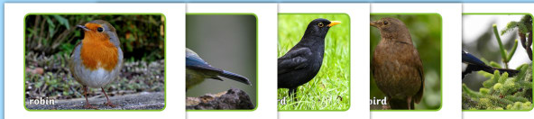 | Number or Shape Hunt –  Go on a hunt for numbers and/or shapes. Sing “We’re going on a shape hunt, we’re going to find them all. We’re really excited, hurray for shapes today!” Point out numbers or shapes in the home environment and let your child take photos of them. Encourage them to spot the shapes.  How many did we get altogether? How many of each shape or number? Let’s look back at the photos we took.  When you next go for a walk have a go at doing this again but outside.  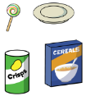 | Egg and Spoon Race –  Boil real eggs until hard. Use some big cooking spoons to balance them on. Have a race with your child in the garden or inside. Who can walk the furthest without dropping the egg?  Who can balance their egg the longest standing on 1 leg? You could time it using your phone. You can count how many steps you  can take. Can you balance your egg on your hand? Can you stand and balance your egg and count to 5 and then 10?
Religious  Education | 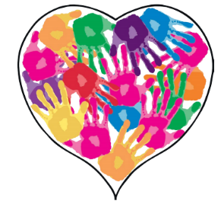  Value - Kindness  Listen the Kindness song https://www.youtube.com/watch?v=enaRNnEzwi4  Watch the episode of Sesame Street called ‘The Kindness Kid’ below.  https://www.youtube.com/watch?v=brOKBsOs4Ik  In this episode ‘The Kindness Kid’ helps Elmo and Grover find ways to be kind to others.  Big question - How can we be kind to ourselves? -  We often think about how we can be kind to others and what effect our behaviour has on other people. Have you ever thought about how you can be kind to yourself? Have a think about how you can be kind to yourself. I’ve given you some ideas to start you off below.  Eating healthy  Being positive  Making good choices  Trying something new  Choosing kind friends that make you happy  Having fun  If you have some paint at home have a go at making a home handprint heart of kindness. You could ask your parents, brothers, sisters or carers to put their handprint in the heart too. If you don’t have any paint draw around your hands and colour them in.
Topic | Growing Cress in Eggshells -  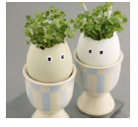  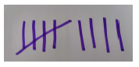  Crack eggs so they have half an empty shell. Carefully draw on silly faces.  Fill shells with wet cotton wool and sprinkle on cress seeds. Keep damp and watch the  eggs hair grow!  Talking Together –  Make a tally of how long it takes your eggs hair to grow or mark the days off on a calendar.  Encourage your child to take a photo every day and look back to discuss what happens over time.  Go hunting for other seeds in your house look and talk about inside tomatoes apples and other fruits.  Can you count the seeds or see the patterns inside when you cut them open.
Talking Together | 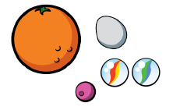  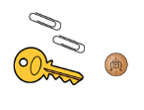  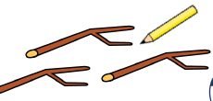  Making Collections -  Go on a springtime walk and hunt for objects that your child finds interesting. You could take a basket or use any container from around the  house.  Spread the objects out and talk about them. Sort into groups or make arrangements. Discuss them e.g. Some of these are plastic some are made of wood. This has corners, this looks like a circle. Can we make a pattern with our objects?  Why are they a group? Do they have the same number of stripes, holes or points?
Physical Education | In the story the baby chicks follow Dora. Play a game of follow the leader with lots of jumping, hopping, skipping, and walking backwards.

