 | Monday |  |  | Tuesday |  |  |  | Wednesday | Thursday |  | Friday
Reading
Spellings | We will be concentrating on our Year 2 Common Exception Words (tricky words). These are words that are tricky to use our phonics skills to sound out and blend, so the only the way to know how to spell them… is to learn them!  Can you include each word in a sentence that makes sense?  plant steak  poor sugar  pretty sure  prove told  should water |  |  |  |  |  | Spelling Test!  Ask your grown up to help you complete a spelling test.  Please email Mrs Bayliss and Miss Sangha your test results at beech@hollyhill.bham.sch.uk and evergreen@hollyhill.bham.uk … We would love to see how you are all doing!
English | This week is all about keeping our teeth healthy!  How can we keep our teeth healthy?  See Big Book.  Chn to create healthy teeth poster, explaining how we should look after our teeth. |  |  |  | Cleaning out teeth is very important…  Research how we shpuld clean our teeth properly  Write instructions about How to brush your teeth…  Remember to include  - Equipment (what you will need)  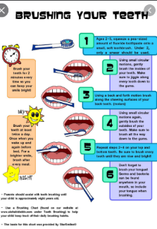  - Numbered steps  - Time openers  - Diagrams  - A DID YOU KNOW FACT!
Science |  |  |  |  |  | Experiment…  What drinks keep our teeth healthy?  Coke? Milk? Water? Squash?  Make a prediction… which drinks do you think will be healthy?  Unhealthy?  How can we find out?  How can we find out?  Tooth Decay Experiment.  Did you know that egg shells are made from a similar materials your teeth?  Equipment… you will need…  5 boiled eggs  5 plastic cups  Orange squash (neat)  Milk  Water  Coke (not diet)  Vinegar  Instructions  Boil 5 eggs  Place each egg into a plastic cup  Pour each drink into a different cup.  Pour vinegar into a final cup, this shows how acidic drinks affect your teeth.  Now leave for 3 days.  After 3 days, pour the liquid away and ;ook closely at each egg (some may be a bit smelly!)  What has happened to the shells?  Which drinks would be healthy/unhealthy for your teeth?  Write about what you found out. |  | Re-read the PowerPoint about Florence Nightingale to help you create information writing, all about her.  Don’t forget to include a title, e.g. Florence Nightingale, Kind Nurse, The Lady of the Lamp.  You can include information/the sub-headings:  Who was she?  When is her birthday?  How old would she be now?  Who did she help?  Why was she called Florence?  What name was she known as and why?  Please email your information writing and any questions to Mrs Bayliss at beech@hollyhill.bham.sch.uk or to Miss Sangha at evergreen@hollyhill.bham.sch.uk  Here is an example to help you: 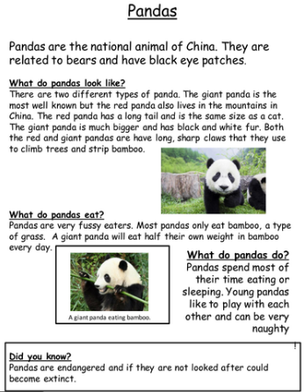
Maths | Bonds to 100 (tens and ones)  Learn: watch videos on:  https://www.bbc.co.uk/bitesize/articles/znmpf4j  Activity 1:  Please complete the 3 activities on:  https://bam.files.bbci.co.uk/bam/live/content/zkkxhbk/pdf |  |  |  |  | Bonds to 100 (tens and ones)  Recap yesterday’s learning by watching videos on:  https://www.bbc.co.uk/bitesize/articles/znmpf4j  Answer the questions:  - 10 + ? = 100  - 70 + ? = 100  - 20 + ? = 100  - ? + 50 = 100  - ? + 40 = 100  - 60 + ? = 100  - 25 + ? = 100  - ? + 69 = 100  - ? + 37 = 100  - 100 – 84 = ?  - 100 - ? = 11  - 100 – 53 = ? |  | Bonds to 100 (tens and ones)/ Reasoning and Problem Solving:  - Teddy has completed the missing number sentence.  46 + 64 = 100  Is Teddy correct? Explain your answer.  - Each row and column add up to 100.  Complete the grid:  - Complete the pattern:  - + 85 = 100  - + 80 = 100  - + 75 = 100  - +___ = 100  ___+___ = 100  Explain the pattern. | Add three 1-digit numbers:  - Find the totals of each row and column:  - Use the symbols:  to compare the number sentences: |  | Add three 1-digit numbers/ Reasoning and Problem Solving:  - Which numbers would you add together first in the following number sentences? Why?  3 + 5 + 7 = ?  8 + 2 + 6 = ?  4 + 3 + 4 = ?  Is there always an easier order to add three 1-digit numbers?  - Always, Sometimes, Never  odd + odd + odd = odd  Use 1-digit numbers to test if this is true, e.g.  3 + 5 + 7
R.E – Hope: What do you want to be when you grow up? |  |  | Dream Jar  Use an empty jar/box/drawer/a container that has a lid. Write down dreams/things that you want to be when you grow up, e.g. jobs, values, hobbies/interests, family, onto a small piece of paper. Fold it up and place it inside your ‘Dream Jar’.  You can also draw/paint a jar with all of your dreams on.  Ask your friends and families to join in and share your ideas with each other at the end of the week.  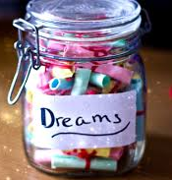  Be creative! Place small objects that are important to you/ that represent your dreams into the ‘Dream Jar’. Here are some examples:  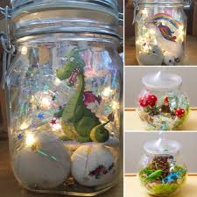  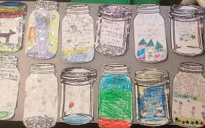
Topic – History: Florence Nightingale |  |  | 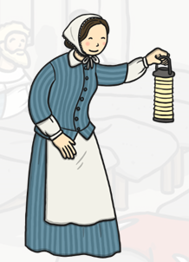  History: Florence Nightingale  This week is all about Florence Nightingale, who was also known as ‘The Lady of the Lamp’.  Create a lamp that is similar to the Lamp that Florence used to check for wounded soldiers at night.  Here are some examples to help you:  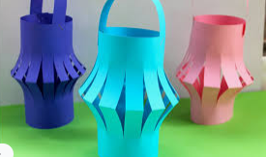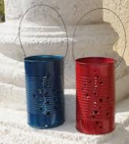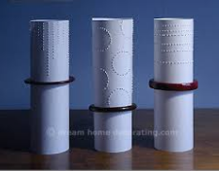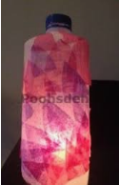  Have fun making your lamps! REMEMBER USE A TORCH FOR YOUR LIGHT – NOT A CANDLE!  Don’t forget to send photos of your lamps to beech@hollyhill.bham.sch.uk or evergreen@hollyhill.bham.sch.uk  We are looking forward to seeing your wonderful designs!

