 | Monday | Tuesday | Wednesday | Thursday | Friday
Reading | Your text choices this week are  Or
Spellings | We will be concentrating on our Year 2 Common Exception Words (tricky words). These are words that are tricky to use our phonics skills to sound out and blend, so the only the way to know how to spell them… is to learn them!  Can you include each word in a sentence that makes sense?  plant steak  poor sugar  pretty sure  prove told  should water  Cleaning out teeth is very important…  Research how we should clean our teeth properly  Write instructions about How to brush your teeth…  Remember to include Equipment (what you will need) Numbered steps Time openers Diagrams A DID YOU KNOW FACT!  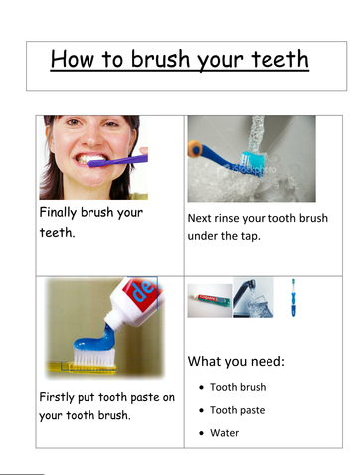 |  |  |  | Spelling Test!  Ask your grown up to help you complete a spelling test.  Please email Mrs Bayliss and Miss Sangha your test results at beech@hollyhill.bham.sch.uk and evergreen@hollyhill.bham.uk … We would love to see how you are all doing!
English | This week is all about keeping our teeth healthy!  How can we keep our teeth healthy?  See Big Book.  Chn to create healthy teeth poster, explaining how we should look after our teeth.! |  | Re-read the PowerPoint about Florence Nightingale to help you create information writing, all about her.  Don’t forget to include a title, e.g. Florence Nightingale, Kind Nurse, The Lady of the Lamp.  You can include information/the sub-headings:  Who was she?  When is her birthday?
Maths | Multiplication x 5  Learn: watch videos on:  https://www.bbc.co.uk/bitesize/articles/zhfjqp3#:~:text=Counting%20in%205s,-Practise%20counting%20in&text=You%20could%20use%20marbles%2C%20plastic,fingers%20as%20you%20count%20aloud.  Count in 5’s to 100 with a grown up | Practise x 5  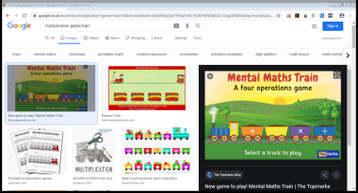  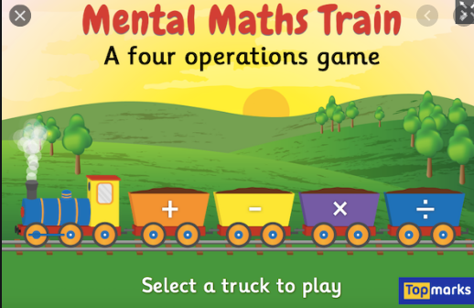  Remember to select the x 5 option  https://www.topmarks.co.uk/maths-games/mental-maths-train | Multiplication x5  Recap counting in 5’s to 100  Answer the questions:  - 5 x 3=  - 5 x 5=  - 5 x10=  - 5 x 6=  - 5 x 8=  - 5 x 11=  - 5 x 1=  - 2 x 5=  - 4 x 5=  - ? x 5= 35  - ? x 5= 60  - ? x 5 = 45 | Multiplication x5 word problems  - May has 5 pots. She puts 8 pencils in each pot. How many pecils does she have?  - Percy has 25 kittens. He wants to buy some baskets for them to sleep in. Each basket is big enough for 5 kittens. How many baskets will Percy need?  - Sally thinks of a numbers. She multiplies it by 5 and gets the answer 50. What is Sally’s number?  - What is two multiplied by nine?  - What are 11 groups of 5? | Multiplication Reasoning  - Peter says he’s counting in 5’s from 0  0, 5, 10, 14, 20, 25, 30  Is he correct, explain why?  - Tom is says he’s counting in 5’s from any number.  4, 9, 14, 19, 24  Is he correct, explain why.  - 5+5+5+5=  Is the same as  4x5=  True or false  - This array shows  4x5=  True or false.
R.E – Thanfulness | As teachers, we are thankful to God every day for having the best job in the world- teaching you guys! This week I would like you to think about all of the people in school who have helped you in school…  Who has helped you? Lunchtime Supervisers, the people in the office, Headteachers, Reverend Pingting and Reverend Jane, the people who serve your dinner, teachers and also the people you don’t see so often, such as Gavin the Caretaker, the people who clean our school and the people who cook our dinners.  Also think about why they have helped… to keep you school safe and clean, to help you with your learning and to keep your tummies full!  Write a beautiful prayer to share your feelings.
Science- Healthy Teeth Experiment | Experiment…  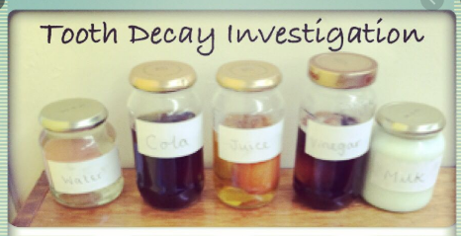  What drinks keep our teeth healthy?  Coke? Milk? Water? Squash?  Make a prediction… which drinks do you think will be healthy?  Unhealthy?  How can we find out?...  Tooth Decay Experiment.  Did you know that egg shells are made from a similar materials your teeth?  Equipment… you will need…  5 boiled eggs  5 plastic cups  Orange squash (neat)  Milk  Water  Coke (not diet)  Vinegar  Instructions  Boil 5 eggs  Place each egg into a plastic cup  Pour each drink into a different cup.  Pour vinegar into a final cup, this shows how acidic drinks affect your teeth.  Now leave for 3 days.  After 3 days, pour the liquid away and ;ook closely at each egg (some may be a bit smelly!)  What has happened to the shells?  Which drinks would be healthy/unhealthy for your teeth?  Now, write about what you found out.  Can you use this scientific vocabulary in your writing?  