 | Monday | Tuesday | Wednesday | Thursday | Friday
Spelling/Phonics  Phonics Play  Username – march20  Password - home | Starter – Ph 5 song  https://youtu.be/YPW-ZkhRUPY  ICT Games - Phonics  Focus phoneme - ay  http://www.ictgames.com/mobilePage/forestPhonics/index.html | Starter – Ph 5 song  https://youtu.be/YPW-ZkhRUPY  ICT Games - Phonics  Focus phoneme - oy  http://www.ictgames.com/mobilePage/forestPhonics/index.html | Starter – Ph 5 song  https://youtu.be/YPW-ZkhRUPY  ICT Games - Phonics  Focus phoneme – a-e  http://www.ictgames.com/mobilePage/forestPhonics/index.html | Starter – Ph 5 song  https://youtu.be/YPW-ZkhRUPY  ICT Games - Phonics  Focus phoneme - ew  http://www.ictgames.com/mobilePage/forestPhonics/index.html | Starter – Ph 5 song  https://youtu.be/YPW-ZkhRUPY  ICT Games - Phonics  Focus phoneme - aw  http://www.ictgames.com/mobilePage/forestPhonics/index.html
English | Handwriting  Can you practise forming the letters  play  day  boy  enjoy  bake  flake  flew  chew  claw  paw  Can you use these words in sentences of your own? | Oh no! Can you help Clent Hills Vets in Rubery?  Since the current pandemic, they have noticed that lots of families have been having new pets but they have run out of leaflets for the new owners.  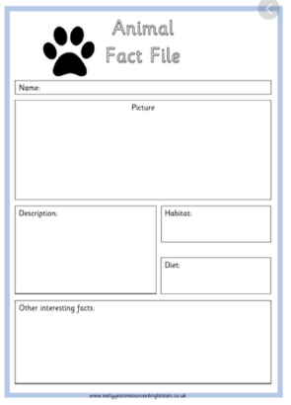  Can you help?  Remember  - Capital letters  - Full stops  - Conjunction – and, but, so  - Adjectives  - Can you research different animals?  What animals would make a good pet? Why?  What animals would not make a good pet? Why?  - Can you choose a good pet to research?  How would you need to look after them?  What would they eat?  Where would they need to live?  What would they need?  - Using your research, can you create a fact file all about your chosen pet?  Can you include lots of information about them?  Can you include images and labels?
Maths | Starter – Number bonds  https://www.bbc.co.uk/teach/supermovers/ks1-maths-number-bonds-with-martin-dougan/zf6cpg8  Summer Term – Week 8 (It does state week commencing 15th June)  Lesson 1 – Making Arrays  *Note – these are lessons to watch only. There are worksheets at the bottom of this document for you to complete.  https://whiterosemaths.com/homelearning/year-1/ | Starter – Counting to 100  https://www.youtube.com/watch?v=1dkPouLWCyc  Summer Term – Week 8 (It does state week commencing 15th June)  Lesson 1 – Making Doubles  *Note – these are lessons to watch only. There are worksheets at the bottom of this document for you to complete.  https://whiterosemaths.com/homelearning/year-1/ | Starter – Counting in 10’s  https://www.youtube.com/watch?v=W8CEOlAOGas  Summer Term – Week 8 (It does state week commencing 15th June)  Lesson 1 – Making Equal Groups - Sharing  *Note – these are lessons to watch only. There are worksheets at the bottom of this document for you to complete.  https://whiterosemaths.com/homelearning/year-1/ | Starter – Counting in 5’s  https://www.youtube.com/watch?v=amxVL9KUmq8  Summer Term – Week 8 (It does state week commencing 15th June)  Lesson 1 – Making Equal Groups - Grouping  *Note – these are lessons to watch only. There are worksheets at the bottom of this document for you to complete.  https://whiterosemaths.com/homelearning/year-1/ | Starter – Counting in 2’s  https://www.youtube.com/watch?v=OCxvNtrcDIs  Summer Term – Week 8 (It does state week commencing 15th June)  Challenge  https://whiterosemaths.com/homelearning/year-1/
Reading | To access these books please follow this link:  https://www.oxfordowl.co.uk/?selLanguage=en&mode=hub  Once on this webpage please click the class login and enter;  Username: hhmaple  Password: maple1  Username: hhfir  Password: Fir12  Once you are logged in click on the bookshelf and search for the title your child will be reading.  Please choose the appropriate level book for your child.  Phase 3 Book  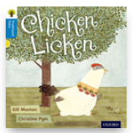  Please spend today reading to page 7.  Phase 5 Book  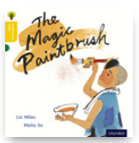  Please spend today reading to page 7.  Phase 5 Book  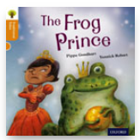  Please spend today reading to page 7. | Comprehension Questions.  Please spend some time revising the pages your child read yesterday and then answer the questions below.  Phase 3 Book  - What does Chicken think fell on him?  - Where did Chicken Licken run to?  - Who does she see in the barn?  - Who do they go and see next?  - Where did Chicken Licken and Hen Len run to?  - Who do they go to visit next?  Phase 5 Book  Read to page 7  - What did Ho look after?  - What did he take to the field?  - Why did Ho only have dry bread to eat?  - Who came up the lane?  - What did Ho give him?  - Why?  - What did the old man give Ho?  - Why do you think this is important?  - What did Ho make paints from?  - What happened when Ho painted the hay?  Phase 5 Book  Read to page 7  - What does the Queen promise her on her birthday?  - What does the Princess ask for?  - Why does the Princess expect the Queen to get it for her?  - What did the Queen make for her?  - What was the Princess playing next to?  - Where did the ball go?  - How do you think the Princess was feeling?  - Why do you think the Princess was surprised when the frog spoke to her?  - Do you think frogs can speak? Why?  - What does the Princess say she will do?  - Do you think she will keep her promise? | Comprehension Questions.  Please spend some time reading pages 8-11 then answer the questions below.  Phase 3 Book  - Where did they all run back to?  - What fell on Duck?  - Where does Duck Luck tell them to look?  Phase 5 Book  Pages 8-13  - What do you think is going to happen when he paints the blue stream?  - How do you think the people felt when the stream became real?  - Why did Ho paint food for the children and workers?  - What did Ho paint for the people?  Phase 5 Book  Pages 8-13  - What does the Frog want?  - Does the Princess think this will be an easy or hard thing to do?  - How do both characters feel?  - Did Frog do what he had promised?  - Did the Princess keep her promise?  - How would you feel if you were the frog?  - What was it that she could hear?  - Why does the Princess not want the door to open?  - How do you think the Queen/Princess/Frog when the door is opened? | Comprehension Questions.  Please spend some time reading pages 12-15 then answer the questions below.  Phase 3 Book  - What fell on Chicken Licken?  - Who was right about what fell on Chicken Licken?  - How do you think he felt?  Phase 5 Book  Read 14-19  - What did the rich farmer do to Ho to get the paintbrush?  - What did the farmer draw?  - Why do you think it did not come real?  - What became real?  - Why do you think he drew the sea?  - How was the farmer feeling?  - Why did he become angry?  - Why did he paint a ship?  Phase 5 Book  Pages 14-19  - What does the Frog want?  - Why doesn’t the Princess want to be his friend?  - How does the Queen respond?  - Do you agree with the Queen? Why?  - What was the plate made from?  - Where does the Frog stay?  - Where did Frog sleep?  - What did the Frog turn into? | Comprehension Questions.  Phase 3 Book  Can you retell what happened in the story?  Phase 5 Book  Read page 20-23  - Is the farmer a hero or a villain? Why?  - What took the farmer away?  - How did the people in the village feel in the end?  Phase 5 Book  Pages 20-24  - Who is he?  - Who turned him into a Frog?  - What breaks the spell?  - How can the boy turn back into a frog?  - How is the Princess a good friend?  - What did they like to play?  - Why didn’t they go near the pond?  - What happened when the Prince and Princess grew up?  - What did they promise eachother?
Topic | Science  Seasonal Changes - Weather  Weather Diary  Following the recent dramatic changes in the weather, I would like you to keep a weather diary for the next week.  Each day I would like you to go outside and write down what the weather is like.  Think about your keyword choices.  Is it raining, sunny, cloudy, windy?  Is it hot, cold or mild?  What is the temperature?  Rain Gauge or Wind Sock  I would also like you to create your own rain gauge or wind sock.  This will show you either how much rain we have had or which direction the wind is blowing. These will be very useful for your weather diary.  I have placed instructions of how to make both the rain or wind monito below.  Have lots of fun and don’t forget to send lots of photographs.
RE | This weeks value is friendship.  Who is your best friend?  Why are they your best friend?  What makes a good friend?  Can you create your own friendship potion? Inside the potion, can you place all of the keywords that describe a good friend?  Template below.

Don’t forget Mrs Thurman and Miss Parsonage are available on the below email address to support you and your child at this difficult time.
Please use the email address to ask any question you might have about this learning.
We are here for you!
Maple: maple@hollyhill.bham.sch.uk
Fir: fir@hollyhill.bham.sch.uk

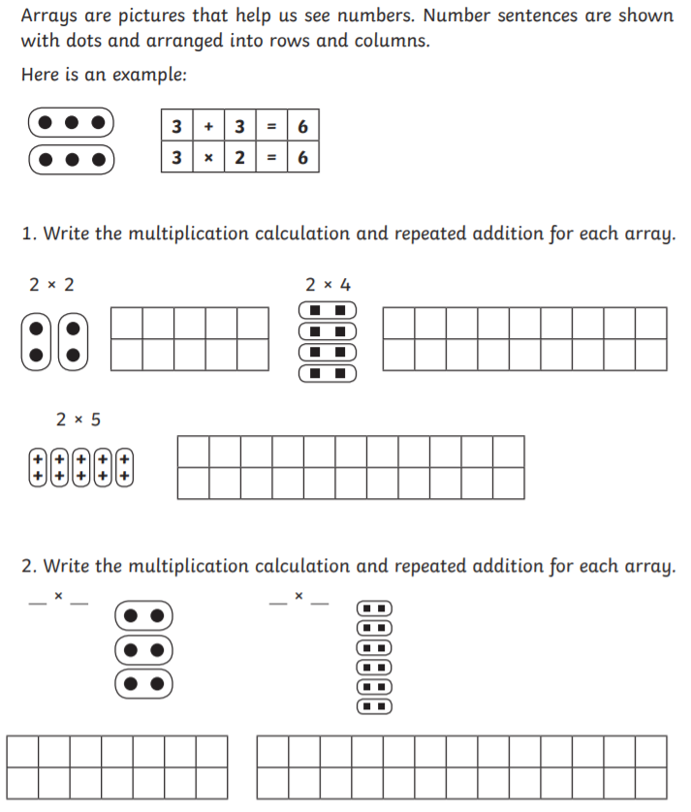
Maths Work Sheets
Lesson 1 – Arrays

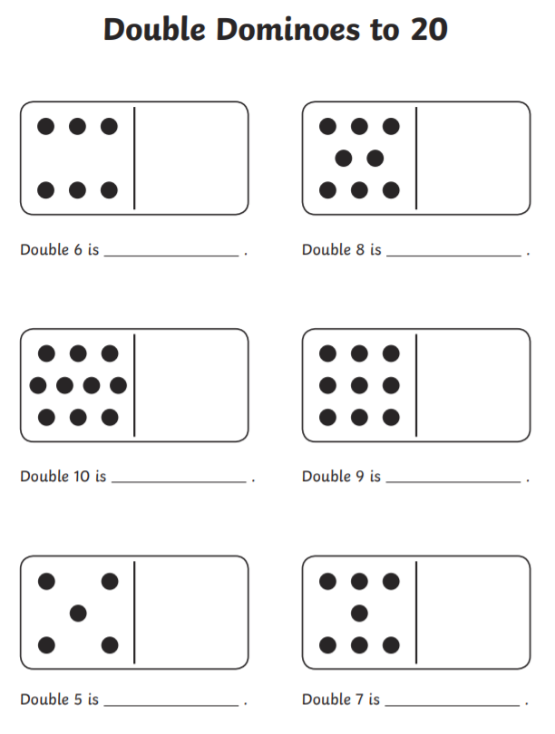
Lesson 2 – Doubles

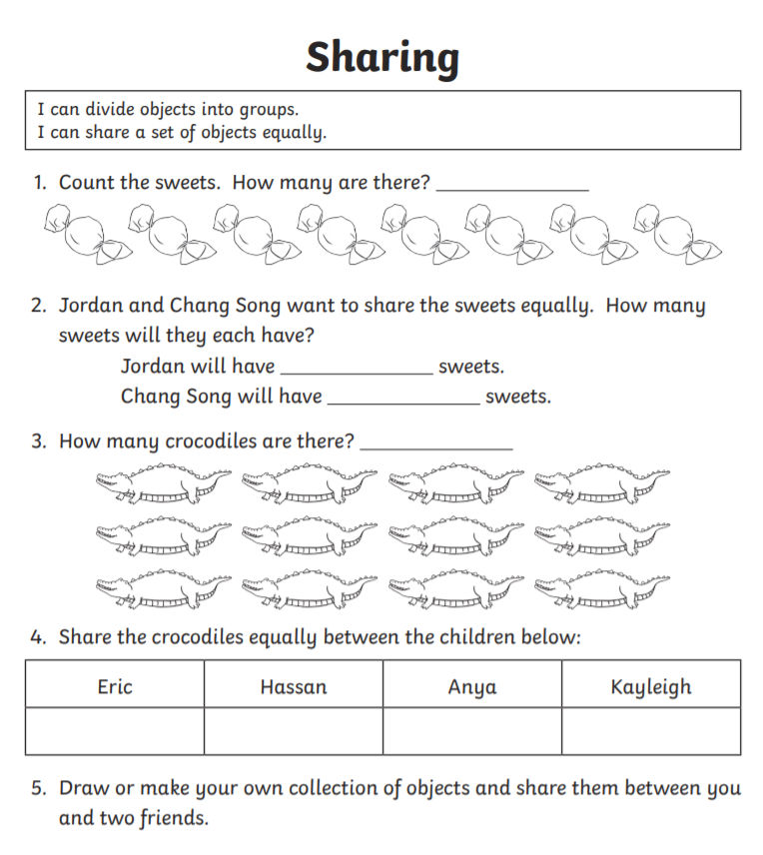
Lesson 3 – Sharing

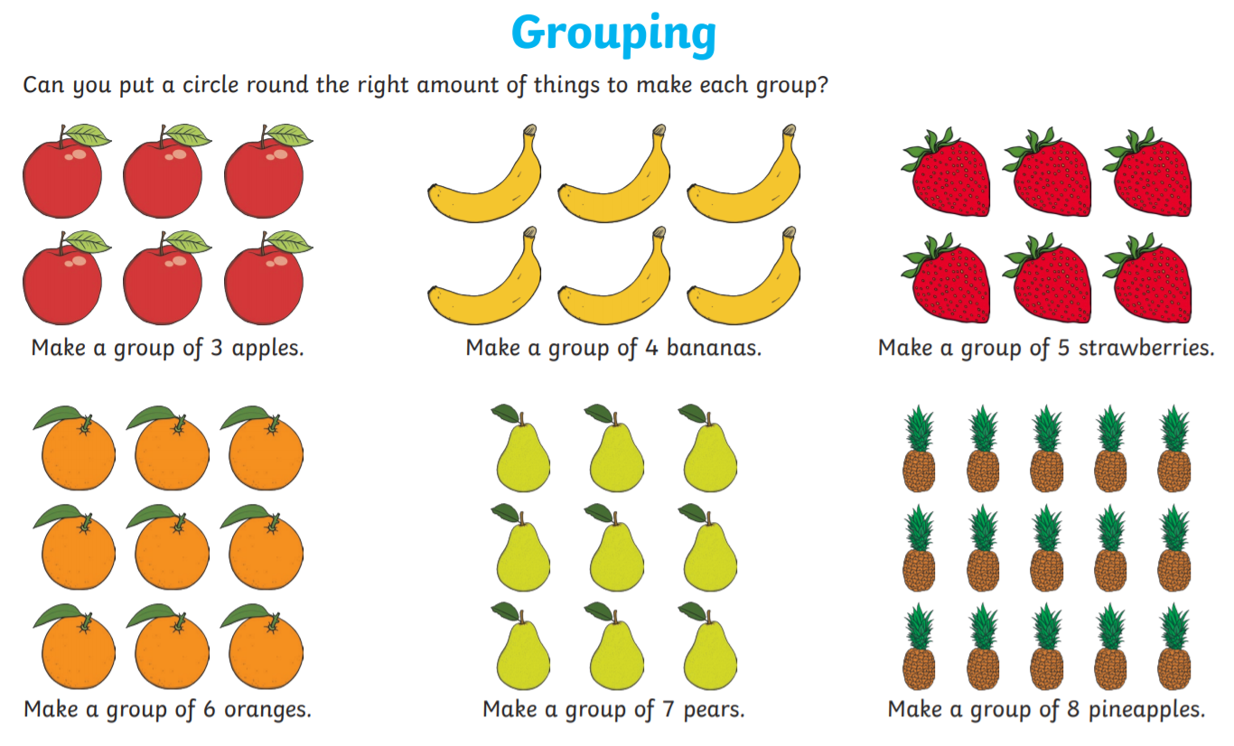
Lesson 4 – Grouping

Science – Wind Sock/ Rain gauge
Wind Sock
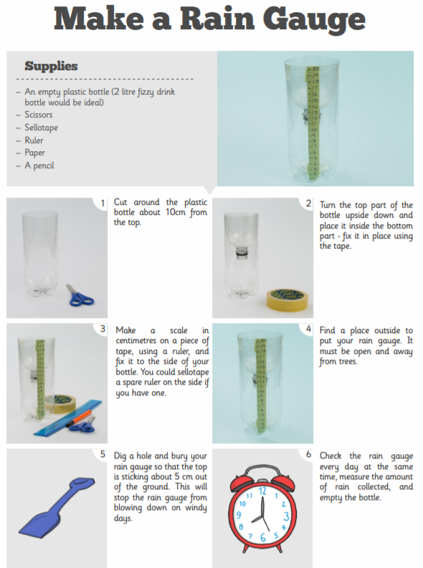
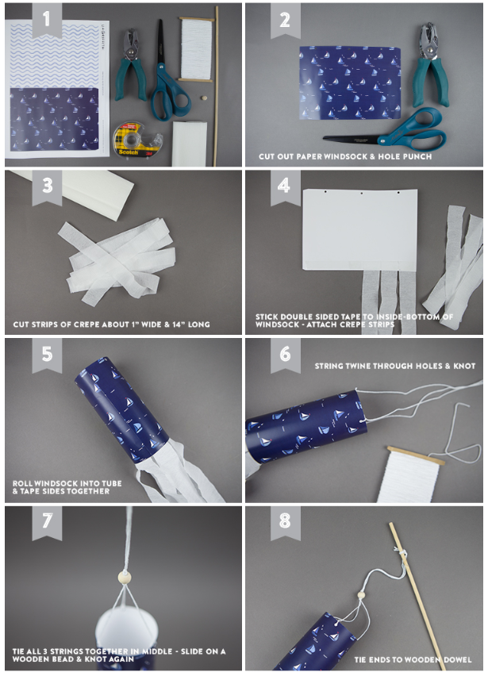

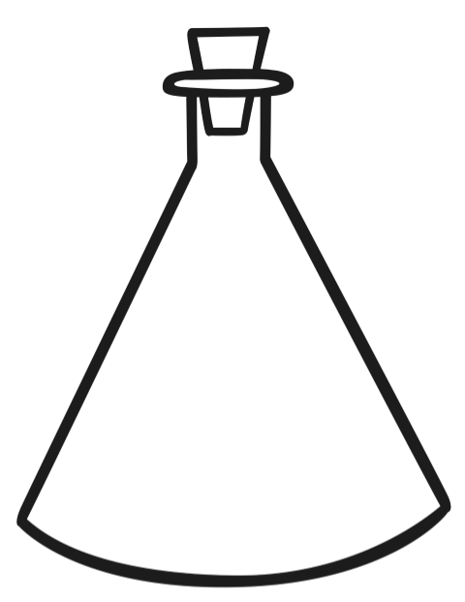
Friendship Potion

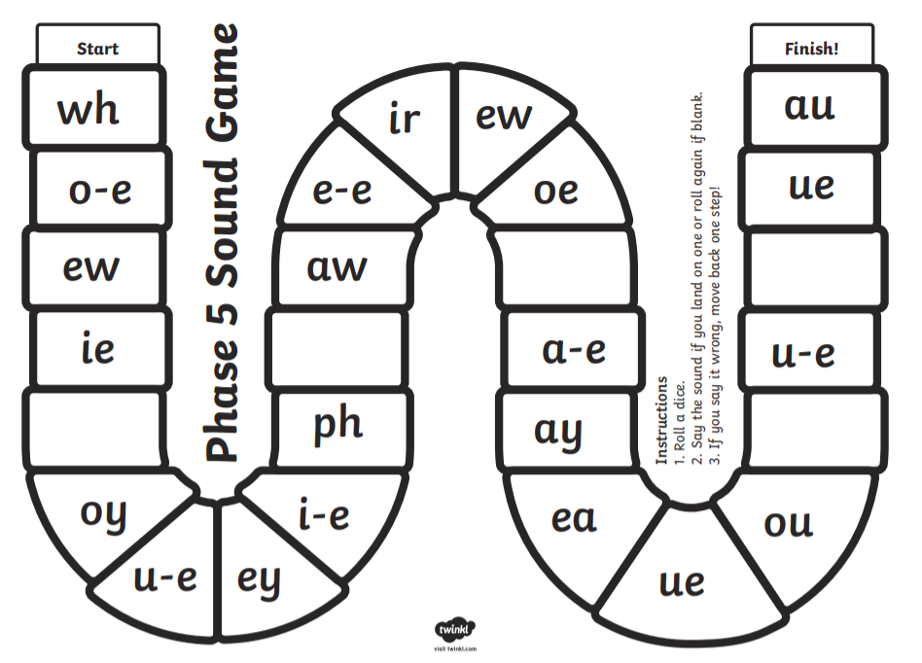
Phonics Games – Phase 5

