 | Monday | Tuesday | Wednesday | Thursday | Friday
Spelling/Phonics  Phonics Play  Username – march20  Password - home | Starter – Ph 5 song  https://youtu.be/YPW-ZkhRUPY  ICT Games - Phonics  Focus phoneme - ir  http://www.ictgames.com/mobilePage/forestPhonics/index.html | Starter – Ph 5 song  https://youtu.be/YPW-ZkhRUPY  ICT Games - Phonics  Focus phoneme - ur  http://www.ictgames.com/mobilePage/forestPhonics/index.html | Starter – Ph 5 song  https://youtu.be/YPW-ZkhRUPY  ICT Games - Phonics  Focus phoneme – i-e  http://www.ictgames.com/mobilePage/forestPhonics/index.html | Starter – Ph 5 song  https://youtu.be/YPW-ZkhRUPY  ICT Games - Phonics  Focus phoneme – o-e  http://www.ictgames.com/mobilePage/forestPhonics/index.html | Starter – Ph 5 song  https://youtu.be/YPW-ZkhRUPY  ICT Games - Phonics  Focus phoneme - ow  http://www.ictgames.com/mobilePage/forestPhonics/index.html
English | Handwriting  Can you practise forming the letters  bake  cake  flake  take  play  day  way  say  boy  enjoy  Can you use these words in sentences of your own? | Can you create your very own chocolate factory?  Over the weekend I have been watching Charlie and the Chocolate Factory and I thought, what an amazing thing it would be to have my own chocolate factory. Do you agree?  - Can you design your own chocolate factory?  Remember  - Capital letters  - Full stops  - Conjunction – and, but, so  - Adjectives  What chocolates would you have?  What decorations would you have?  What will the different machines look like?  Can you design your own chocolate factory and include lots of labels?  - Can you create a map of inside of your factory for your customers?  Where would the entrance be?  Where might the shop be?  Where would each machine making the different chocolate be?  Would you have a river of chocolate running through your factory?  Will you have any special rides for the customers to go on?  Will you have plants and trees made of chocolate for people to eat?  Can you create you map of the chocolate factory and include signs and labels? Make sure the path for people to walk on is clear!  - You need to advertise your factory!  Can you create an advert or poster for your chocolate factory?  Can you include images and labels?  - Finally, you need to create a ticket for the customers.  What will your ticket say?  How much will it cost to come to the factory?  What colour will your ticket be?  Have fun!
Maths | Starter – Number bonds  https://www.bbc.co.uk/teach/supermovers/ks1-maths-number-bonds-with-martin-dougan/zf6cpg8  Summer Term – Week 8 (It does state week commencing 22nd June)  Lesson 1 – Counting to 100.  *Note – these are lessons to watch only. There are worksheets at the bottom of this document for you to complete.  https://whiterosemaths.com/homelearning/year-1/ | Starter – Counting to 100  https://www.youtube.com/watch?v=1dkPouLWCyc  Summer Term – Week 8 (It does state week commencing 22nd June)  Lesson 2 – Partitioning Numbers  *Note – these are lessons to watch only. There are worksheets at the bottom of this document for you to complete.  https://whiterosemaths.com/homelearning/year-1/ | Starter – Counting in 10’s  https://www.youtube.com/watch?v=W8CEOlAOGas  Summer Term – Week 8 (It does state week commencing 22nd June)  Lesson 2 – Comparing Numbers  *Note – these are lessons to watch only. There are worksheets at the bottom of this document for you to complete.  https://whiterosemaths.com/homelearning/year-1/ | Starter – Counting in 5’s  https://www.youtube.com/watch?v=amxVL9KUmq8  Summer Term – Week 8 (It does state week commencing 22nd June)  Lesson 2 – Comparing Numbers  *Note – these are lessons to watch only. There are worksheets at the bottom of this document for you to complete.  https://whiterosemaths.com/homelearning/year-1/ | Starter – Counting in 2’s  https://www.youtube.com/watch?v=OCxvNtrcDIs  Challenge  Can you create your own board game using numbers 0-100?  Be creative! It can be any theme or design that you want.  Have fun!
Reading | To access these books please follow this link:  https://www.oxfordowl.co.uk/?selLanguage=en&mode=hub  Once on this webpage please click the class login and enter;  Username: hhmaple  Password: maple1  Username: hhfir  Password: Fir12  Once you are logged in click on the bookshelf and search for the title your child will be reading.  Please choose the appropriate level book for your child.  Phase 4 Book 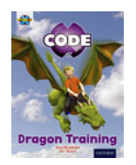  Please spend today reading pages 2, 3 and 4 to your child.  Phase 5 Book  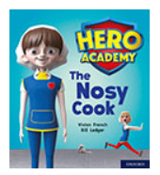  Please spend today reading to page 7.  Phase 5 Book  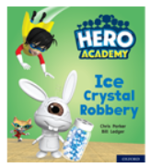  Please spend today reading to page 7. | Phase 4 Book  Read pages 5-10 and discuss the dragons den, looking after pet dragons and training pet dragons.  Phase 5 Book  Read to page 7  - What was wrong with Mrs Butterworth?  - Who offered to help Miss Baker get lunch ready?  - What Cam scrub?  - What is the new cooks name?  - What did Philippa put on?  Phase 5 Book  Read to page 7  - What was the cape designed to do?  - Who did she give the cape to?  - What did she tip on the cape?  - What did they turn in to?  - What happened to the crystals?  - What does Miss Linen think will happen? | Phase 4 Book  Read pages 11 and 12 to your child.  Phase 5 Book  Pages 8-13  - What did her teeth look like?  - Why did they look like metal?  - What did Cam say to herself?  - What did Philippa demand?  - What noise did her foot make?  - What was she asked to do?  - Why do you think a spark flew out of her hand?  - What did Cam get Philippa to protect her hands?  Phase 5 Book  Pages 8-13  - Who stole the crystals?  - What Who is Ray Ranter?  - What did the bunny-wunny do to the window?  - Where did they run?  - What is slink?  - What did they spin in to?  - What were their names now?  - What was the bunny-wunny going down? | Phase 4 Book  Please read pages 13-19  Phase 5 Book  Read 14-19  - What did Cam turn into?  - What did Philippa continue to do?  - Do you think this is strange? Why?  - What did Cam turn back into?  - What do cooks normally hate?  - What was Philippa made out of?  - Where did Miss Baker go?  - What does Philippa want to know?  - Who did Miss Baker come back with?  - What did they have?  Phase 5 Book  Pages 14-19  - What was the bunny-wunny heading towards?  - Who shot off with the van?  - What did they chase the van over?  - What did they come to?  - Who was inside the shed?  - What was he clutching?  - What was strapped to his back?  - What did Ranter switch on and where did he go?  - Where did he sprinkle the crystals?  - How does he describe the snow? | Phase 4 Book  Please read pages 20-23  Spend time enjoying the parts on page 24 too!  Phase 5 Book  Read page 20-24  - Why did Philippa fly across the room?  - Who checks for clues?  - What did they have to do before they could celebrate?  Can you retell the story?  Phase 5 Book  Pages 20-24  - What did he drop?  - What did Swoop manage to do?  - Where did they take the crystals?  - What did the spilled crystals make?  - Where did they land?  - Who did they land next to?  - How does Miss Linen feel now?
Topic | History  Cadbury  Can you find out all about Cadbury World?  Have you ever been?  When did Cadbury world start?  What chocolates do they make there?  Who invented Cadbury?  Who owns Cadbury now? Using your information, can you create a fact file?  You could draw a picture of either the Cadbury brothers, Cadbury World or even your favourite chocolate bar in the centre of a plain piece of paper. Then using your facts, your could write these all around the outside space to create a spider diagram all about Cadbury.
Family | I would like you to think about all of the lovely people in your family.  Can you create a family tree?  Don’t forget to include the people in your house and then you can move onto your other family like nan and grandad, aunties and uncles.  You could write all of your families names down in order from the oldest to the youngest. You could even create a tree out of their names.

Don’t forget Mrs Thurman and Miss Parsonage are available on the below email address to support you and your child at this difficult time.
Please use the email address to ask any question you might have about this learning.
We are here for you!
Maple: maple@hollyhill.bham.sch.uk
Fir: fir@hollyhill.bham.sch.uk

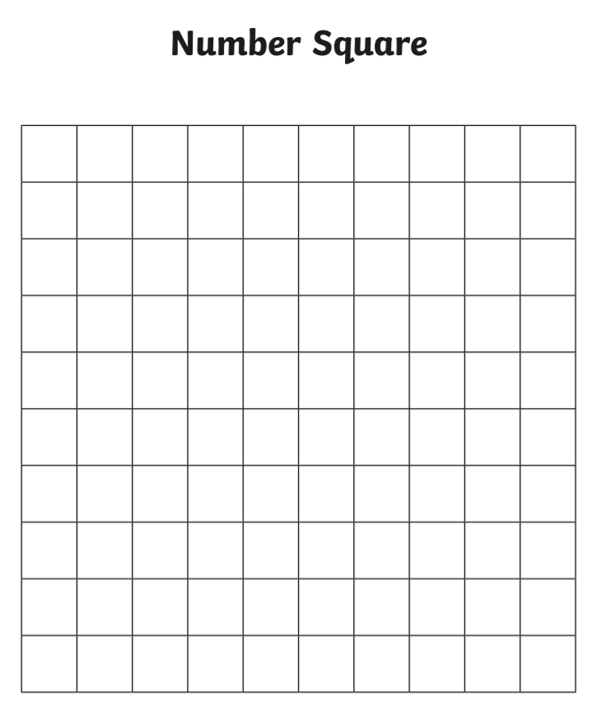
Maths Work Sheets
Lesson 1 – Numbers to 100

Lesson 2 – Partitioning
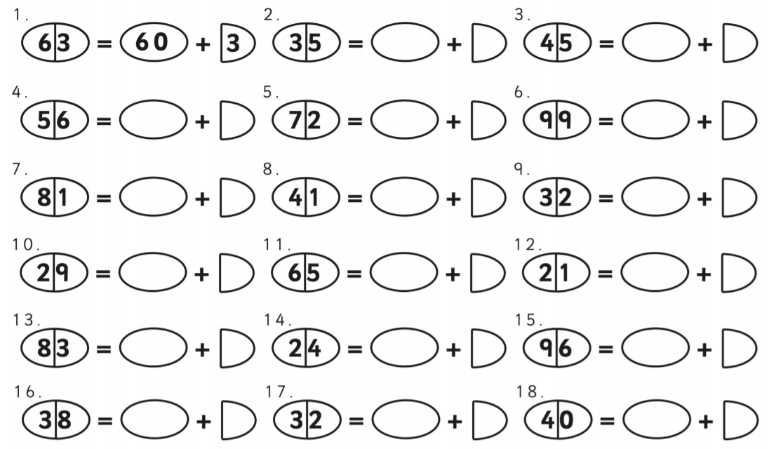

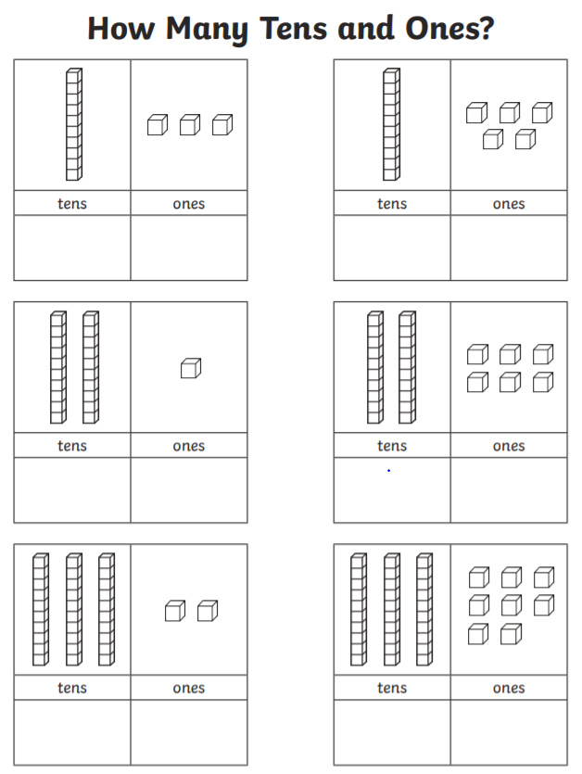
Lesson 2 – Partitioning Numbers

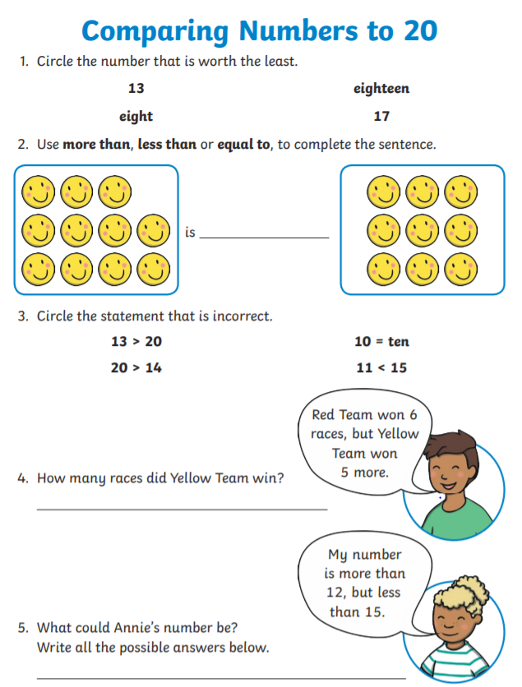
Lesson 3 – Comparing Numbers

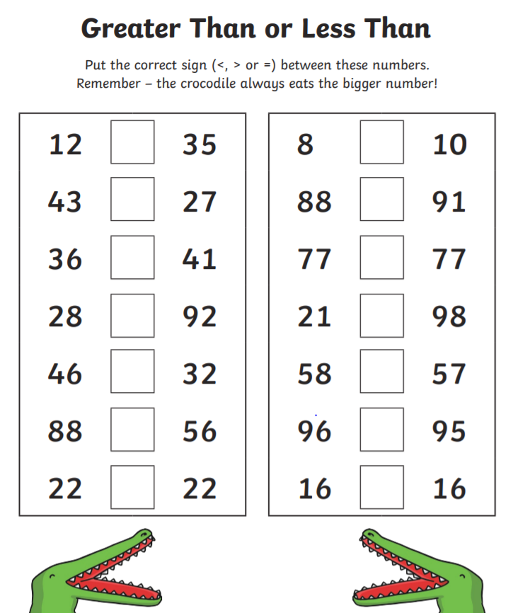
Lesson 4 – Comparing Numbers Greater than and Less than

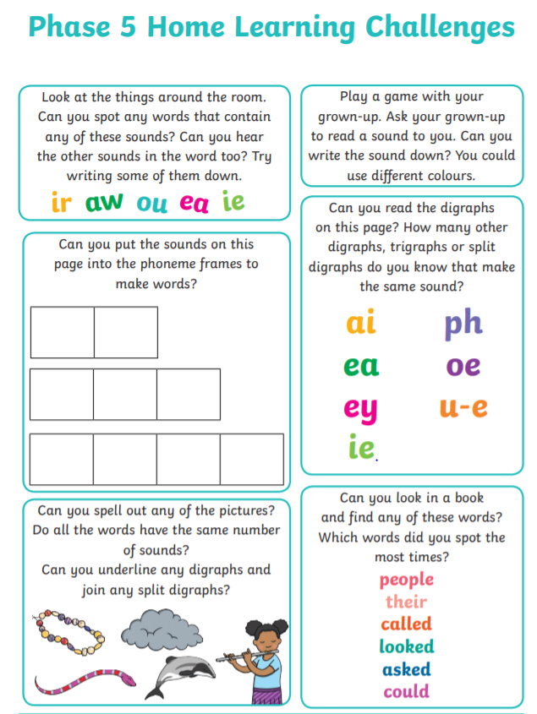
Phonics

