Reception Home Learning
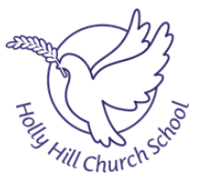
Phonics

Letters and Sounds Youtube channel – Phonics daily lessons uploaded daily at 10am and 11am.
Available are -
- Reception lesson - lessons suitable for children who can blend and read words such as 'fish', 'chat' and 'rain'. New lessons uploaded every week day at 10am.
- Learning to blend lessons - lessons for children who need more practise sounding and reading words such as 'tap', 'cap', 'mat'. New lessons uploaded every week day at 11am.
https://www.youtube.com/channel/UCP_FbjYUP_UtldV2K_-niWw/featured
Phonics Play
https://new.phonicsplay.co.uk/
Username: march20
Password: home
WB 6/7/20 | Review Sounds | Activity | Review Tricky Words
Monday
Tuesday |  | 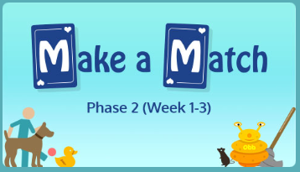 | 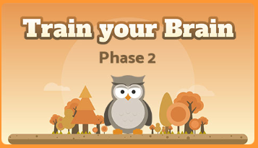
Wednesday |  | 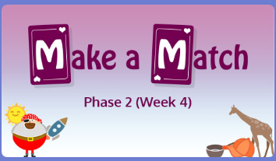
Thursday |  | 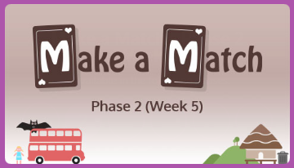 | 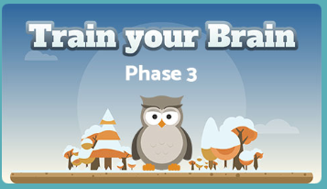
Friday | 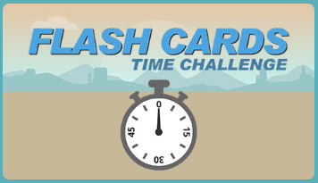 | 