Nursey Home learning 6.7.20

6.7.20 | Day 1 | Day 2 | Day 3
These activities and ideas are  based around the book  “Zog”  By Julia Donaldson | https://youtu.be/9_LmS3q4E6k  Story  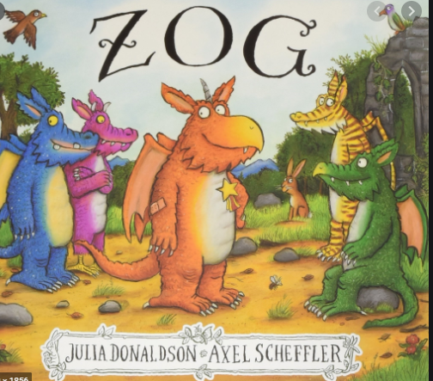
Phonics | 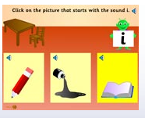  Please follow the link below and click on ‘Initial sounds game’ and then select level 1 from the sounds menu.  http://www.crickweb.co.uk/Early-Years.html  Initial Sounds game -  An initial sounds phonic activity that develops the link between letters and the initial sounds of some common objects. | Crazy Stir-Fry 's’ and Monster Treasure Hunt songs: say it and see it -  Animated songs for both revising and teaching letter-sounds. Catchy and easily adaptable, children will want to sing along and invent their own. In this version, the letters are shown at the same time as the letter sounds are heard, allowing children to make the connection between the sound and the letter.  ‘s’ -https://www.teachyourmonstertoread.com/classroom-toolkit/phonics-songs/crazy-stirfry-s-song-say-it-and-see-it  ‘a’ –  https://www.teachyourmonstertoread.com/classroom-toolkit/phonics-songs/crazy-stirfry-a-song-see-it-and-say-it  ‘t’ -  https://www.teachyourmonstertoread.com/classroom-toolkit/phonics-songs/monster-treasure-hunt-t-song-see-it-and-say-it | 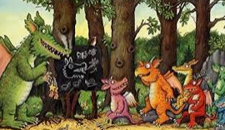  Imagine you are in Dragon school.  Try making some different sounds to show different feeling and emotions throughout your day at school e.g ‘oh!’ when surprised, ‘mmmmmm’ when eating something yummy, ‘shhhh’ when trying to be quiet and ‘roooaaaaarrrrr’ when trying to scare someone!
Writing | 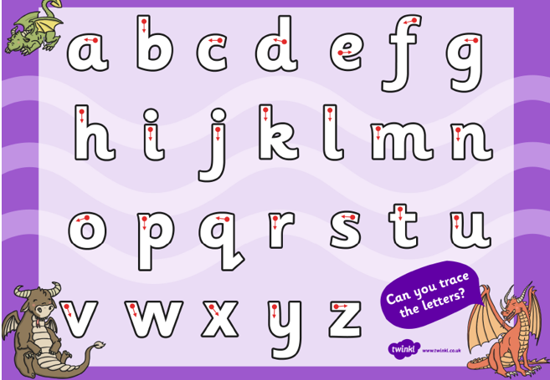  Use this letter writing worksheet to reinforce letter formations. | 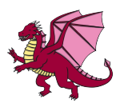  Can you design your own dragon and give him or her a name? Look carefully at the different dragons in the story to inspire you! Can think of a sentence to tell me something about your dragon? E.g. My dragon is green and spotty or my dragon is very good at flying. I wonder what initial sound your Dragons name starts with? Mine is ‘n’ for Norbert | What’s in the doctor’s bag?  To help develop your child’s understanding of the equipment needed to help patients who are hurt or ill. They can cut out the correct items on the ‘what’s in the doctor’s bag’ resource sheet 2 enclosed and stick them onto the outline of a doctor’s bag.
Math’s | 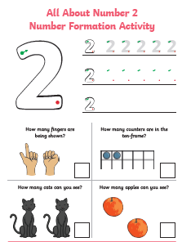  All about the number 2 – Number formation. Use the colourful worksheet enclosed to help children practise number formation for the number 2. The sheet provides opportunities for children to trace over the numeral and write the numerals in answer to counting questions. Perfect for practising number formation and recognition | Flying doctor biscuits -  Lots of us have been doing baking recently. We know how helpful the flying doctors are. Use your skills in weighing and measuring to make flying doctor biscuits. Who could you bake these for?  Use the White Rose link below to access the recipe.  https://wrm-13b48.kxcdn.com/wp-content/uploads/2020/06/Day-5-Zog.pdf | 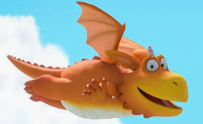  Flying lesson -  In the story, Zog learns to fly in dragon  school, can you pretend to fly like Zog?…  Who can jump the furthest into the sky?  With your family practice jumping  up high. Who can jump up the highest?  Who can jump the furthest distance forward?  Who can jump the furthest distance backwards?
Religious  Education | Value – Patience  Big Question - Are there times when it is hard to be patient?  The value this week is Patience. Patience is waiting for something.... Patience is showing restraint... Patience could be showing tolerance... Patience could be how you deal with feeling anxious...  Some questions to consider: How good are you at waiting for something? What makes you become impatient? What  helps you become more patient? How long can you sit still?  The Marshmallow Test -  Watch the video - https://www.ignitermedia.com/products/1350-the-marshmallow-test  In this popular test, several children struggle with waiting to eat a marshmallow in hopes of a bigger prize. This video is a good illustration of temptation and the hope in future rewards. This experiment is based on many previous and similar scientific tests.  Can you have a go and see if you can wait? You don’t have to use a marshmallow you can use your favourite food or sweet (if you’ve been good!)
Topic – Creative and dance | Dragon Dance -  For the festival of Chinese New Year people dress up as dragons to perform and ward off evil spirits!  Design your own dragon and dance!  The dragon dance is often performed during Chinese New Year. Chinese dragons are believed to bring good luck to people,  therefore, the longer the dragon is in the dance, the more luck it will bring to the community. How long will your dance last? Could you make a special dragon mask to wear when doing your dance?  You could do a special Zog version!  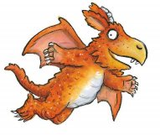  Plan your moves! The dances are very spectacular! Have a look on the internet! See if you can do 20 moves.  Here is mine!  Miss Cox’s Dragon dance  3 head nods  3 big kicks  2 arm flaps  2 turns  3 jumps  1 small roar  2 side steps right  2 side steps left  3 steps forwards  3 steps back  2 big roars!
Talking Together | Read the story of Zog to your child, and focus on Zog’s new career at the end of the story. What does your child think Zog will do in his new job of transporting the flying doctors? What sort of patients might Zog take Princess Pearl and Sir Gadabout to help? What things will the flying doctors need in their doctor’s bag? Use your child’s suggestions to pack a doctor’s bag, linking back to Zog’s injuries and how Princess Pearl treated them. As you introduce each piece of equipment from the story, ask your child for ideas on what it is used for – can they remember how Princess Pearl used the equipment to treat Zog and nurse the other dragons?  Task -  Make your own role play flying doctors’ base. Ask your child to suggest where this could be – you could look at images from the book for ideas; maybe it will be a cave, a forest, castle ruins, etc. Tell your child that they are going to pretend to be one of the flying doctors. Read out the scenarios on Resource Sheet 1 enclosed: A doctor’s checklist and encourage your child to suggest the correct treatment to give to their patients. Teddies or dolls could be used as the patients, each with a card stating what their problem is and your child can act out how to treat their ailments.
Physical Education | There are a lot of PE activities available that you can do depending on the space or resources available. Here are some suggestions.  Kids Zumba - https://www.youtube.com/watch?v=RoYxG0avSfY  Fitness with Joe Wicks - https://www.youtube.com/channel/UCAxW1XT0iEJo0TYlRfn6rYQ  Go Noodle - https://family.gonoodle.com  Cosmic Kids Yoga - https://www.youtube.com/user/CosmicKidsYoga
Challenge | 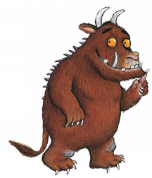  The Gruffalo -  A little secret!  Hidden in the book is a secret Gruffalo!  You know what he looks like!  See if you can find him using your super observations skills. Tell your grown up where he is using your positional language.

