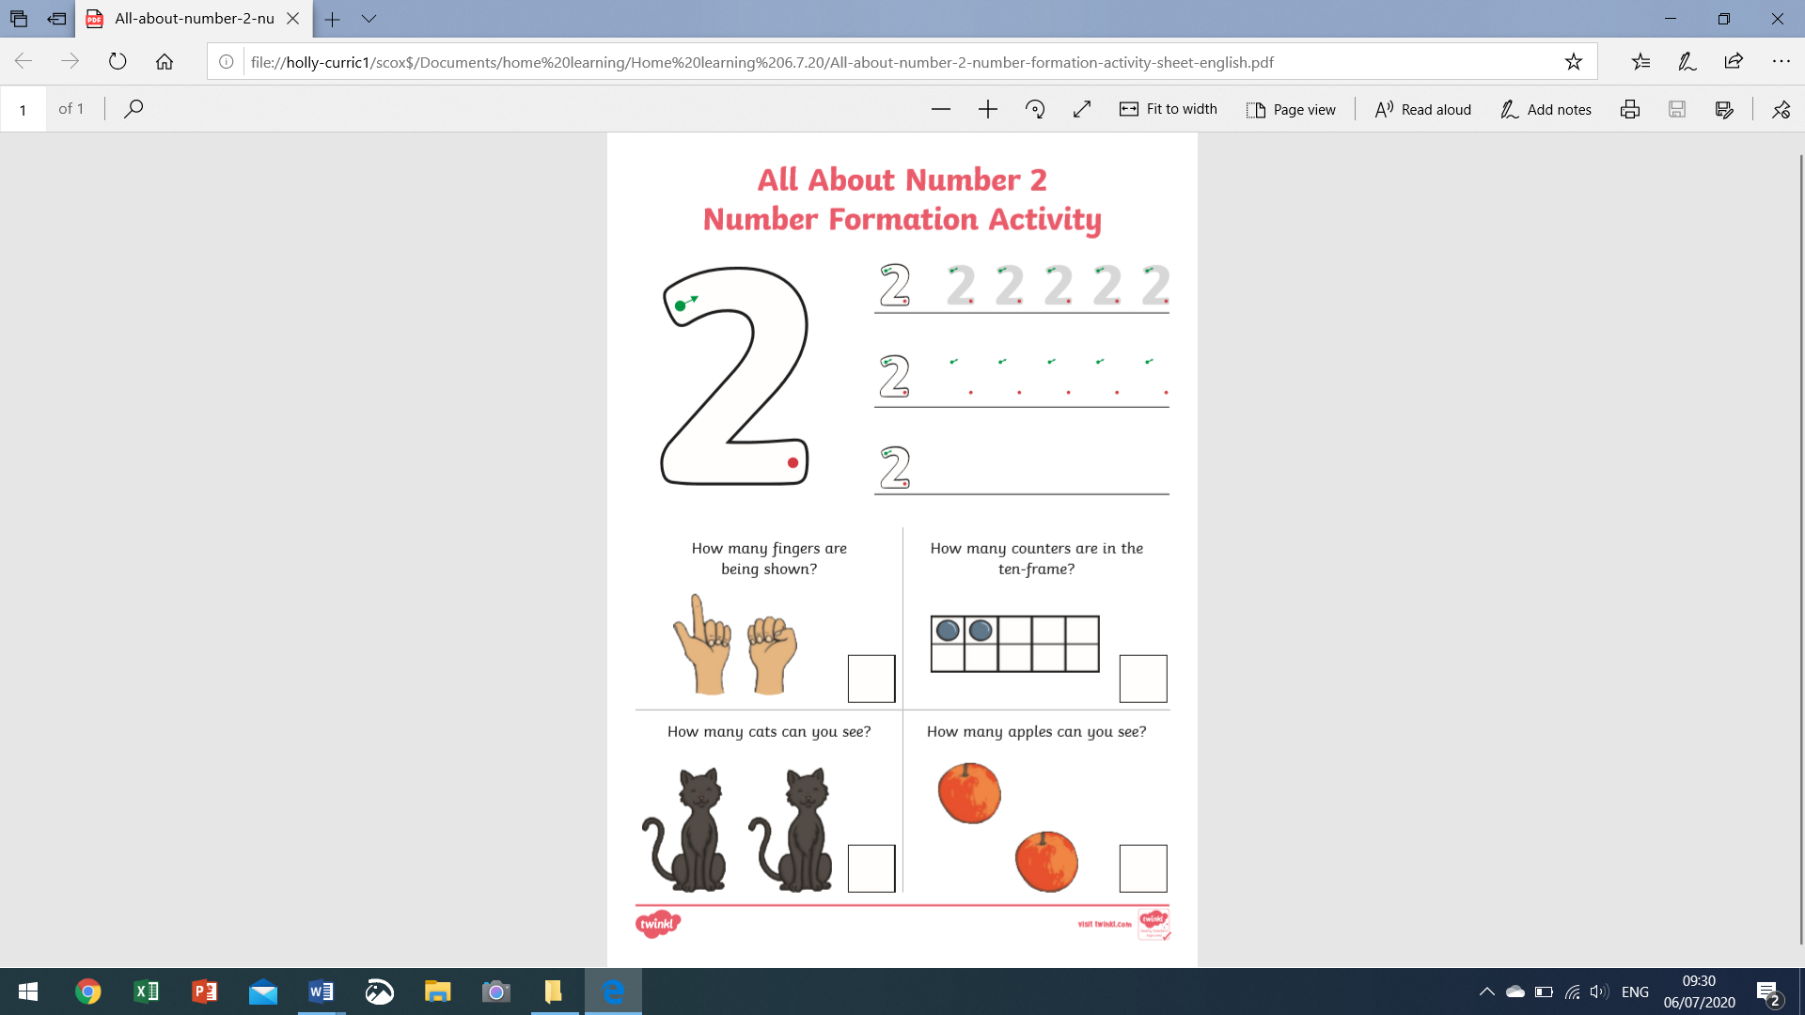

Challenge - how many different ways can you show me two using the fingers on both your hands. Keep a tally chart, challenge your family to see who can come up with the most.