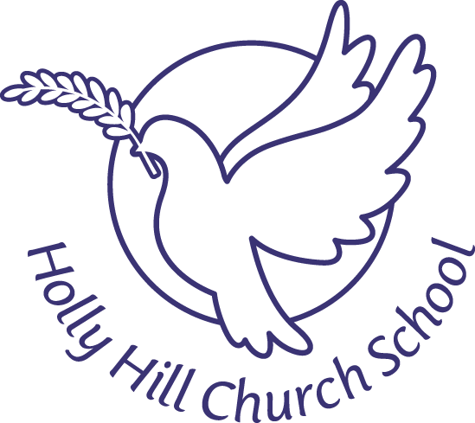
COVID 19 - Visitor Code of Conduct
(updated 4th November 2020)

Holly Hill is working hard to ensure the safety and wellbeing of all our pupils, staff, families and visitors. Providing a safe environment is important, so we kindly request that you follow the following simple rules.
- If you are unwell with a new continuous cough or a high temperature you should stay at home and follow the government guidance. Please call the school to advise us. You can also contact NHS 111: https://111.nhs.uk/covid-19/ .
- Please use hand sanitiser when entering the school, and ensure you follow government guidelines and regularly wash hands during the day.
- Please wear a mask at all time on the premises.
- Please follow all queue signage and please adhere to any placed distance markers.
- Please follow one-way routes around the outside of the school.
- Please respect and maintain a 2m social distancing (where possible) with other staff in school
- Please use available disinfectant spray and disposable paper towels to sanitise any shared items before and after use.
- Please clear tables after use and dispose of all your rubbish in the bins provided.
- Hand sanitiser is available throughout school, please use this regularly.

These measures are designed to help maintain a safe environment for your visit.
Our office staff will be delighted to answer any questions you may have.

