

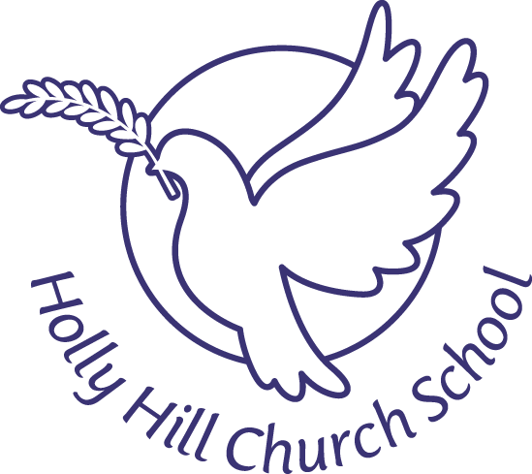

Holly Hill Church School

**Activities/Events during December 2021**

6th Parents Evening telephone calls this week

10th Christmas Jumper Day for all pupils

13th All Nativity videos on website this week

Year Two pupils to Selly Oak Methodist Church for Carol Service

14th Year One and Two to The Palace Theatre, Redditch to see Jack and the Beanstalk **(uniform to be worn)**

15th Christmas Dinner Day

Visit from Father Christmas

Stories around the tree **(pyjamas may be worn to school)**

16th Nursery and Reception to Midland Arts Centre to see One Snowy Night **(uniform to be worn)**

Year One and Two Party Day **(Uniform to be worn)**

17th Non uniform day for whole school