Spellings
/10
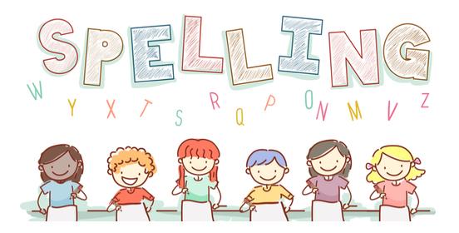
Date: 7.3.23 for a test this Friday!

Double consonant and add ed Group 11 | Monday | Tuesday | Wednesday | Thursday | Friday
yapped
jogged
hummed
chopped
dropped
ripped
shopped
dripped
stirred
grinned

