Pupil premium strategy statement - Holly Hill Church School

This statement details our school’s use of pupil premium (and recovery premium) funding to help improve the attainment of our disadvantaged pupils.

It outlines our pupil premium strategy, how we intend to spend the funding in this academic year and outcomes for disadvantaged pupils last academic year.

School overview
Detail | Data
Number of pupils in school | 152 School  26 Nursery
Proportion (%) of pupil premium eligible pupils | 69%
Academic year/years that our current pupil premium strategy plan covers (3 year plans are recommended) | 2022/23- 2025/26
Date this statement was published | 15th November 2022
Date on which it will be reviewed | September 2024
Statement authorised by | Mark Carr  Head of School  Full Governors Meeting 28th November 2022
Pupil premium lead | Mrs Kate O’Neill
Governor / Trustee lead | Mr Gary Hopkins
Funding overview
Detail | Amount
Pupil premium funding allocation this academic year | £147,503
Recovery premium funding allocation this academic year | £15,443
Pupil premium funding carried forward from previous years (enter £0 if not applicable) | £0
Total budget for this academic year  If your school is an academy in a trust that pools this funding, state the amount available to your school this academic year | £162,946

Part A: Pupil premium strategy plan

Statement of intent – in line with School Improvement Plan
As a Christian school our vision is to serve the families of one of Britain’s most disadvantaged areas by transforming children’s opportunities through the immersion in high quality education. Holly Hill Church School promotes a nurturing environment where every child is enabled to thrive and grow educationally, socially and spiritually. It is with the firm foundations of knowledge, pride and self-belief that our children will develop their group consciousness for the community and the wider world.
‘Life in All its Fullness’ (John 10.10) is the foundation stone for our high expectations of all our families and partners to work together to affect change from within the heart of this community. Children will be encouraged to develop strong aspirations and a desire to make a positive difference in a society faced with continual challenges that require resilience, understanding and a desire for peace.
Our intention is that all pupils, irrespective of their background or the challenges they face, make good progress and achieve high attainment across a broad and balanced curriculum. The focus of our pupil premium strategy is to support disadvantaged pupils to achieve that goal, including progress for those who are already high attainers.
High-quality teaching and learning is at the heart of our approach, with a focus on areas in which disadvantaged pupils require the most support. This is proven to have the greatest impact on closing the disadvantage attainment gap and at the same time will benefit the non-disadvantaged pupils in our school. Implicit in the intended outcomes detailed below, is the intention that non-disadvantaged pupils’ attainment will be sustained and improved alongside progress for their disadvantaged peers.
Our strategy is also integral to wider school plans for education recovery, for example, in its targeted support through the National Tutoring Programme for pupils whose education has been worst affected, including non-disadvantaged pupils.
Our approach will be responsive to common challenges and individual needs, rooted in diagnostic assessment. The approaches we have adopted complement each other to help pupils excel. To ensure they are effective we will:
• ensure disadvantaged pupils are challenged in the work that they are set
• act early to intervene as the point need is identified
• continue to work as a whole school in which all staff take responsibility for disadvantaged pupils’ outcomes and raise expectations of what they can achieve educationally, socially and spiritually.

Challenges

This details the key challenges to achievement that we have identified among our disadvantaged pupils.
Challenge number | Detail of challenge
1 | Assessments, observations, and discussions with pupils indicate underdeveloped oral language skills and vocabulary gaps among many disadvantaged pupils. These are evident from Reception through to KS1 and in general, are more prevalent among our disadvantaged pupils than their peers.
2 | Assessments, observations, and discussions with pupils suggest disadvantaged pupils generally have greater difficulties with phonics than their peers.  (Last published data 2019 – National – end of Year 2 (all children) 91% passed Phonics screen, at HH in 2022 PP 92% passed Phonics screen. However, last published data 2019 – National – end of Year 1 (all children) 82%, at HH in 2022 PP 53% passed Phonics screen.)  This negatively impacts their development as readers.
3 | Assessment data indicates that Mathematics, Reading and Writing attainment among disadvantaged pupils is below that of non-disadvantaged pupils in school and all pupils nationally.  On entry to EYFS, disadvantaged children’s attainment is significantly below that of their non-disadvantaged peers and whilst they often make accelerated progress through school, there are still gaps at the end of Key Stage 1, particularly in the percentage of PP children achieving the greater depth level. This trend is set to continue with the current Year Two cohort.  Last published data 2019 for National compared to Holly Hill PP in 2022:  National -all Expected Holly Hill PP Expected National – all Greater depth Holly Hill PP Greater depth  Mathematics 76% 78% 22% 14%  Writing 69% 64% 15% 14%  Reading 75% 81% 26% 11%
4 | Our observations indicate and discussions with pupils and parents indicate that physical and mental wellbeing of many of our disadvantaged pupils have been impacted by partial school closures during the pandemic to a greater extent than for other pupils, for example by a lack of enrichment and opportunities to develop social and communication skills.  These findings are supported by national studies.
5 | Our attendance data over the last 4 years indicates that attendance among disadvantaged pupils has been on average lower than for non-disadvantaged pupils.  To date, in 2022/23, the attendance of disadvantaged children is on average 92.19%.

Intended outcomes
This explains the outcomes we are aiming for by the end of our current strategy plan, and how we will measure whether they have been achieved.
Intended outcome | Success criteria
Improved oral language skills and vocabulary among disadvantaged pupils. | Assessments and observations indicate significantly improved oral language among disadvantaged pupils. This is evident when triangulated with other sources of evidence, including engagement in lessons, book scrutiny and ongoing formative assessment.
Improved phonics outcomes among disadvantaged pupils. | Phonics outcomes in 2024/25 show that more than 91%* of disadvantaged pupils met the expected standard by the end of Year Two.  (*based on 2019 national outcomes for all children. This will be reviewed and updated to be in-line with national expectations/ trends)
Improved maths, reading and writing attainment for disadvantaged pupils at the end of Key Stage 1.  Improved maths, reading and writing progress for disadvantaged pupils at the end of Key Stage 1. | Outcomes in 2024/25 show that percentage of disadvantaged pupils met the expected standard is equal to or greater than that of all children nationally.  Maths- 76%*  Reading – 75%*  Writing – 69%*  (*based on 2019 national outcomes for all children. This will be reviewed and updated to be in-line with national expectations/ trends)  Outcomes in 2024/25 show that 100% of disadvantaged pupils have made at least the expected level progress (identified by FFT) by the end of Key Stage 1.
To achieve and sustain improved wellbeing for all pupils in our school, particularly our disadvantaged pupils. | Sustained high levels of wellbeing from 2024/25 demonstrated by:  - qualitative data from pupil voice, parent surveys and staff observations  A significant increase in the provision of and participation in enrichment activities (such as after school clubs), particularly among disadvantaged pupils.
To achieve and sustain improved attendance for all pupils, particularly our disadvantaged pupils. | Sustained high attendance from 2024/25 demonstrated by:  - the attendance rate for all pupils to be 96% or higher,  - the attendance gap between disadvantaged pupils and their non-disadvantaged peers being reduced  - Persistent absence rates will have fallen year on year and will be broadly in line with National Average  - A robust and proven strategy for improving attendance.
To have a sustainable program in place to develop teaching and learning resulting in high quality provision across all year groups and curriculum areas. | The school has robust, proven programmes for developing the quality of teaching and learning.  The school has developed members of the leadership team and teaching staff who are able to coach others to improve the quality of education.  All children make at least good progress from their starting points.

Activity in this academic year
This details how we intend to spend our pupil premium (and recovery premium funding) this academic year to address the challenges listed above.

Teaching (for example, CPD, recruitment and retention)
Budgeted cost: £ 9000
Activity | Evidence that supports this approach | Challenge number(s) addressed
Improve the quality of teaching in English through Oracy CPD/ staff meetings  A range of quality texts will be purchased to inspire children to read.  Reading opportunities are meaningful, engaging and mapped across the curriculum.  Tier 2 vocabulary to be identified and mapped across the curriculum.  Cost:£1000 | ‘Good teaching is the most important lever that schools have to improve outcomes for disadvantaged pupils’ (EEF guide to the PP)  Reading Comprehension Strategies/ Toolkit/ EEF  EEF – Oral Language Intervention  Oral language interventions | EEF (educationendowmentfoundation.org.uk)  The EEF found that Oral language interventions (also known as oracy or speaking and listening interventions) refer to approaches that emphasise the importance of spoken language and verbal interaction in the classroom and can have 6+ month progress over the course of a year | 1,2,3
Continue to implement a DfE validated Systematic Synthetic Phonics programme (Super Sonic Phonic Friends) to secure stronger phonics teaching for all pupils.  Cost:£2000 | Phonics approaches have a strong evidence base that indicates a positive impact on the accuracy of word reading particularly for disadvantaged pupils:  Phonics | Toolkit Strand | Education Endowment Foundation | EEF | 2
Enhancement of our maths teaching and curriculum planning in line with DfE and EEF guidance.  We will provide CPD for all teaching staff to ensure teacher knowledge will be improved and that practice is consistent across school  Cost:£1000 | We will use DfE non-statutory guidance that has been produced in conjunction with the National Centre for Excellence in the Teaching of Mathematics, drawing on evidence-based approaches:  Maths_guidance_KS_1_and_2.pdf (publishing.service.gov.uk) | 3
Coaching for all Class Teachers using the ‘Leverage Leadership’ approach.  Weekly/ fortnightly teaching and learning coaching sessions for all classroom teachers.  Cost:£4000 | Coaching is the most powerful way to ensure all staff in schools have the skills to influence change, reflect on learning and deliver outstanding pedagogy. Coaching builds confidence, creates a culture that is non-judgemental, highly motivating will transform practice. Once teachers have been trained they will have the tools to greater problem solve and manage problems within their team which will in turn improve wellbeing.  Leverage Leadership is based around the Uncommon School agenda in the USA. | 1,2,3,4
Bespoke programme of support for NQT/ECTs  Cost:£1000 | Guided by Teachers’ Standards, identifying areas of strength and development will increase the confidence and capability of newly qualified/ early career teachers. | 1,2,3,4

Targeted academic support (for example, tutoring, one-to-one support structured interventions)
Budgeted cost: £ 152,792
Activity | Evidence that supports this approach | Challenge number(s) addressed
Teaching Assistant support in each class  Cost:£112,432 | Children have access to additional adult support, enabling misconceptions to be addressed quickly.  Social and emotional needs can also be supported effectively as TAs are able to provide pastoral support in a timely manner. | 1,2,3,4
Additional phonics sessions targeted at disadvantaged pupils who require further phonics support. This will be delivered by a qualified teacher and be funded in-part by The National Tutoring Grant  Cost:£22,860 | Phonics approaches have a strong evidence base indicating a positive impact on pupils, particularly from disadvantaged backgrounds. Targeted phonics interventions have been shown to be more effective when delivered as regular sessions:  Phonics | Toolkit Strand | Education Endowment Foundation | EEF | 1,2,3
Use of research based interventions: Wellcomm, Direct Phonics, Colourful Sematics  and the Talkabout resources for social skills/ well-being  Cost:£3000 | EEF Toolkit suggests that TA delivered interventions can enhance progress by 4 months.  As all interventions used are research based, they have been proven to be effective. | 1,2,3,4
Speech and Language Therapist in school (1 day per week)  Teaching Assistants work on speech and language targets with children  Cost:£14,500 | As some of our disadvantaged children have poor communication skills early intervention from school SALT reduces the time children are waiting to access core NHS services and therefore lessens the impact communication difficulties have on their education and wellbeing. | 1,4
Engaging with the National Tutoring Programme to provide a blend of tuition, mentoring and school-led tutoring for pupils whose education has been most impacted by the pandemic.  A significant proportion of the pupils who receive tutoring will be disadvantaged, including those who are high attainers.  Cost:£22,860 | Tuition targeted at specific needs and knowledge gaps can be an effective method to support low attaining pupils or those falling behind, both one-to-one:  One to one tuition | EEF (educationendowmentfoundation.org.uk)  And in small groups:  Small group tuition | Toolkit Strand | Education Endowment Foundation | EEF | 2,3

Wider strategies (for example, related to attendance, behaviour, wellbeing)
Budgeted cost: £ 3,852
Activity | Evidence that supports this approach | Challenge number(s) addressed
Whole staff training on behaviour management approaches with the aim of developing our school ethos and improving behaviour across school, using resources from Beacon School Support which is an recommended by DLP.  Cost:£600 | Both targeted interventions and universal approaches can have positive overall effects:  Behaviour interventions | EEF (educationendowmentfoundation.org.uk) | 3,4,5
Embedding principles of good practice set out in the DfE’s Improving School Attendance advice and implementing the Attendance Framework.  This will involve training and release time for staff to develop and implement new procedures and appointing attendance/support officers to improve attendance.  Attendance and punctuality tracked and monitored. Member of staff responsible for attendance and working with parents to improve pupil attendance.  Cost:£1000 | The DfE guidance has been informed by engagement with schools that have significantly reduced levels of absence and persistent absence.  This approach has been successful in raising overall attendance at Holly Hill. | 5
Curriculum is planned to include trips, experiences, visitors, specialist music teacher (KS1) and a range of after school clubs which are funded by school.  Cost:£1000 | Memory hooks are a powerful approach to securing learning (The Science of Learning, Deans for impact). These experiences also aim to increase engagement for learning, pupil aspiration and well-being.  Funding of these activities results in increased participation and equity of opportunity. | 1,2,3,4,5
Learning Mentor employed to support mental health, wellbeing and behaviour.  Cost:£1254 | Children are able to access support necessary which enables them to thrive and engage in all aspects of school life. | 4,5

Total budgeted cost: £ 162, 946

Part B: Review of outcomes in the previous academic year

Outcomes for disadvantaged pupils
This details the impact that our pupil premium activity had on pupils in the 2021-2022 academic year.
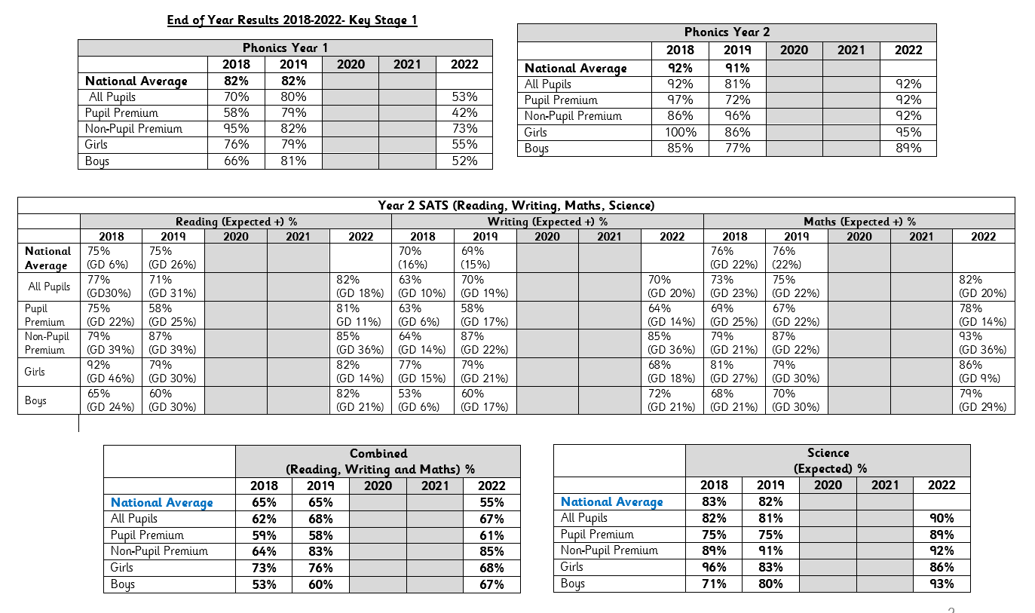
In 2022, Year 2 PP pupils passing phonics screen was 92% (1% higher than 2019 National and 11% higher than 2019 HH PP)
In 2022, 82% of Year 2 PP Pupils reached ARE or higher in Reading (7% higher than 2019 National and 11% higher than 2019 HH PP)
In 2022, 64% of Year 2 PP Pupils reached ARE or higher in Writing ( 5% lower than 2019 National but 6% higher than 2019 HH PP)
In 2022, 82% of Year 2 PP Pupils reached ARE or higher in Maths (6% higher than 2019 National and 15% higher than 2019 HH PP)
Wellbeing: Parent Voice Survey – July 2022

Externally provided programmes
Please include the names of any non-DfE programmes that you purchased in the previous academic year. This will help the Department for Education identify which ones are popular in England
Programme | Provider
Not applicable

Service pupil premium funding (optional)
For schools that receive this funding, you may wish to provide the following information:
Measure | Details
How did you spend your service pupil premium allocation last academic year? | Not applicable
What was the impact of that spending on service pupil premium eligible pupils?

Further information (optional)

