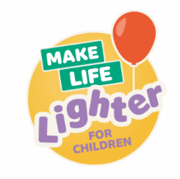

On Friday 14th November,
children can come to school wearing their own clothes for a recommended donation of £1
BBC Children in Need 2025
November 2021

BBC Children in Need 2025
November 2021
On Friday 14th November,
children can come to school wearing their own clothes for a recommended donation of £1

