Reception Home Learning
Phonics
https://www.phonicsbloom.com/

WB 4/5/20 | Review Sounds | Activity | Review Tricky Words
Monday | 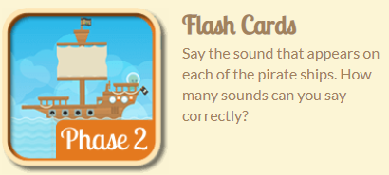 | 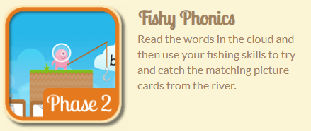 | Tricky word hunt  Ask a grown up to write out the tricky words I no to go no the into and hide them around the house for you to find.
Tuesday |  | 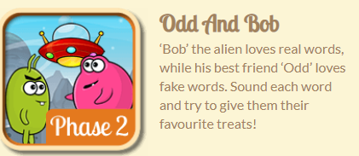 | Tricky word hangman  Play hangman with the tricky words I no to go no the into
Wednesday | 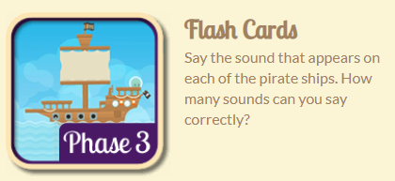 | 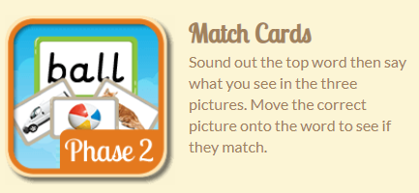 | Tricky word hunt  Ask a grown up to write out the tricky words me he she we my and hide them around the house. or you to find.
Thursday |  | 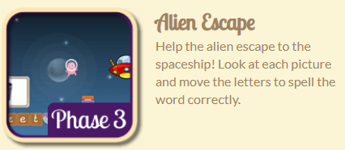 | Tricky word hangman  Play hangman with the tricky words me he she we my
Friday | 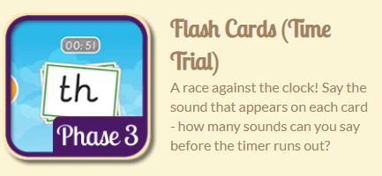 | 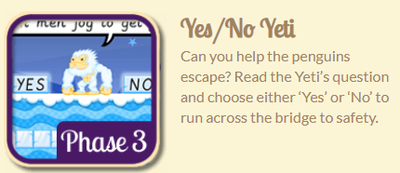 | 