 | Monday | Tuesday | Wednesday | Thursday | Friday
Reading | Please click on the links below to access the books. Once the page has loaded click onto:  ‘My Class Login’  Evergreen:  ‘My Class Name’ = evergreen20  ‘My Class Password’ = evergreen  Orange Group – When Animals Invade (2 Acitivities)  https://www.oxfordowl.co.uk/api/digital_books/1467.html  Purple Group – Attack of the Centipede (2 Activities)  https://www.oxfordowl.co.uk/api/digital_books/1167.html  White Group – Making a Book  https://www.oxfordowl.co.uk/api/digital_books/1323.html  Others – Free Readers – Choose a book of your choice/continue reading the library books you were given in school. Or if you are unable to access the online reading, then please continue to read the books you have available at home.  Please complete answers in your books, or on paper for the following questions:  What was your book about?  Who were the characters?  What did you like/dislike about the book? Why?  Would you recommend the book to me? Why?  Write a list of any words that you are unsure of the meaning of and write the definition in the books provided or on a piece of paper.
Spellings | We will be concentrating on our Year 2 Common Exception Words (tricky words). These are words that are tricky to use our phonics skills to sound out and blend, so the only the way to know how to spell them… is to learn them!  Also, can you explain the meaning of each word?  child class could door  children climb cold even  Christmas clothes |  |  |  | Spelling Test!  Ask your grown up to help you complete a spelling test.  Please email Mrs Bayliss and Miss Sangha your test results at beech@hollyhill.bham.sch.uk and evergreen@hollyhill.bham.uk … We would love to see how you are all doing!
English | PurpleMash – Conjunctions  https://www.purplemash.com/#app/texttoolkit/activities/text_tool_kit_rainy_day | This week, there a very special celebration! Friday 8th May is the 75th anniversary of VE day. Today, I would like you research VE to find out it. There is a PowerPoint presentation for you to read to help you. | We would like you write information writing about VE day, based on the text that you read yesterday.  https://www.twinkl.co.uk/resource/t2-h-4788-ve-day-powerpoint  You will need to include …  A title  Subheadings…  What does VE stand for?  When is VE day and what is it?  How do people celebrate it?  Who did people listen to on their wireless sets?  Who came out onto their balcony after Sir Winston Churchill’s speech?  Amazing fact! Did you know…  Don’t forget to include a range a conjunctions (and, but, or, because, if, so, when, that) that you pracised on Monday,to add extra information.  Here is an example to remind you what information writing looks like and what you need to include…  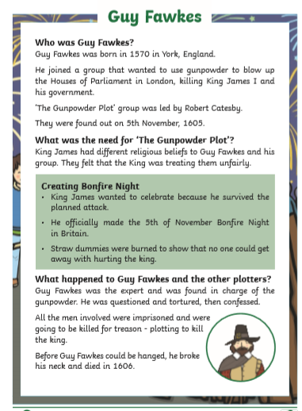  If you have any questions, please email Mrs Bayliss at beech@hollyhill.bham.sch.uk and Miss Sangha at evergreen@hollyhill.bham.sch.uk. You can always send your work to us on a word document if you wish to!  We are so excited to see your beautiful writing already!
Maths | Our focus this week will be on subtraction.  Your tasks have already been set on PurpleMash, or you can use the links below:  https://www.purplemash.com/app/games/wtr_SUBTRACTION_20_single_format  Challenge:  https://www.purplemash.com/app/games/wtr_SUBTRACTION_20 | Your tasks have already been set on PurpleMash, or you can use the links below:  https://www.purplemash.com/app/games/wtr_SUBTRACTION_100_single_format  Challenge:  https://www.purplemash.com/app/games/wtr_SUBTRACTION_100 | Complete these questions in your books or on a piece of paper:  - 40 – 30 =  - 25 – 10 =  - 19 – 11 =  - 44 – 20 =  - 35 – 15 =  - 26 – 13 =  - 50 – 45 =  - 60 – 31 =  - 66 – 38 =  - 49 – 38 =  - 84 – 63 =  - 57 – 26 = | 1.  2.  Partition the number 34.  Partition 13 and subtract the ones and the tens.  Place the partitioned number back together.  3. | Write the answers in the book that was sent home to you or on a piece of paper:  1.  Annie has 33 stickers.  Dexter has 54 stickers.  How many more stickers does Dexter have?  What method did you use to solve the problem?  2.  Find the missing numbers.  Is this the only possible solution? Explain your answer.  Make the numbers using Base 10 to help you find your answer.
R.E – Does everybody deserve our respect? | What does respect mean?  Draw a picture or write what respect means to you. | Create a poster, a drawing or a piece of writing about:  Ways to show respect in your school.  Ways to show respect to your friends. | Create a poster, a drawing or a piece of writing about:  Ways to show respect to yourself.  Ways to show respect to your family/others. | Random acts of kindness.  How many random acts of kindness can you think of and complete? | Does everybody deserve our respect?  Write a For and Against debate, arguing both sides.
Topic | D&T - Based on our writing theme of VE day, I would like you design and make a medal.  Your medal could be created using ribbon, sting, coloured paper, foil, milk bottle tops etc… anything you wish! Please take a photo and send it to Mrs Bayliss at beech@hollyhill.bham.sch.uk or to Miss Sangha at evergreen@hollyhill.bham.sch.uk so that we can see your wonderful creations!  Here are some examples to help you …  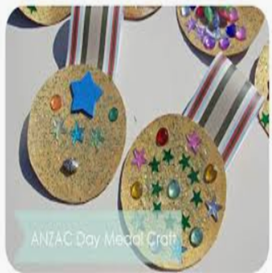  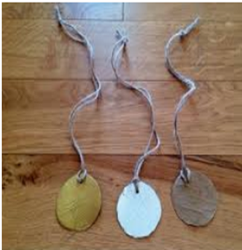  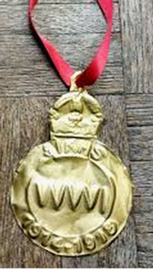  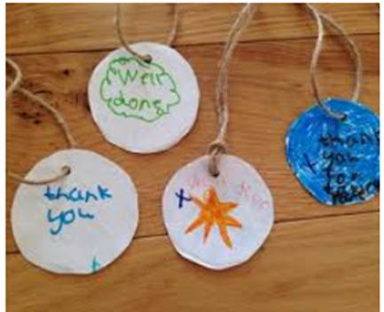  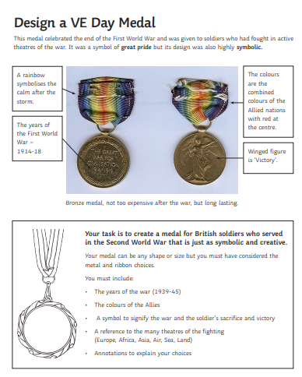  Have fun making your creations and remember to send us pictures of them to beech@hollyhill.bham.sch.uk or evergreen@hollyhill.bham.sch.uk

