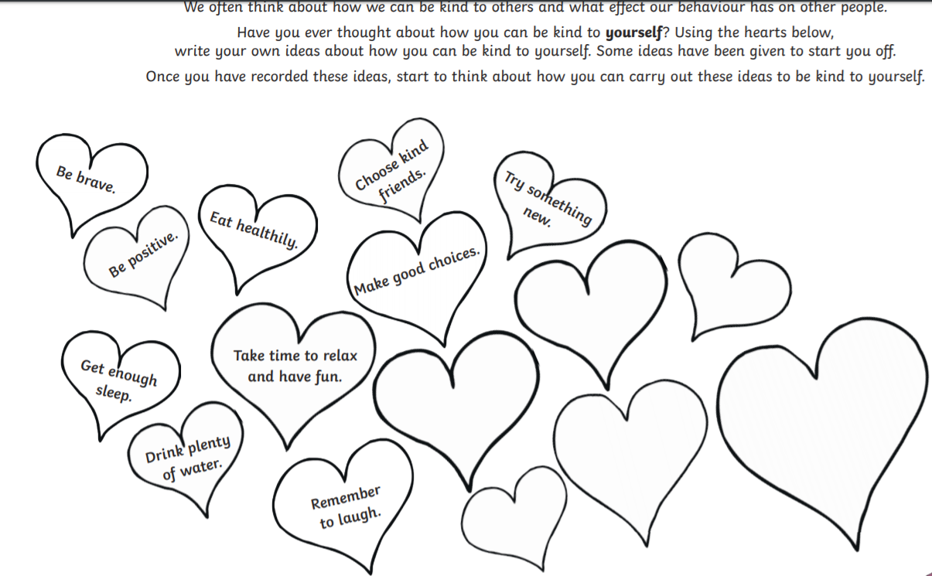

**Be Kind To Yourself!**

We often think about how to be kind to others and what effect our behaviour has on other people.

Have you ever thought about how you can be kind to **yourself**?

Using the hearts below, can you write your own ideas about how you can be kind to yourself?

Some ideas have been given to start you off.

Don’t forget to carry these out!