 | Monday | Tuesday | Wednesday | Thursday | Friday
Spelling/Phonics  Phonics Play  Username – march20  Password - home | Starter – Ph 5 song  https://youtu.be/YPW-ZkhRUPY  Phonics Bloom – Odd and Bob https://www.phonicsbloom.com/uk/game/list/phonics-games-phase-5 | Starter – Ph 5 song  https://youtu.be/YPW-ZkhRUPY  Phonics Bloom – Phonics Frogs https://www.phonicsbloom.com/uk/game/list/phonics-games-phase-5 | Starter – Ph 5 song  https://youtu.be/YPW-ZkhRUPY  Phonics Bloom – Tricky Trucks  https://www.phonicsbloom.com/uk/game/list/phonics-games-phase-5 | Starter – Ph 5 song  https://youtu.be/YPW-ZkhRUPY  Phonics Bloom – Yes/No Yeti https://www.phonicsbloom.com/uk/game/list/phonics-games-phase-5 | Starter – Ph 5 song  https://youtu.be/YPW-ZkhRUPY  Can you go on a phoneme treasure hunt?  Place different phase phonemes around your home. Can you find them? Can you sound them? Can you think of a word which contains that sound?
English | Handwriting  Can you practise forming the phonemes?  ay  oy  ir  er  aw  ure  ea  ey  ie  Can you use these sounds in words of your own? | Can you create your own riddle?  Last week we created our very own chocolate factory and I hope you had lots of fun.  This week I would like you to create your own riddle focusing on your favourite chocolate.  - Can you describe your favourite chocolate?  Remember  - Capital letters  - Full stops  - Conjunction – and, but, so  - Adjectives  Can you create a mini fact file all about your favourite chocolate?  What is your favourite chocolate called?  What does it look like?  What colour is the wrapper?  Why do you like it?  - Can you think of interesting words to describe your chocolate?  Is your chocolate yummy, delicious, scrumptious, mouth-watering, exciting, delicate,  soft, smooth?  How does your chocolate taste?  - Now can you create a riddle all about your chocolate?  Will the reader be able to guess what chocolate you have chosen?  Have you put tricky clues at the beginning of your riddle?  Where would you buy it from?  Is it big, huge or tiny, little?  What does the inside of your chocolate look/taste/smell/feel like?
Maths | Starter – BBC Super movers 10 x table  https://www.bbc.co.uk/teach/supermovers/ks1-maths-the-10-times-table-with-webster-the-spider/zm32cqt  Summer Term – Week 8 (It does state week commencing 29th June)  Lesson 1 – Ordering Numbers  *Note – these are lessons to watch only. There are worksheets at the bottom of this document for you to complete.  https://whiterosemaths.com/homelearning/year-1/ | Starter – BBC Super movers 5 x table  https://www.bbc.co.uk/teach/supermovers/ks1-maths-the-5-times-table/zhbm47h Summer Term – Week 8 (It does state week commencing 29th June)  Lesson 2 – Recognising Coins  *Note – these are lessons to watch only. There are worksheets at the bottom of this document for you to complete.  https://whiterosemaths.com/homelearning/year-1/ | Starter – BBC Super movers 5 x table  https://www.bbc.co.uk/teach/supermovers/ks1-maths-the-2-times-table-with-bridget-the-lioness/zrrx92p Summer Term – Week 8 (It does state week commencing 29th June)  Lesson 3 – Recognising notes  *Note – these are lessons to watch only. There are worksheets at the bottom of this document for you to complete.  https://whiterosemaths.com/homelearning/year-1/ | Starter – Jack Hartmann – Counting to 100  https://www.youtube.com/watch?v=1dkPouLWCyc  Summer Term – Week 8 (It does state week commencing 29th June)  Lesson 4 – Counting coins  *Note – these are lessons to watch only. There are worksheets at the bottom of this document for you to complete.  https://whiterosemaths.com/homelearning/year-1/ | Starter – Number bonds  https://www.bbc.co.uk/teach/supermovers/ks1-maths-number-bonds-with-martin-dougan/zf6cpg8  Challenge  Can you count out real life coins?  Ask your parent or carer to give you some change.  How much have you got?  What coins have you got?  What happens if you take a coin away?  Can you create your own mini shop?  How much will you sell your items for?  Can you give out change?
Reading | To access these books please follow this link:  https://www.oxfordowl.co.uk/?selLanguage=en&mode=hub  Once on this webpage please click the class login and enter;  Username: hhmaple  Password: maple1  Username: hhfir  Password: Fir12  Once you are logged in click on the bookshelf and search for the title your child will be reading.  Please choose the appropriate level book for your child.  Phase 4 Book  Can you read to page 7? 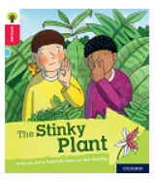  Phase 5 Book  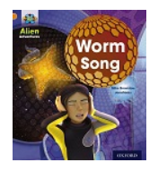  Please spend today reading to page 7.  Phase 5 Book  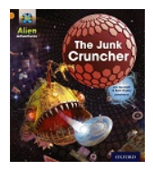  Please spend today reading to page 7. | Phase 4 Book  Can you read to page 7 again and answer the questions below?  - Where are the children?  - How did Mum describe the smell of the flowers?  - How do you think Wilf is feeling? Why?  - What started to glow?  - What does the word glow mean?  - Where did the key take them?  - Why do you think the man is not happy?  - What do you think will happen next?  Phase 5 Book  Read to page 7  - Look at page 4. Where were they going in Nok’s spaceship?  - What was ahead?  - What did they see?  - How has the author described the rock?  - What noise was coming from the rock?  - What does the word distress mean?  Phase 5 Book  Read to page 7  - Look at page 4. What is the name of the closest planet to Exis?  - Why is planet Senton a messy place?  - What was flying in their direction?  - What was it doing?  - What was it called? | Phase 4 Book  Read pages 7 - 13  - What is a botanist?  - Have you got a favourite plant?  - What is the man looking for?  - Why can’t the man smell the flowers?  - Look at page 13. How is Wilf feeling?  - What do you think is going to happen?  Phase 5 Book  Pages 8-13  - What was the rock doing?  - Is the rock dead or alive?  - Is it a rock?  - How is Nok feeling on page 10? How do you know?  - What does the word lunged mean?  - What was the creature?  Phase 5 Book  Pages 8-13  - Who What did the junk cruncher do to their ship?  - What closed around them?  - How do you think they feeling?  - Why do you think they screamed?  - What was sorting the rubbish inside?  - What did the ship land on?  - What was the pounder doing?  - What shape was the metal being squashed in to? | Phase 4 Book  Please read pages 13-21  - What did the smell remind them of?  - Why did the Botanist get excited?  - Why did the stink get stronger?  - What did the Botanist use to look at the flower closely?  - Why did the children have to go?  - How did the children try to get rid of the smell?  - What could Mum smell?  Phase 5 Book  Read 14-21  - What was the baby worm whistling for?  - What was heading towards the ship now?  - What does the word veered mean?  - What did the mother worm do on page 17?  - What did the space worm blow out?  - Look at page 20. What does the word protect mean?  - What happened to the space worms?  Phase 5 Book  Pages 14-23  - What landed on top of the ship?  - Why could Nok not take off?  - What might happen to the ship?  - How do you think they are feeling?  - What did they try and do in the engine room?  - Do you think they will get out in time?  - What noise did the engine make?  - Did they escape?  - How do you think they are feeling now?  - Where did they head to? | Phase 4 Book  Can you retell the story using page 22?  Did you like the story?  Why?  Phase 5 Book  Look at pages 22 and 23  What do you know about space worms?  Phase 5 Book  Look at page 24. Can you retell the story?  What feelings and emotions did the characters show throughout the story?  Why?  How would you have felt?
Topic | Geography  Can you create a map of your journey to school?  Where do you live?  Do you know your address?  Can you find your home on Google Earth?  How far is your home from school?  Can you draw a map of your journey to school?  What buildings would you pass?  Do you know the names of the streets you would walk through?
Science | Hygiene  This week I would like you to think about why we must keep our mind and bodies healthy.  - Can you recognise, name and sort different foods into healthy and unhealthy?  - Why must we brush our teeth? What would happen if we did not keep our teeth clean?  - How can we keep our bodies clean inside and out?  - How can we keep our mind healthy and relaxed?  Use the internet and books to find out information and don’t forget to share your thoughts and ideas with a parent or carer.

Don’t forget Mrs Thurman and Miss Parsonage are available on the below email address to support you and your child at this difficult time.
Please use the email address to ask any question you might have about this learning.
We are here for you!
Maple: maple@hollyhill.bham.sch.uk
Fir: fir@hollyhill.bham.sch.uk

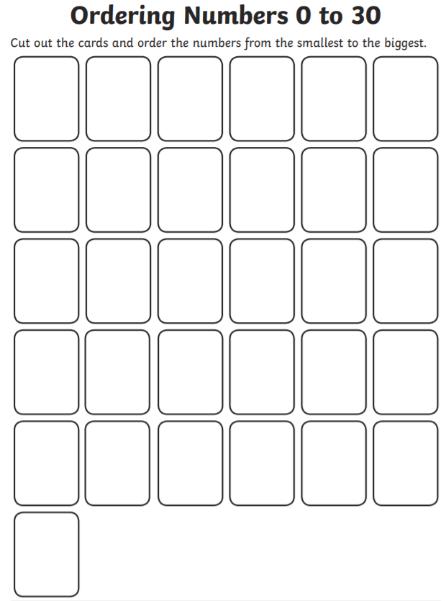
Maths Work Sheets
Lesson 1 – Ordering Numbers

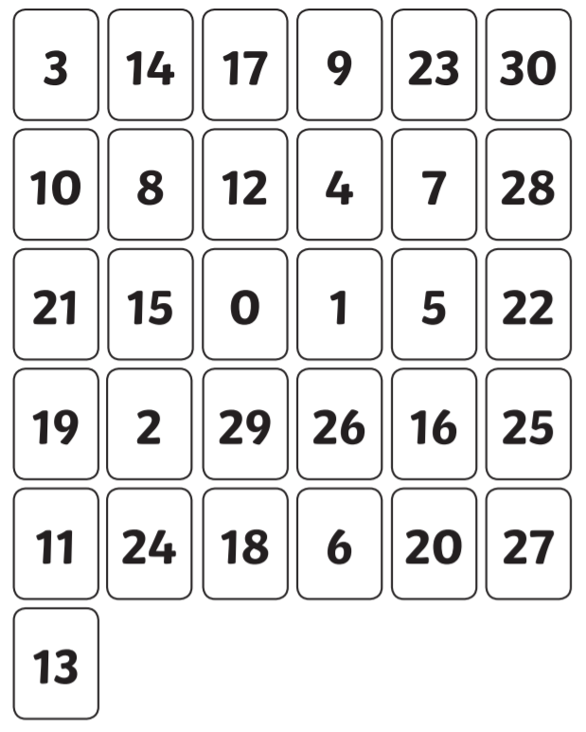

Lesson 2 – Recognising Coins
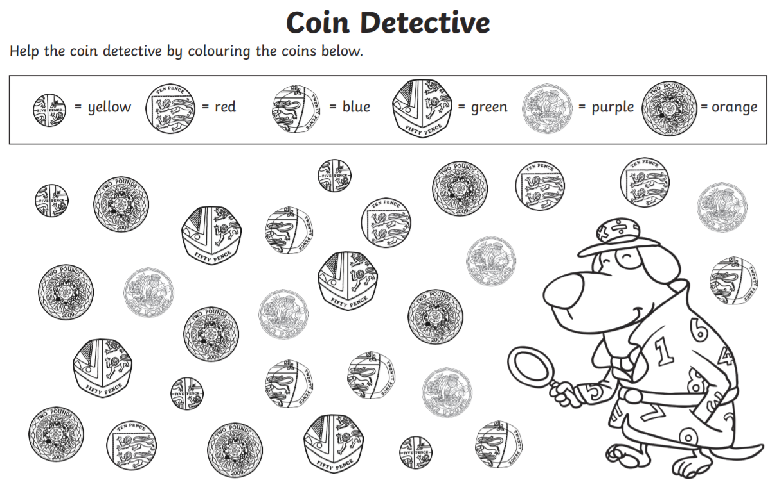

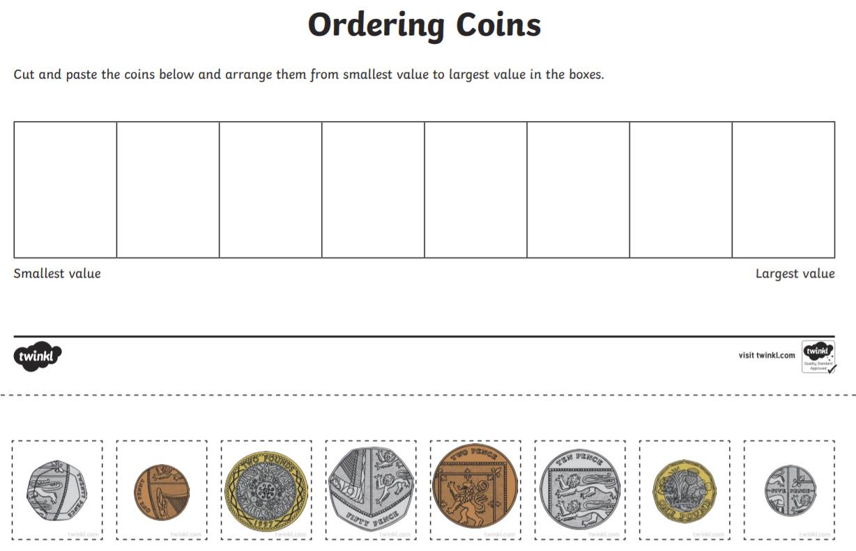
Lesson 2 Ordering Coins

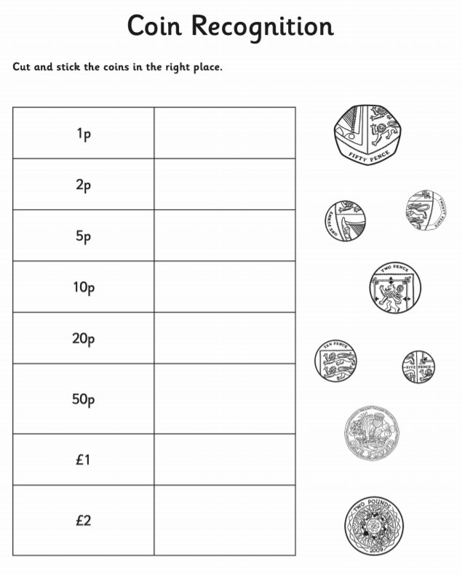
Lesson 2 – Coins

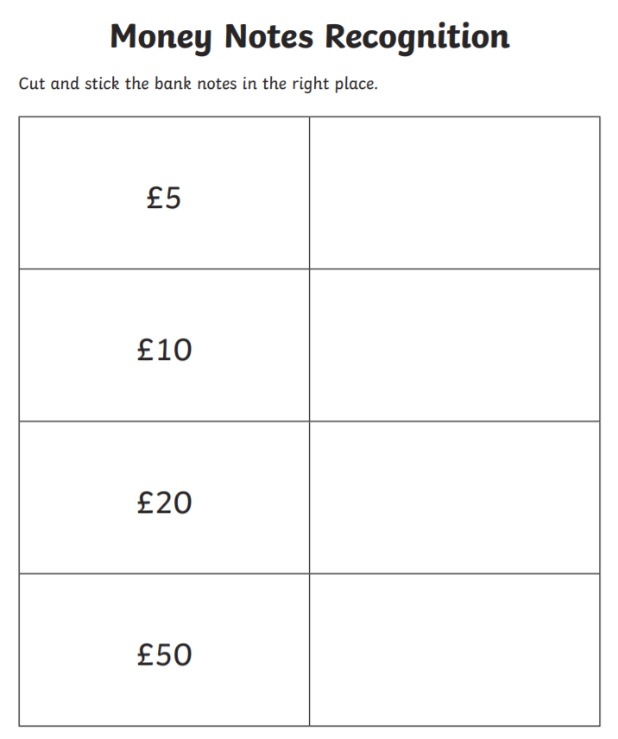
Lesson 3 – Recognising Notes

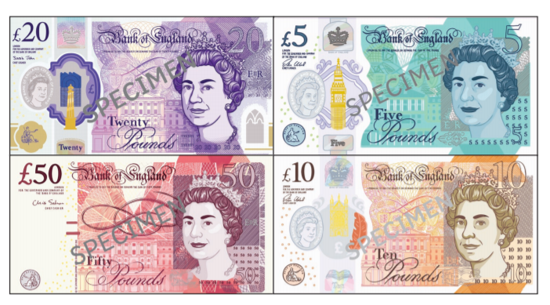

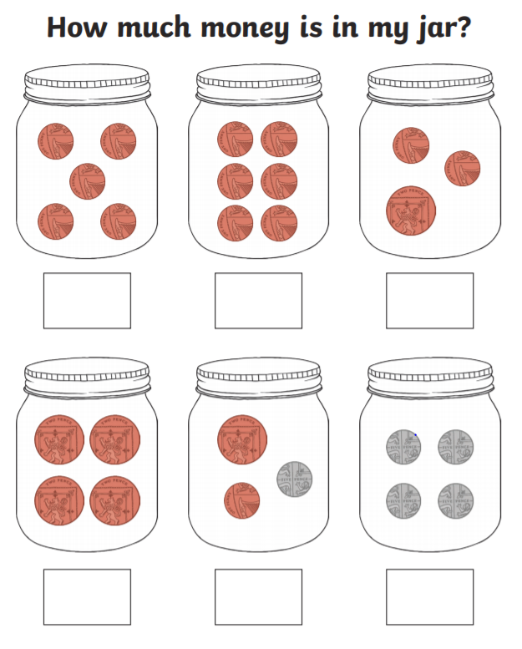
Lesson 4 – Counting Coins

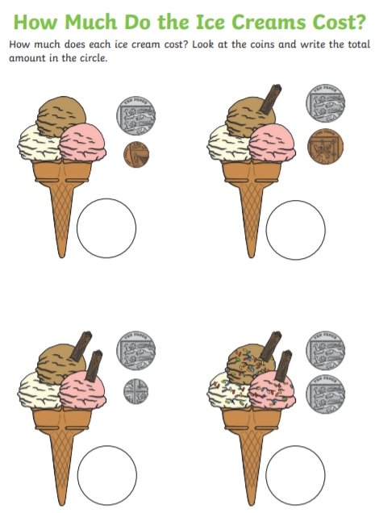

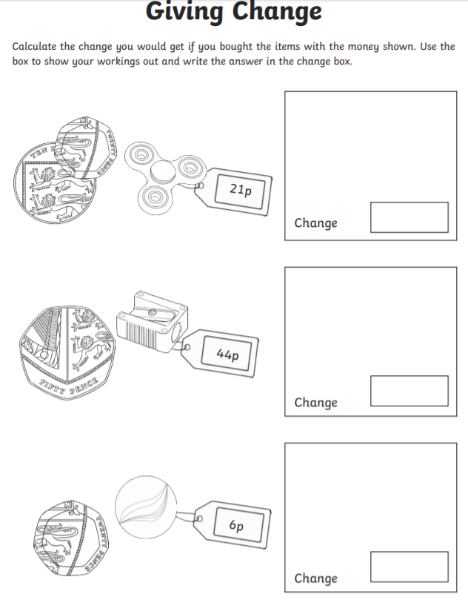
Challenge – Making change

Phonics Challenge
