 | Monday | Tuesday | Wednesday | Thursday | Friday
Spelling/Phonics  Phonics Play  Username – march20  Password - home | Starter – Ph 5 song  https://youtu.be/YPW-ZkhRUPY  Phonics Bloom – Odd and Bob https://www.phonicsbloom.com/uk/game/list/phonics-games-phase-5 | Starter – Ph 5 song  https://youtu.be/YPW-ZkhRUPY  Phonics Bloom – Phonics Frogs https://www.phonicsbloom.com/uk/game/list/phonics-games-phase-5 | Starter – Ph 5 song  https://youtu.be/YPW-ZkhRUPY  Phonics Bloom – Tricky Trucks  https://www.phonicsbloom.com/uk/game/list/phonics-games-phase-5 | Starter – Ph 5 song  https://youtu.be/YPW-ZkhRUPY  Phonics Bloom – Yes/No Yeti https://www.phonicsbloom.com/uk/game/list/phonics-games-phase-5 | Starter – Ph 5 song  https://youtu.be/YPW-ZkhRUPY  Can you go on a phoneme treasure hunt?  Place different phase phonemes around your home. Can you find them? Can you sound them? Can you think of a word which contains that sound?
English | Handwriting  Can you practise forming the days of the week?  Monday  Tuesday  Wednesday  Thursday  Friday  Saturday  Sunday  Can you each day of the week within a sentence? | Can you write a short description all about yourself ready for your new teacher. They would love to find out all about you.  - Can you describe yourself?  Remember  - Capital letters  - Full stops  - Conjunction – and, but, so  - Adjectives  What is your hair colour?  What is your eye colour?  How old are you?  When is your birthday?  - Can you describe who you live with?  Who is in your family?  Who do you live with?  Do you have any pets?  - Can you describe what you enjoy?  What is your favourite game?  Who is your best friend? Why?  What do you like to eat?  What don’t you like to eat?
Maths | Starter – BBC Super movers 10 x table  https://www.bbc.co.uk/teach/supermovers/ks1-maths-the-10-times-table-with-webster-the-spider/zm32cqt  Summer Term – Week 9 (It does state week commencing 6th July)  Lesson 1 – Find a half.  *Note – these are lessons to watch only. There are worksheets at the bottom of this document for you to complete.  https://whiterosemaths.com/homelearning/year-1/ | Starter – BBC Super movers 5 x table  https://www.bbc.co.uk/teach/supermovers/ks1-maths-the-5-times-table/zhbm47h Summer Term – Week 9 (It does state week commencing 6th July)  Lesson 2 – Find a half.  *Note – these are lessons to watch only. There are worksheets at the bottom of this document for you to complete.  https://whiterosemaths.com/homelearning/year-1/ | Starter – BBC Super movers 5 x table  https://www.bbc.co.uk/teach/supermovers/ks1-maths-the-2-times-table-with-bridget-the-lioness/zrrx92p Summer Term – Week 9 (It does state week commencing 6th July)  Lesson 3 – Find a quarter  *Note – these are lessons to watch only. There are worksheets at the bottom of this document for you to complete.  https://whiterosemaths.com/homelearning/year-1/ | Starter – Jack Hartmann – Counting to 100  https://www.youtube.com/watch?v=1dkPouLWCyc  Summer Term – Week 9 (It does state week commencing 6th July)  Lesson 4 – Find a quarter  *Note – these are lessons to watch only. There are worksheets at the bottom of this document for you to complete.  https://whiterosemaths.com/homelearning/year-1/ | Starter – Number bonds  https://www.bbc.co.uk/teach/supermovers/ks1-maths-number-bonds-with-martin-dougan/zf6cpg8  Challenge  Can you find a half and a quarter of different things around your home?  Can you split/divide food into a half and a quarter?  Can you find different shapes that can be split?  Take pictures of your findings to share with your teacher.
Reading | To access these books please follow this link:  https://www.oxfordowl.co.uk/?selLanguage=en&mode=hub  Once on this webpage please click the class login and enter;  Username: hhmaple  Password: maple1  Username: hhfir  Password: Fir12  Once you are logged in click on the bookshelf and search for the title your child will be reading.  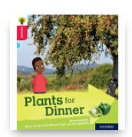  Please choose the appropriate level book for your child.  Phase 4  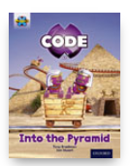  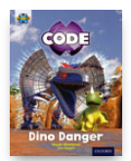  Phase 5
Value  Love | This weeks value is LOVE.  What do you love about Holly Hill?  As this is the final week, I would like you to write about your time in Holly Hill.  What has been your favourite thing you have done?  What is your favourite lesson?  What has been your favourite trip?  What are you going to miss the most?  Why do you love Holly Hill?

Don’t forget Mrs Thurman and Miss Parsonage are available on the below email address to support you and your child at this difficult time.
Please use the email address to ask any question you might have about this learning.
We are here for you!
Maple: maple@hollyhill.bham.sch.uk
Fir: fir@hollyhill.bham.sch.uk

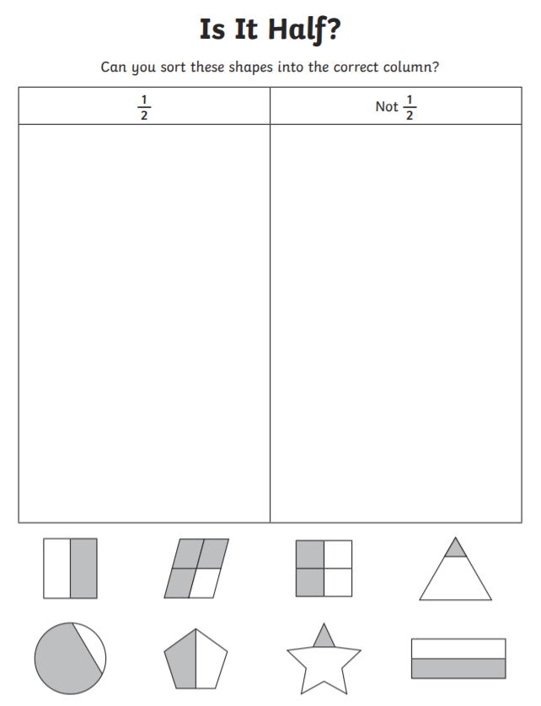
Maths Work Sheets
Lesson 1 – Find a half

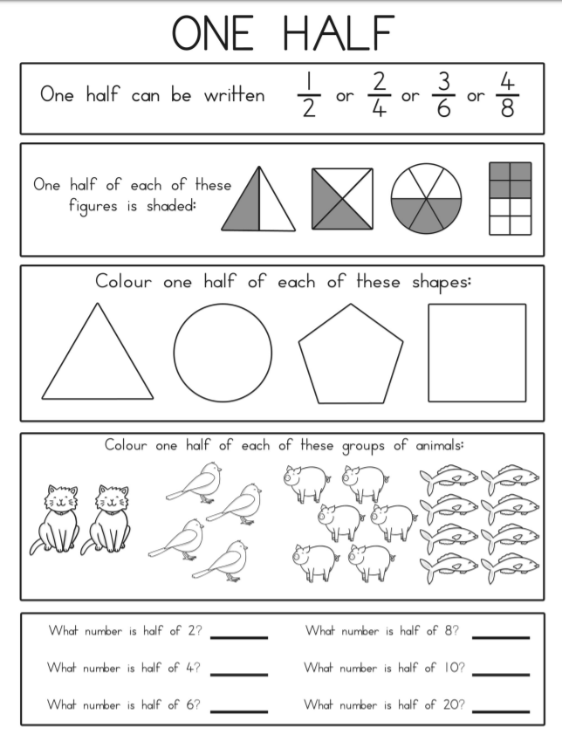
Lesson 2 – Find a half

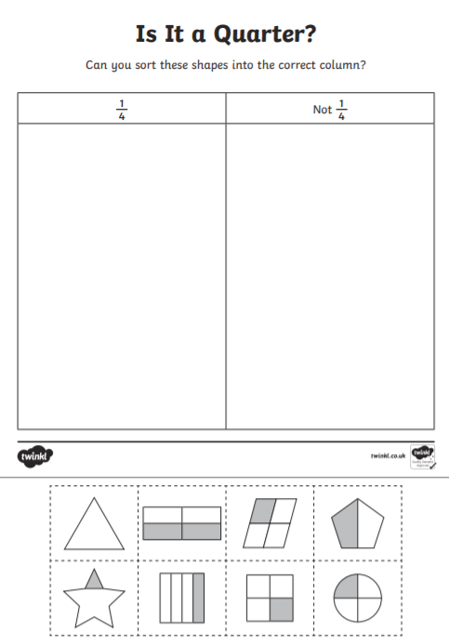
Lesson 3 Finding a quarter

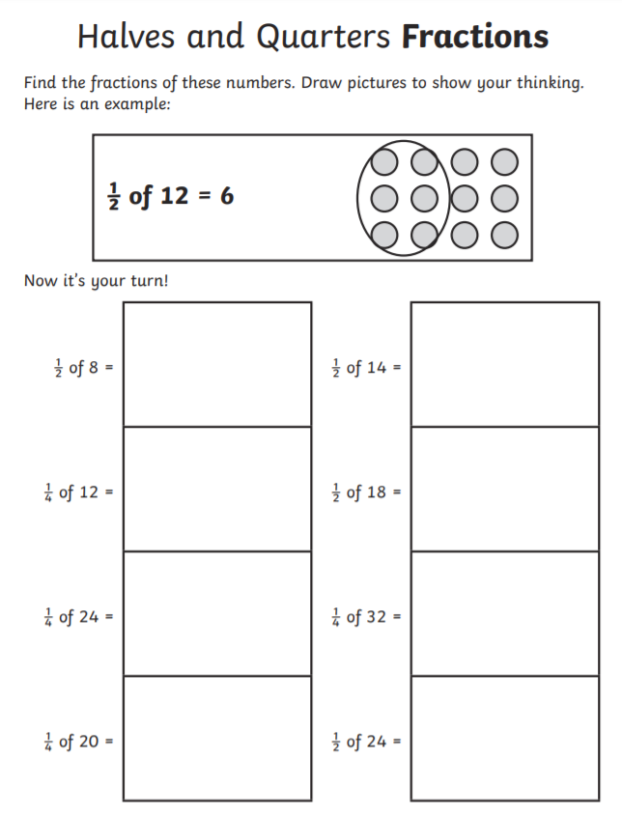
Lesson 4 – Finding a quarter

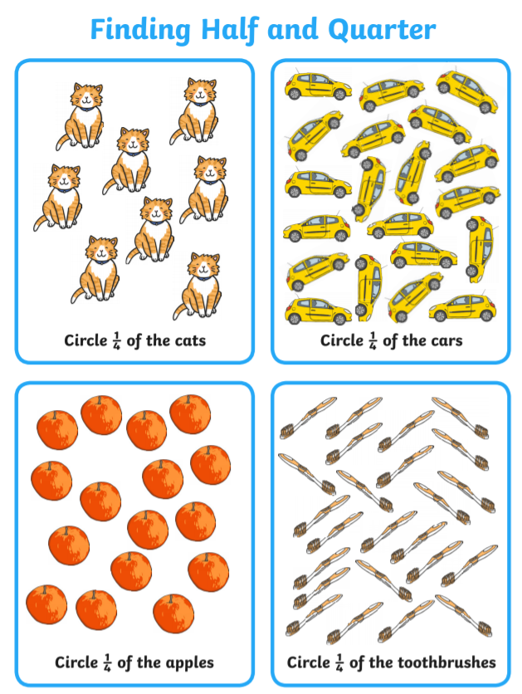

Phonics
