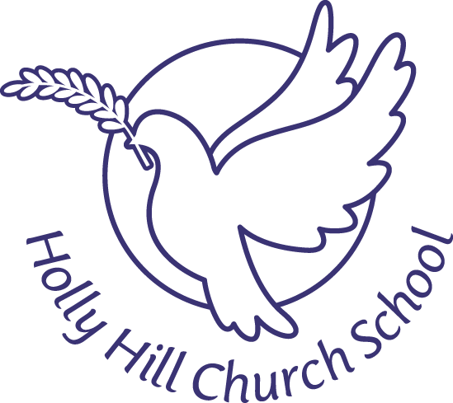

Covid-19 Business Continuity Policy
(How to Manage Coronavirus)
- Aim
The aim of this policy is to advise about the precautions needed when dealing with a coronavirus outbreak. This policy also takes into account the guidance given from both Public Health England and Birmingham City Council. This policy should be read alongside the risk assessment for the safe return of children to schools, and our Critical Incident Document.
- Scope
This policy contains guidelines, which will be adapted as necessary, for members of staff, parents and pupils.
- The Policy Statement

The risk of severe disease associated with COVID-19 infection for people in the EU/EEA and UK is currently considered moderate for the general population and high for older adults and individuals with chronic underlying conditions. In addition, the risk of milder disease, and the consequent impact on social and work-related activity, is considered high.(European centre for disease control (13-03-2020))
As of 2.3.20 The Department of Education has sent the following communication to all schools: “No school should close in response to a suspected (or confirmed) COVID-19 case unless directed to do so by Public Health England.”

Central Government has overall responsibility for contingency planning and for national policy decisions. Local Authorities will communicate information from Central
Government to all schools. Depending on the nature of the virus, children's vulnerability to it and the regions it has reached, schools may be advised to close. It is the Head's responsibility to respond appropriately to the advice received. Schools have been advised to plan for remaining open and for possible closure during a pandemic. If there is no advice to close the school, Holly Hill will remain open as long as there are sufficient staff available for the school to function.
Plans that are guiding our response
- National Covid-19 plan and guidance
- https://www.gov.uk/government/publications/coronavirus-action-plan

Coronavirus helpline

Staff, parents and young people can contact the helpline as follows:
Phone: 0800 046 8687

Email: DfE.coronavirushelpline@education.gov.uk

Opening hours: 8am to 6pm (Monday to Friday)

The following plans will provide a basis for the school's response to the coronavirus. Should the Local Authority inform the school that a pandemic is imminent, the Head would revisit the plans alter as appropriate and according to the latest advice.

4. Emergency Management plan.
KEY AREAS:
- Health & Safety
- Communication
- Continuity of Educational Provision
- Health & Safety
Coronavirus is a viral infection. It is spread by breathing in air containing the virus or by contact of contaminated hands and infected surfaces, and is highly infectious.

  - It mainly affects the nose, throat and lungs.
  - The infection is not serious for most people including children
  - There is currently no vaccine
  - Most people make a full recovery with enough rest, water to drink and medicine for pain
  - It can cause flu-like symptoms, including fever, cough and difficulty breathing and in some cases loss of taste and smell.

• | All staff and families need to self-isolate for 14 days if
anyone in the household shows coronavirus symptoms of a persistent dry cough and/or temperature of 37.8 or higher

Reducing spread of virus would involve and include:

  - Covering nose and mouth when coughing or sneezing (preferably with a tissue or if need be coughing into the crook of the elbow).
  - Dispose of dirty tissues promptly and carefully in the nearest bin, and in line with Public Health England guidance
  - Maintain good basic hygiene (frequent hand washing with soap and water for 20 seconds).
  - Avoid non-essential trips that involve using public transport and those that would involve staff and students coming into contact with large crowds
  - Cleaning all hard surfaces frequently (work surfaces, door handles), and this will include additional cleaning during at lunchtime.
  - Limiting access to school to essential visitors only who have been pre booked with the office.
  - Use of any contractors for statutory testing would be held with control measures

Those in school who start to have flu like symptoms would be instructed as follows:
  - Pupils should tell an adult as soon as possible
  - Staff should inform the Head Teacher
  - Pupil to use the isolation room until parent / carer can collect
  - The requirement to go/be taken home as soon as possible

Please see appendix 1 for chart of vulnerable people.

General Hygiene at school:
  - Teaching staff should ensure that pupils follow the hygiene guidelines described above with regular daily reminders about routines and keeping safe. All children to be monitored when hand washing.
  - The site team must ensure that there are adequate supplies of tissues, soap, hand cleaning gel and hot water and that bins are emptied regularly.
  - We will limit the amount of things being brought into school (coat, hat, gloves) and only accept reading books brought and taken home in school book bags
  - The school cleaning team will be carefully directed to priority areas e.g. door handles, computer keyboards, toilet flushers and photocopiers and door frames. Additional cleaning is completed at lunchtime.
  - Children will continue to use their school water bottle, clearly marked with their name which will be washed each night.

- Communication
When necessary, parents will be contacted with important updates via the school app, email or letter. This information will also be available on our school website.

Regular communication will be held with the chair of governors who will liaise with all governors as appropriate and where necessary formulate a governor action plan.
- Continuity of Education
- It is the schools' intention to provide educational continuity wherever possible.
- If there is no advice to close the school, it would remain open as long as there are sufficient staff available for the school to function.
- Should the school be advised to close, governors and the local authority would be consulted and kept up to date and we will inform parents/carers immediately via the school app and website.
- In the case of closure staff will be directed to work from home with regular contact maintained with the school / school head teacher with staff workload being monitored by senior leadership
- The school opening times may differ to meet the needs of children/staff and a reduced timetable put in place Key staff roles will be identified as may be required to establish suitable availability for on and off site
- Individual Risk Assessments will be conducted for any children/staff who may be deemed as ‘vulnerable’/have underlying medical issues
- We will undertake a deep clean before reopening.
- If school should close or there is a partial closure pupils will be set work via home emails from the class teachers, to support home learning.

This policy is subject to constant review and amendment as necessary.
Approved by: ………………………………………………….
Date: September 2020

Appendix 1
