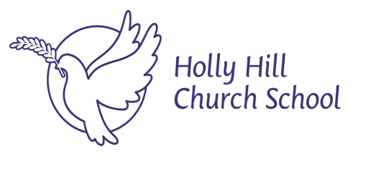

Children with health needs
who cannot attend school

Policy

Date issued: June 2020
Date of Review: September 2024
Next Review due by: September 2025

Approved at FGB Meeting: 23rd September 2024

Approved :
Chair of Full Governing Board

1. Aims
At Holly Hill, we aim to ensure that all children, regardless of circumstance or setting receive a good education to enable them to shape their own futures, this is in line with our vision of ‘Life in all its fullness.’ Where children are unable to attend school because of their health, the school will provide work on the short-term basis, but then liaise with the Local Authority and the James Brindley hospital school if applicable.

This policy aims to ensure that:
- Suitable education is arranged for pupils on roll who cannot attend school due to health needs
- Pupils, staff and parents understand what the school is responsible for when this education is being provided by the local authority

2. Legislation and guidance
This policy reflects the requirements of the Education Act 1996.
It also based on guidance provided by our local authority and the Department of Education. This policy complies with our funding agreement and articles of association.

3. The responsibilities of the school
If the school makes arrangements
Initially, the school will attempt to make arrangements to deliver suitable education for children with health needs who cannot attend school:
- Work will be sent to the parent / carer via email. If this is not possible, hard copies will be sent home or to the hospital (if applicable)
- The Office Manager will be responsible for making and monitoring these arrangements, liaising with the class teacher for applicable work.
- Parents / carers will be consulted regularly if the child is off school for more than 2 weeks.
- When the pupil is ready to return to school, a risk assessment will be completed (if it is the child that has been poorly) in how we can reintegrate the pupils safely back into school.
- The family will be able to stay in touch with Holly Hill school life, value of the week, through the website and parent app. Weekly check-ins by the learning mentors to the family will be completed.

4. Monitoring arrangements
This policy will be reviewed annually by Kate O’Neill (SENDCO). At every review, it will be approved by the full governing board. The DfE advises that we review this policy annually, in its list of statutory policies.

5. Links to other policies
This policy links to the following policies:
- Accessibility plan
- Supporting pupils with medical conditions
- Safeguarding and Child Protection

